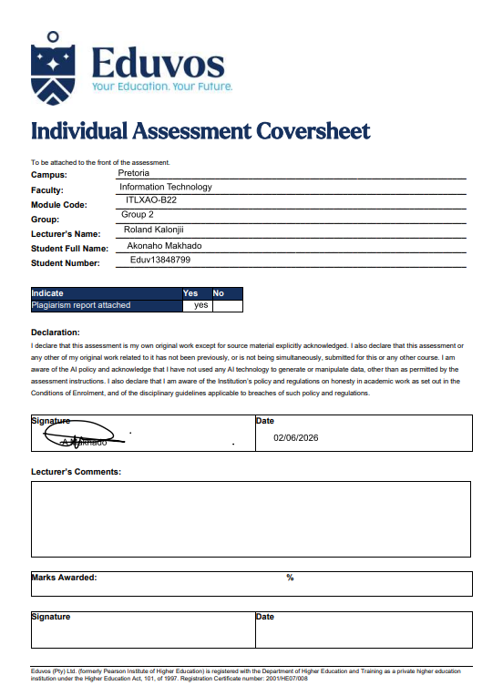

Acknowledgement
I would like to express my sincere gratitude to the academic staff and lecturers at Eduvos, especially Roland Kalontji, for their guidance, support, and valuable feedback throughout the completion of this Ubuntu Linux practical project. Their expertise and commitment to academic excellence contributed significantly to the successful completion of this assessment.
I would also like to extend my appreciation to the TUT senior students who generously shared their knowledge, advice, and academic insights during the development of this project. Their guidance helped me better understand project requirements and academic expectations.
Special thanks are due to Keamogetswe Ntoagae, a Eduvos third-year Law student, for her valuable guidance regarding the structure, formatting, and presentation of academic projects at Eduvos. Although her field of study differs from Information Technology, her advice on academic writing, report organization, and professional presentation greatly assisted in ensuring that this project met the expected academic standards.
I would also like to acknowledge A. Mudau, a member of the Council for Scientific and Industrial Research (CSIR), for providing valuable advice on the professional structuring and organization of this project. His recommendations helped improve the overall quality and presentation of the report.
I am equally grateful to my peers and colleagues, Siyabonga Mahlangu, Reabetswe Maitisa, and Mamabolo Mabotse, for their collaboration, constructive discussions, and encouragement throughout the completion of this assessment.
Special appreciation is extended to my family and close supporters for their encouragement, patience, and continuous motivation throughout this academic journey. Their unwavering support helped me remain focused and committed to completing this project successfully.
Finally, I acknowledge the use of official Ubuntu and Linux documentation, technical resources, and best practice guidelines that served as valuable references during the completion of this assessment. These resources contributed to the implementation of industry-standard Linux administration practices and supported the accuracy and professionalism of the work presented.
This project reflects the collective support, guidance, and encouragement of all those who contributed to its successful completion, and I am sincerely grateful for their assistance.

Abstract
This project presents the practical implementation and administration of an Ubuntu 26.04 LTS environment, demonstrating the fundamental skills required for modern Linux system deployment, configuration, security, virtualization, networking, and user management. The project was conducted to develop practical competencies in Linux system administration while applying industry-standard procedures and best practices.
The assessment involved the installation and configuration of Ubuntu Linux, the creation and management of user accounts and permissions, system maintenance, network configuration, virtualization, and the deployment of essential services and applications. Various administrative tasks were performed using both the graphical user interface (GUI) and command-line interface (CLI), highlighting the flexibility and efficiency of Linux-based operating systems in professional environments.
Furthermore, the project explored key concepts related to system security, resource management, software installation, email client configuration, and network services. Throughout the practical exercises, emphasis was placed on maintaining system stability, security, and operational efficiency while adhering to established Linux administration standards.
The successful completion of this project demonstrates a comprehensive understanding of Ubuntu Linux administration and the practical skills necessary to manage Linux-based systems in academic, enterprise, and professional environments. The knowledge and experience gained through this assessment provide a strong foundation for further studies and future roles in information technology, systems administration, cybersecurity, and cloud computing.

Executive Summary

This report highlights my completed Ubuntu Linux administration project, covering deployment, configuration, management, and maintenance of Ubuntu 26.04 LTS. The goal was to pick up practical Linux admin skills while using standard methods from the IT world.
I tackled a bunch of crucial tasks like installing the OS, managing users and groups, dealing with the file system, and handling software packages. I also configured networks, set up email clients, and beefed up system security. For each task, I used both GUI tools and the command line to show that I can manage these systems well.
A big part of this project was getting hands-on with Ubuntu and seeing how the theory actually works. Finishing all those tasks showed I understood Linux's inner workings, knew admin procedures and troubleshooting tricks, and was clued up on keeping systems secure and dependable.
Another neat thing? This project underscored the role of open-source tech today, showing how Ubuntu is relied upon for its stability, security, and value in everything from schools to cloud setups. It really drove home the value of these systems.
So, in wrapping this up, I've shown my ability to work with Ubuntu Linux following industry guidelines and best practices. All the stuff I learned here gives me a strong start for further study or a career in Linux admin, tech support, cybersec, cloud tech, or IT management overall.

Contents
Acknowledgement 2
Abstract 3
Executive Summary 4
Introduction 8
Question 1 Virtual Machine Installation 9
Step 1: Preparation & VirtualBox Installation 10
Step 2: Downloading the Ubuntu 26.04 LTS ISO 11
Step 3: Creating the Virtual Machine in Oracle VirtualBox 13
Step 4: Starting the Virtual Machine 15
Step 5: Beginning the Ubuntu Installation 17
Step 6: Ubuntu Boot and Installation Screen 18
Step 7: Ubuntu Installation Wizard Loading 19
Step 8: Selecting the Installation Language 20
Step 9: Choosing the Installation Type 21
Step 10: Disk Setup for Ubuntu Installation 22
Step 11: Creating Your User Account 23
Step 12: Selecting Your Timezone 25
Step 13: Finalizing Installation 26
Step 14: Reviewing Installation Settings 28
Step 15: First Login to Ubuntu 29
Step 16: First Look at the Ubuntu Desktop 31
Step 18: Final Step — System Update Confirmation 32
a) Justify your chosen VM configuration. 35
b) Explain TWO risks of poor VM configuration. 37
c) Explain why virtual machines are preferred in training environments. 38
Question 2 System Verification 40
Ubuntu System Information Commands 41
a) Interpret the output of each command. 43
b) Explain how this information helps in troubleshooting. 45
c) Identify ONE potential system issue from your outputs. 46
Question 3 GNOME Desktop and Preferences 48
1. Launch TWO applications using different methods. 49
2 Use GNOME Help to search for a system feature. 53
3 Modify TWO system settings (e.g., Display, Appearance, Keyboard). 55
4 Analyse How GNOME Improves Usability 58
5 Evaluate how your changes affect system performance or usability. 59
6 Explain when GUI is better than CLI. 60
Question 4 File System and Directory Management 62
Linux Directory Management 63
1.Perform file operations (create, copy, move, rename). 67
2. Explain absolute vs relative paths using your structure. 73
3. Explain why Linux uses a single-root filesystem. 76
4. Identify risks of incorrect file handling. 81
Question 5 Terminal and vi Editor 87
1.Demonstrate command syntax with examples. 88
2. Use man, --help, and apropos. 97
3. Create and edit a file using vi containing system usage rules. 103
4.Use output redirection and a pipe 110
5.Compare man, --help, and apropos. 113
6.Explain vi modes. 116
7.Explain difference between pipe and redirection. 120
Question 6 Terminal and vi Editor 126
1. Use Firefox (bookmark + download). 127
2.Create a document in LibreOffice titled Intern Guide. 129
3.Edit an image using GIMP. 131
4.Use workspaces to organise tasks. 135
5.Evaluate how these applications support productivity. 136
6.Explain benefits of multitasking. 137
8. Identify risks of poor application management. 138
Conclusion 140
Reference 142
Articles 142
Websites 142
End of Project 143

Introduction
Linux has gotten super popular lately in every kind of computing setup – from big servers in businesses to the clouds and people's PCs at home. The reason? Its rock-solid stability and top-notch security, mostly thanks to being open source. This lets folks see what’s going on and fix any potential problems fast, so lots of pros rely on it.
For our project, we looked at Ubuntu 26.04 LTS, a very reliable and commonly used Linux version. With its long-term support and big community for help and updates, it was perfect for our needs. We wanted to hone our Linux admin skills by installing, setting up, managing, and keeping the OS running smoothly.
We did everything from installing the OS and setting up file systems to managing users and groups, installing software, and tweaking network settings. We even dipped into virtualization, securing the system, and setting up email clients. We used both the GUI and the command line, just like the real IT world.
Going through all this really drove home how crucial Linux is for today’s tech setups. Plus, we learned tons about keeping systems running smoothly and securely. Be it solving problems, managing resources, or setting up configurations, we handled it all.
In short, this project shows that we've got a good handle on Ubuntu admin stuff. It sets us up nicely for a career in system admin, cloud tech, cybersecurity, or IT support.

Question 1 Virtual Machine Installation

You are required to install Ubuntu 24.04 LTS in a virtual environment.
- Create a virtual machine using appropriate RAM, CPU, and disk settings.
- Install Ubuntu using the ISO file.
- Create a secure user account.
- Log into the system and perform system updates using Terminal.
a) Justify your chosen VM configuration.
b) Explain TWO risks of poor VM configuration.
c) Explain why virtual machines are preferred in training environments.

[Subtotal 25 Marks]

Step 1: Preparation & VirtualBox Installation
To get Ubuntu up and running you need to have a hypervisor, which's basically a program that helps with virtualization already on your computer. For this we will use Oracle VirtualBox.
Action:
• First, you need to download the VirtualBox installing from the Oracle website you can do this using a browser like Google Chrome.
• Then select the version that's, for Windows and run the installer it will be a.exe file.
• Now just follow what the installation wizard tells you to do keep going until it is all set up and done.
Verification:
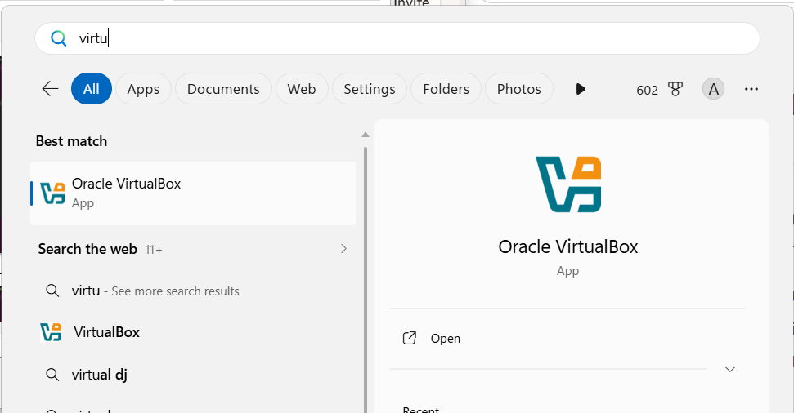
Once VirtualBox is installed, it can be found by searching for the phrase “VirtualBox” in the Windows search bar.
The following image shows how this can be done: since VirtualBox has been installed on the computer, searching for “VirtualBox” returns VirtualBox as the primary result.
Important information:
- When VirtualBox is not installed, it needs to be installed from the official website of Oracle. Without VirtualBox or any other type of hypervisor software, Ubuntu 26.04 will not be able to run on the Windows operating system.

Step 2: Downloading the Ubuntu 26.04 LTS ISO
In order to begin the installation, one must first obtain the official ISO file of the Ubuntu operating system.
Process:
• Open up the Google Chrome browser and conduct a search for “Ubuntu download.”
• Visit the official Ubuntu website where one can download the latest Long-Term Support (LTS) version.
• Select Ubuntu Desktop 26.04 LTS (64-bit), which is optimized for Intel and AMD processors.
• Download the ISO file, which is around 5.9 GB in size.
Verification:
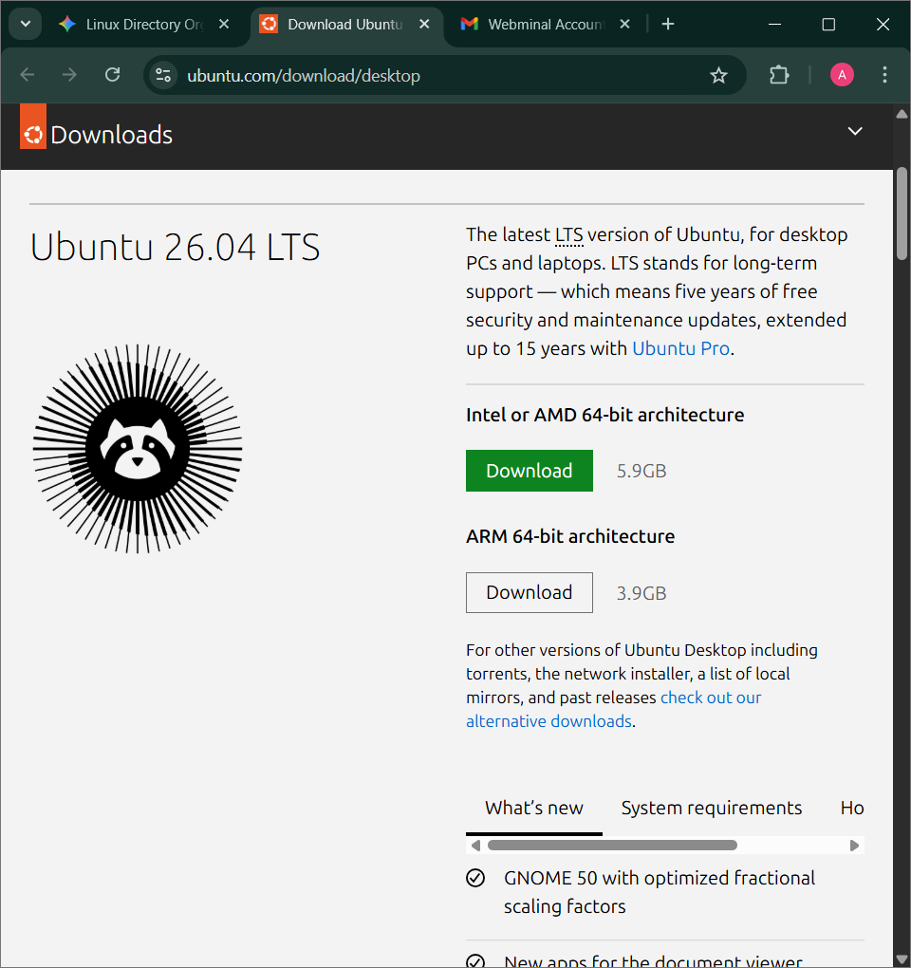
Linux has blown up lately across every type of computing setup—from big servers in companies to the cloud and even on people’s personal computers. One major reason for its popularity is how stable and secure it is, mostly because it’s open source. That’s why a lot of businesses rely on Linux for their tech needs.
For this assignment, we went with Ubuntu 26.04 LTS, which is super popular and dependable. The LTS stands for Long Term Support, meaning it gets updates and fixes for years. Plus, there’s a huge community that contributes and assists with problems. We chose this project to boost our Linux admin abilities, covering everything from install to manage and maintain Ubuntu.
We got into OS installation, user and group management, file systems, software installs, network tweaks, and more. That includes playing with virtualization, beefing up security, and setting up email clients. We tackled each task using both GUI tools and command line interfaces, just like what you deal with in actual IT jobs.
This practical work really hammered home how crucial Linux is for modern tech infrastructures. Plus, we picked up important methods for keeping systems running smoothly and safely. From fixing glitches to managing resources and settings, there was a ton of stuff to learn.
All in all, this wraps up showing that we’ve got the basics of Ubuntu administration down. It gives us a great start for diving into system administration, cloud tech, cybersecurity, or IT support roles.
2.1 Downloading the Ubuntu 26.04 LTS ISO
In order to get Ubuntu installed inside the virtualization software, the ISO image should be obtained from the official site. This can be done as described below:
1. Open Google Chrome and search for "Download Ubuntu."
2. Visit the official site of Ubuntu and choose "Ubuntu Desktop 26.04 LTS (64-bit) for Intel/AMD processors."
3. Start downloading the ISO image, which is about 6.1 GB in size.
Verification:
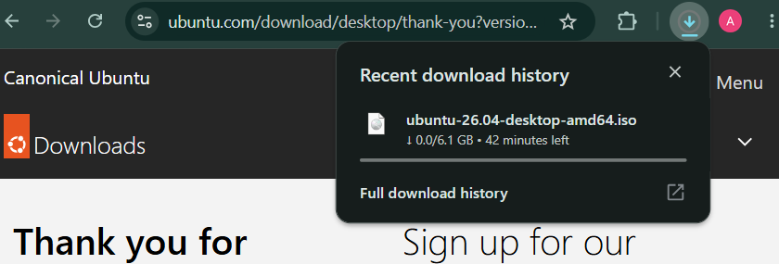
The screenshot shows that the ISO image download is happening, with the file named ubuntu 26.04 desktop amd64.iso. It'll end up in the Downloads folder, or wherever you picked when starting the download.
Important to note:
This ISO file is key for making a virtual machine of Ubuntu. In fact, it's the installable image needed for VirtualBox.

Step 3: Creating the Virtual Machine in Oracle VirtualBox
After setting up VirtualBox software and downloading the Ubuntu ISO file, the next step will be to create a virtual machine.
Steps:
1. Launch Oracle VirtualBox from the Windows search bar.
2. From the VirtualBox Manager screen, click on the blue “New” button (blue circle with a star inside it).
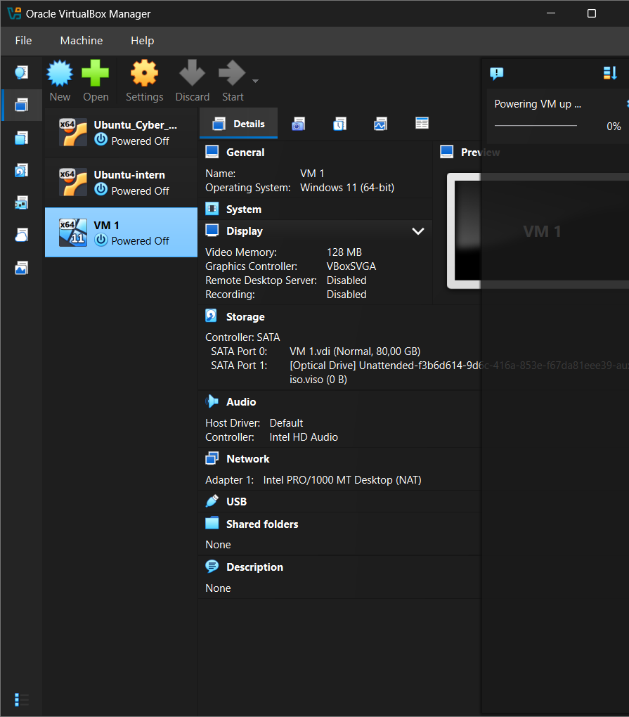
- Enter the following details:
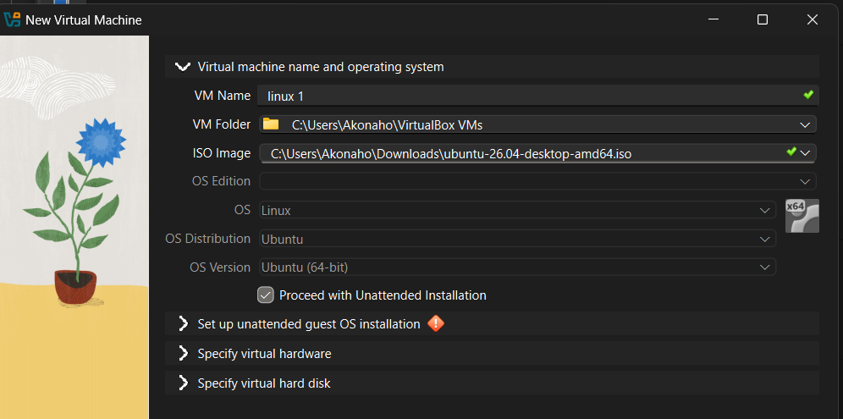
A dialog box appears which asks for the following information:
- Name: Enter an appropriate name for your virtual machine (such as "Linux 1" or "Ubuntu Internal VM").
- ISO Image: Click on the ubuntu-26.04-desktop-amd64.iso image file that you downloaded earlier. This acts as the installation CD of your virtual machine.
- OS type: Choose Linux -> Ubuntu (64-bit).

Virtual Hardware, adjust the sliders:
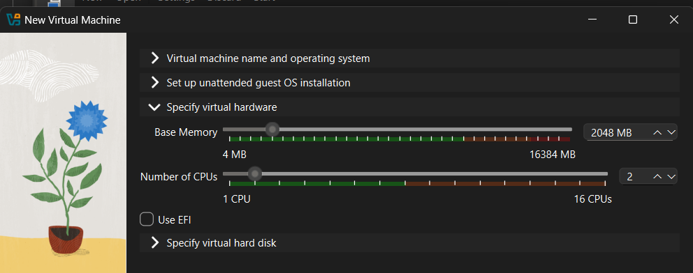
• Base Memory (RAM): Set to 2048 MB (2 GB). This indicates the short-term memory assigned to the virtual machine.
• Number of CPUs: Set to 2. This indicates the number of CPU cores that are assigned to the virtual machine.
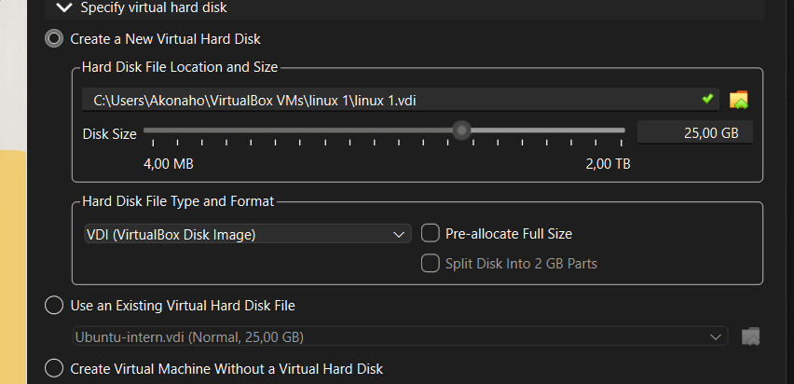
Disk Space: Assign 25GB of space; expand dynamically if necessary. This will be the main storage device used for the virtual machine. The Unattended Installation checkbox must not be deselected.

Step 4: Starting the Virtual Machine
After creating and setting up the virtual machine, the following procedure entails starting up the virtual machine for running Ubuntu using VirtualBox.
Steps Involved:
1. Launch Oracle VirtualBox Manager and select the virtual machine that was created (in this case, linux 1).
2. Click on Start (or Show) after selecting the Linux entry.
3. The Linux system will begin booting, and the GNU GRUB will display. This is what boots the Ubuntu OS.
4. Select the default entry (Ubuntu starts normally).

Verification:
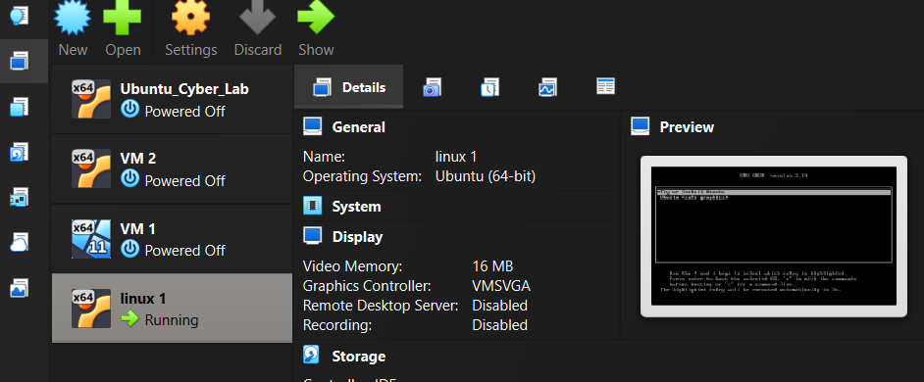
The following screenshot shows the VirtualBox manager having multiple virtual machines where Linux 1 has been powered on.
• The preview shows that the virtual machine is successfully initiated, which is evident from the GRUB interface displaying the selection of the Ubuntu Operating System to boot from.
Reasoning:
This process can be thought of as similar to powering up a new PC. After the creation of a virtual machine, it is ready for operation and starts loading its operating system. The GRUB interface just provides Ubuntu a way to select a procedure for the start-up process, which is initiated by default settings.
Important Note:
•If you have reached this point and can view the GRUB Menu, this indicates that your VM has successfully connected to the ISO file of Ubuntu and now can install or run Ubuntu.
•Once the GRUB menu is displayed, you will move on with the installation process that begins by creating a secure user account and configuring the system.

Step 5: Beginning the Ubuntu Installation
After the virtual machine has been created and is functioning, it is now time to install the operating system for the virtual machine (Ubuntu).
Next steps (step-by-step):
1. When the virtual machine is powered on, you will see the GNU GRUB screen (booting up screen). This is how you can select how you would like Ubuntu to boot up (try or install).
2. Highlight the option “Try or Install Ubuntu” by using the arrow keys.
3. Press the Enter key to continue.
4. The next thing that happens is the system loads the Ubuntu Installer (sets the environment up for installing).
Verification:
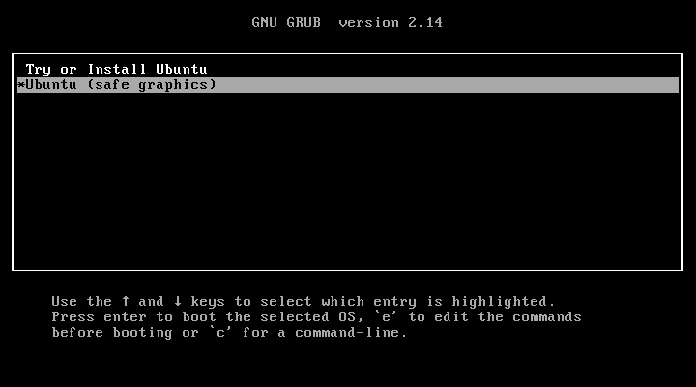
In the screenshot above, you see the GRUB menu. It lets you choose between trying or installing Ubuntu, or installing Ubuntu with safe graphics. This shows the VM is correctly connected to an ISO file, and you're all set to install Ubuntu.
Think of this step like putting a DVD or USB into a real computer and turning it on. The GRUB screen just asks how you want to boot the system.
Important Note:
Only choose 'Try Ubuntu' if you'll be using it just for a limited time or testing. It kicks off the installation wizard which sets up languages and keyboard layouts. You also pick the type of installation and secure your user account setup.

Step 6: Ubuntu Boot and Installation Screen
Once you have selected "Try or Install Ubuntu" from the GRUB menu, your system will now begin to load Ubuntu.
Step by Step Instructions:
1. The screen will change to a solid purple background and display "Ubuntu 26.04" centered on the screen.
2. Dots will appear below the text on the screen and will either move or change color which indicates that Ubuntu is being loaded.
3. As soon as the Ubuntu installer is ready, you will need to wait until it prepares the operating system for use. Depending on how fast your computer is, this could take some time to complete.
Verification:
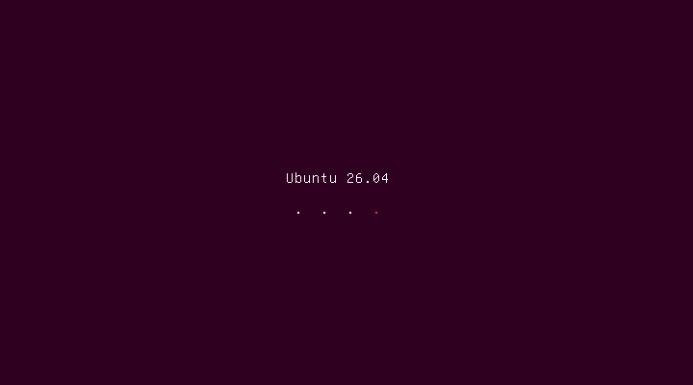
- The screenshot used in this guide shows the start screen of Ubuntu, which lets us know that our ISO file is working correctly, and so, we can boot our virtual machine to the installer of Ubuntu.
Explanation:
More simply, imagine when you turn on the power for your new computer and see the lettering of the company that built the computer on the screen while the computer starts. Ubuntu is simply starting itself up to show you that the installer is on its way to opening. Each of the dots above the first line of text represents progress as the operating system gets loaded onto your hard drive.

Important Note:
- You absolutely must not close or otherwise interfere with your VM until the operating system has finished loading, and you see the Ubuntu Installation Wizard.
- After Ubuntu has finished loading, the installation wizard will open, and you will be able to choose the language of your installation, set your keyboard layout for typing, select the method of installation, and set up a secure username and password.

Step 7: Ubuntu Installation Wizard Loading
Once you've chosen to "Install Ubuntu" from the GRUB menu, the system will continue booting, loading the installation wizard in the process.
What's happening (a step-by-step view):
1. The Ubuntu logo will display on the screen with a loading spinner, indicating that the operating system is currently being installed.
2. The Operating System (OS) is currently being loaded while preparing the installation GUI.
3. Be patient while Ubuntu is loading. It could take some time to load depending on how quickly your computer performs.
Verification:
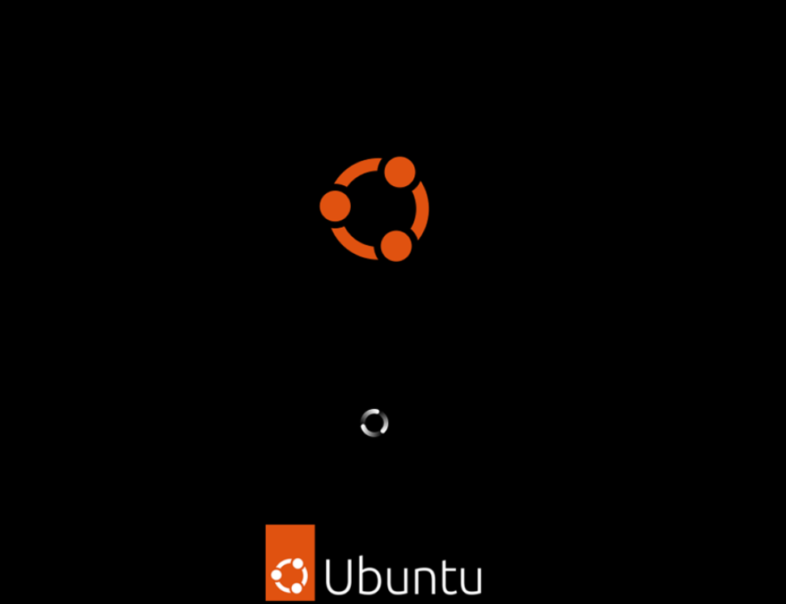
Check out the screenshot; when the Ubuntu logo shows up and spins, it means the ISO file is working right, and the VM has successfully booted to the installation environment.

Important Note:
Don't shut down or restart the VM yet.
When the loading finishes, an installation wizard will start. It lets you choose your language, set up your keyboard, pick how to install the software, and create a username and password for the intern.

Step 8: Selecting the Installation Language
The first step after Ubuntu has finished booting is running the installation wizard which will assist you in configuring your new computer system.
ACTION STEP-BY-STEP
1) The "Welcome to Ubuntu" window will be displayed.
2) On the far right of the screen, you will see a list of supported languages.
3) Find your preferred language (English) by scrolling through the list and select it.
4) Click the "Next" button or select other options to proceed to the next setup stage.
Verification:
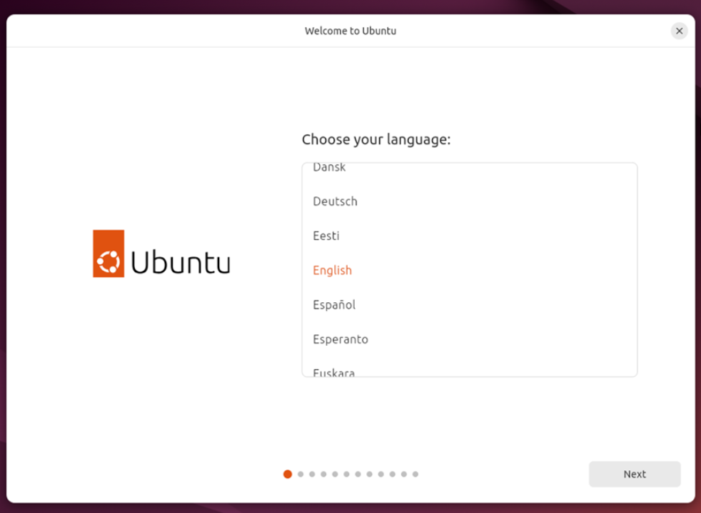
You can see from the screenshot above that the installation wizard for Ubuntu has successfully started by showing an option for English highlighted on the screen labelled “Welcome to Ubuntu”.
Important Note:
It is very important when selecting your language to remember that this will affect your keyboard layout, regional settings and accessibility options during the set-up process.
Once you have made your selection and clicked on the Next button, Ubuntu will give you additional steps in order to configure items such as Keyboard Layout, How You Want to Install Ubuntu and Creating Your User Account.

Step 9: Choosing the Installation Type
After your language will be selected, you’ll be prompted to select one of two types of installations that are possible for Ubuntu.
What Do I Do? (Step by Step)
1. My screen will show “Type of Installation”
2. There are Two Options
-Installation (Interactive): A Guided Install that is Step by Step; it is Suitable for Novice users.
-Installation (Automated): For Experienced users who have already created a configuration file.
3. Select the Interactive Installation (highlighted in orange).
4. Select Next to continue.
Verification:
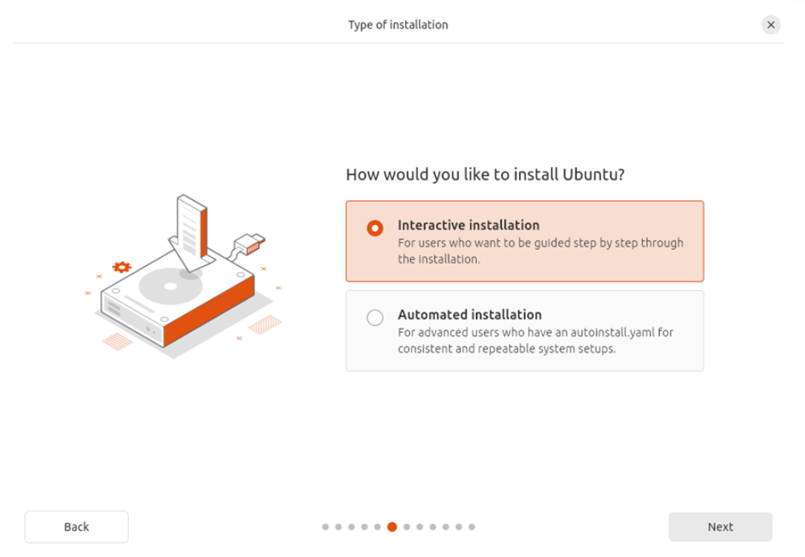
The installation type option is visible in the screenshot, and it indicates that you selected the Interactive installation type. Therefore, you are going to use the guided installation method.
Important Note:
• If you choose Interactive installation, you will be able to specify important details such as keyboard layout, how the disk will be divided up, and the creation of your user account.
• The Automated installation method is best used by IT professionals who are installing Ubuntu on several machines using the same settings on all of them

Step 10: Disk Setup for Ubuntu Installation
This stage of the process will determine the location of your virtual installation of Ubuntu.
Instructions (In Order):
1. The screen for setting the disk appears indicating how you wish to install Ubuntu.
2. You have two options:
a. Erase disk and install Ubuntu - will wipe the disk and set up Ubuntu for you.
b. Manual Installation - provides advanced users with the ability to set custom partitions.
3. Select the first option (erase disk and install Ubuntu) as this is the recommended option for beginners.
4. Click Next to continue.
Verification:
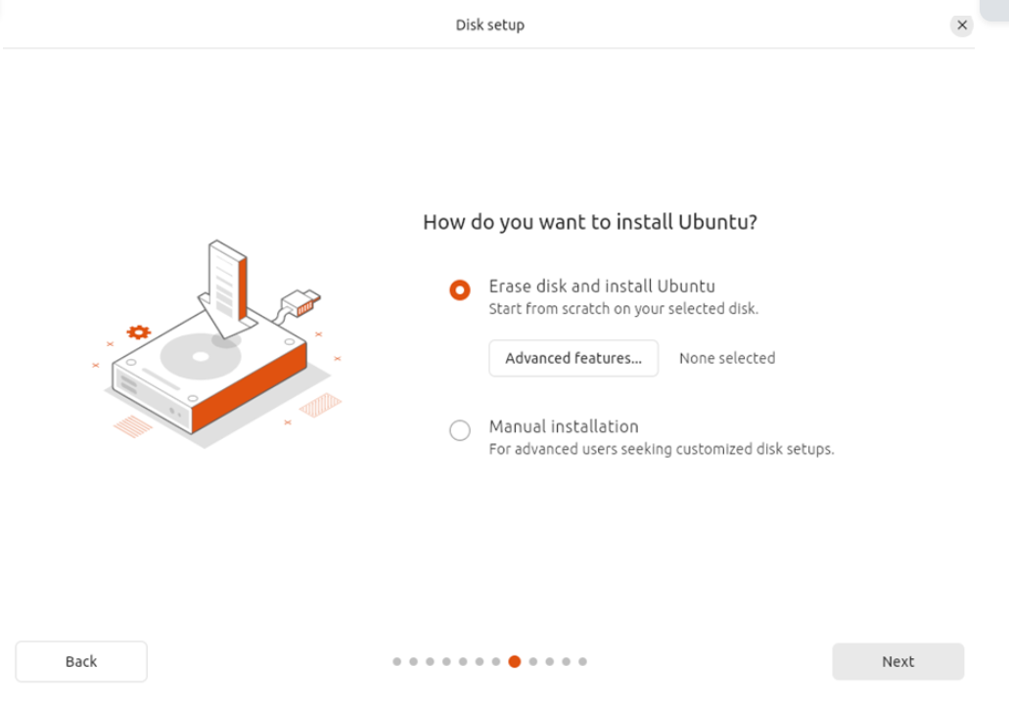
At the stage shown in the screenshot, the Virtual Disk will have been set up at exactly the same time (as shown by having "Erase Disk" and "Install Ubuntu" checked, essentially the same as formatting a new HD on your computer) and will be formatted and have the necessary partitions set up by the Virtual Machine automatically, so it is safe for any person who is new to a PC and therefore needs to be set up by the VM this way as there are no physical files from the real computer on the VM, as the only files being used from the VM are those on the Virtual Disk you created prior to getting to the Disk Setup Screen.
IMPORTANT NOTE:
• Always select Erase Disk and Install Ubuntu when setting up a new Virtual Machine unless you are very familiar with partitioning your own drives through manual installation.
• The Advanced button is only needed for applications that use disk encryption or special types of installations or setups and not generally required for standard installations.

Step 11: Creating Your User Account
Once your hard drive is ready to set up Ubuntu, you will have to create a user account that you will use to log in to the system and manage all aspects of it.
Steps:
1. You will be presented with a screen that says, "Create your account".
2. In this screen, you will be required to provide the following information:
•Your name: This is your full name, so if your name is "Akonaho Makhado” you will type "Akonaho Makhado" in the box.
•The name of your computer: This is how your computer will show up on a local network, so if your computer name is "Ubuntu Intern PC", type it into the box. (You can also use some other naming convention like this: My Computer).
•User account name: You will need to create a short username, e.g. "akonaho". Do not put any spaces or special characters in your username, only letters and numbers.
•Password: Create a complicated password that you can remember; keep it as complicated as possible.
•Confirm password: Type the same password you used above again in this box.
3. Leave the "Require my password to log in" box checked for your security.
4. Click Next to continue.
The image below illustrates the creation of a new account by displaying the new account creation pop up window. This initiates the account creating process and is part of installing your computer and creating a user profile.

As mentioned before, creating a user account is similar to the process of setting up an entirely new user profile on a completely clean computer, except you will use the same username and password you created at step 4 to access your computer into 7. In addition, the password you create will be very important, as it acts as a way of securing access to your computer whenever installing new programs, or making changes to your system settings.

Other important aspects of creating your user account:
• Use a strong, secure password (mix of letters, numbers and symbols).
• The name of the computer you are creating (e.g. 'Office') will assist in identifying your computer in case it’s connected to any network.
• The account you created is the administrator account; this account has complete access to the system.

Verification:
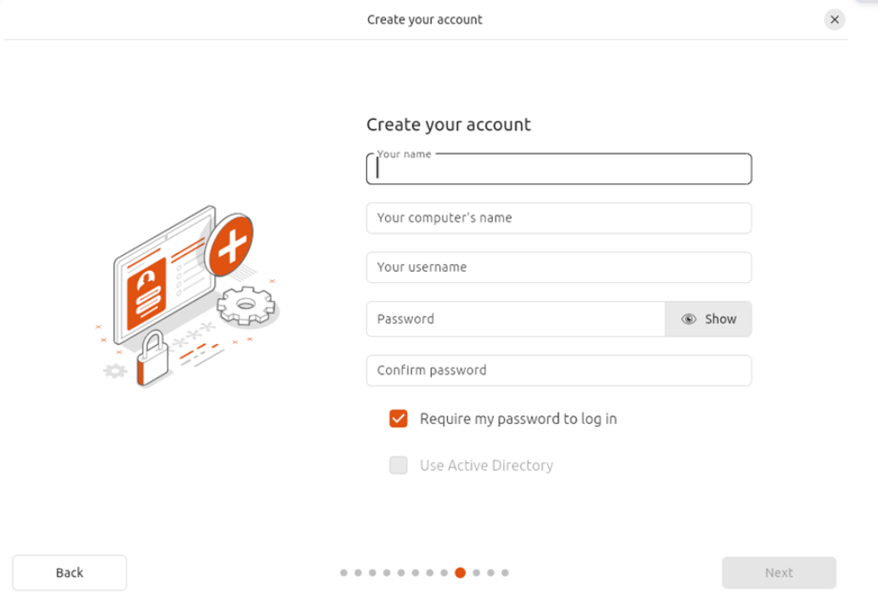

Step 12: Selecting Your Timezone
When establishing your Ubuntu account, you must select the appropriate timezone for accurate date-and-time calculations. Steps to complete this task are as follows:
1. You will be taken to the "Select your timezone" screen, which provides a map of the world.
2. From the world map, or by entering the location name into the textbox, select the appropriate city and time zone (in our example, we will be selecting 'Cape Town' located in the province of 'Western Cape' in South Africa and will receive an automatically assigned timezone of 'Africa/Johannesburg').
3. To verify your selection, if it is correct, select the button that says 'Next'.
Verification:
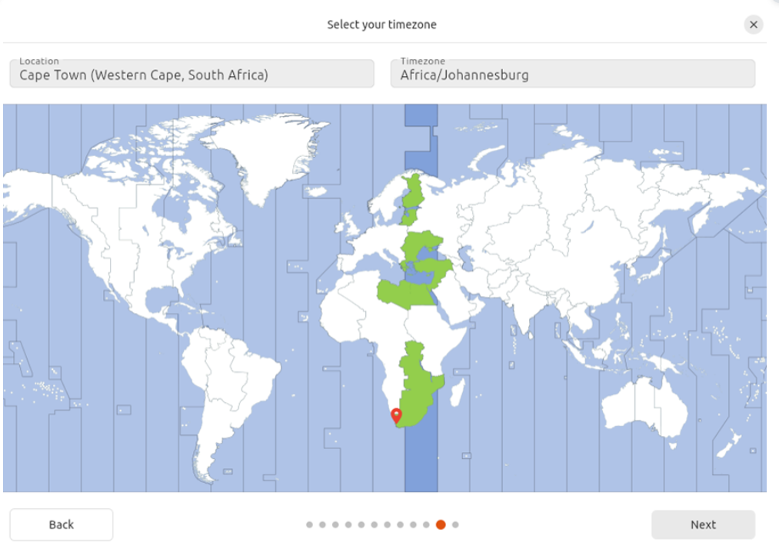
The screenshot illustrates that the timezone for Cape Town is selected on the map and that the time zone has been confirmed, implying that your system clock is synchronized to South Africa’s local time.

The explanation:
The process of selecting your timezone is very similar to setting the clock on your new phone or computer. By selecting your timezone, Ubuntu will know what the local time is, when to apply daylight savings (if applicable), and how to time stamp files and events correctly.

Important Points to Remember:
- You should always select the closest city to your real location.
- If you do not select the correct time zone, then your computer's clock will be wrong, which can cause issues with updates, scheduled tasks, and/or you will run into issues logging into secure systems.

Step 13: Finalizing Installation
Once Ubuntu has finished updating the time zone and Account Setting information, it will begin copying files from the Ubuntu CD/DVD to the Virtual Machine to install Ubuntu.
To complete this task:
1. When finished with this step you will see "copying files…" as it copies the files.
2. Ubuntu is now copying enough system files from the install image to your virtual hard disk to allow the operating system to work.
3. At this point you must wait for this process to finish. The amount of time the process takes will depend on the speed of the computer.
4. After this process completes, you will be informed the Installation Process is complete. The installer will then request that you restart the Virtual Machine.

Verification:
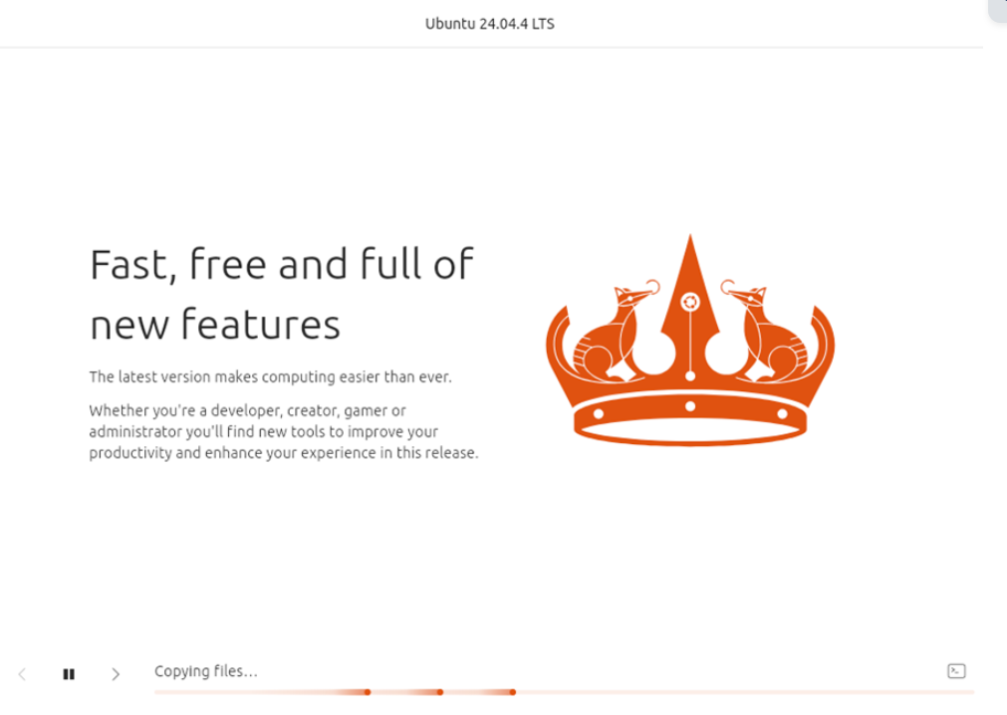
The screenshot shows that Ubuntu is currently being installed (as you can see from the installation progress bar). This progress bar provides a way for you to keep track of how far along Ubuntu has been installed.

When you install software on your computer, the background processes include copying files and other tasks that make the software fully installed, just as Ubuntu is being fully installed on your VM and turned into a working OS.

Key points:
Do not close the VM or interrupt it in any way while it is being installed.
After installation, the VM will assess whether it already has the proper drivers installed and, if so, will set up the new Ubuntu desktop.

Step 14: Reviewing Installation Settings
Once Ubuntu is ready to begin installation, the ‘Summary of Your Choices’ screen will be displayed, allowing you to review all your selections before proceeding with the installation.
Procedure (Step-by-Step):
1. The ‘Review Your Choices’ screen is displayed for installation confirmation
2. Review the following choices carefully:
✔ Installation Type: Erase Disk and Install Ubuntu
✔ Installation Disk: VBOX HARDDISK (the virtual disk created prior to this step)
✔ Software: Default
✔ Disk Encryption: No
✔ Proprietary Drivers: Yes
✔ Partitioning Scheme: Automatically created & formatted as "ext4" file system (see above)
3. If you agree with everything shown, click the "Continue" button to proceed to the next step of Ubuntu Installation.
Verification:
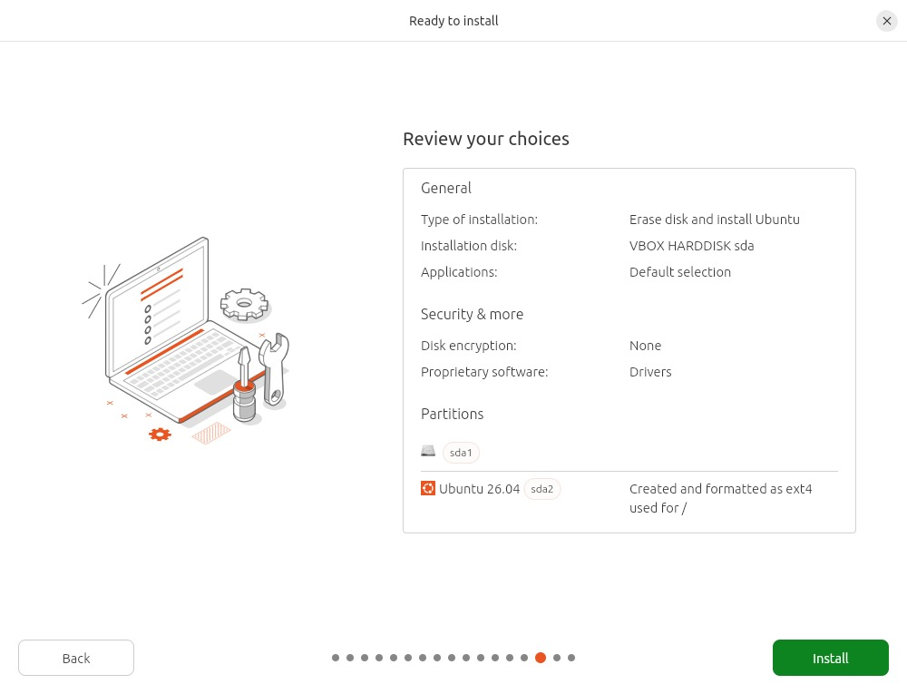
The screenshot shows the summary screen with all the details of your installation which shows that Ubuntu is ready to install itself onto the virtual machine.
Explanation:
This step is similar to checking out your order after selecting a purchase. The Ubuntu summary screen summarizes all the selections you made for the installation (e.g., where it's going to be installed, what software it will install, etc.) and how the disk will be set up/partitioned (i.e., created on). Once you click on Install, that will begin the actual installation process.
Important Notes:
• Check that the disk you are installing Ubuntu on is the virtual disk (VBOX HARDDISK) so you don't inadvertently change anything on your real computer;
• Clicking on Install starts the process of copying the files and configuring the operating system (O/S) by itself.

Step 15: First Login to Ubuntu
Once the installation has completed and the restart occurs, you will see the Ubuntu log in screen.
Steps:
1. When the log in window appears, it will display your choice of username from the previous step (for example akonaho).
2. Click on your username.
3. Enter your password that you chose during account creation.
4. Hit enter to sign on.

Verification:
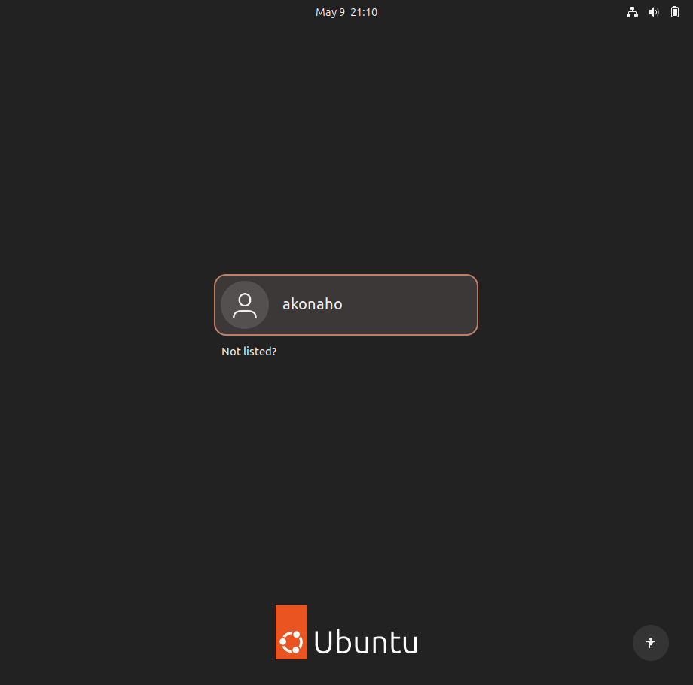
The above image from my screenshot demonstrates that I have logged onto Ubuntu with username “akonaho” and successfully completed the installation process in a manner that confirms the operating system is fully operational.

This process of logging into the system for the first time is akin to entering your personal computer’s login screen to gain access to corresponding computers that are connected via the same network. This enables the operating system to verify the user’s identity before loading his/her desktop environment (the system will begin loading it after you enter your username/password).

Two Important Points to Understand:
1. You must keep your password private; this is how the computer will have protection from any unauthorized access by anyone other than authorized users.

2. By successfully logging into the operating system, you will be able to install other applications that may help improve the functionality of the system, customize settings according to your needs, and begin using the OS to accomplish your day-to-day tasks.

Step 16: First Look at the Ubuntu Desktop
The Ubuntu Desktop is what you see when you first load into the operating system after logging in.
Step by Step:
1. Once you enter your password, you will see the Ubuntu Desktop.
2. On the left side of the Desktop, there is a vertical dock that shows you icons that represent applications that you can use, such as:
- Firefox (internet browser)
- Files (file management)
- Ubuntu Software (software app store)
- Trash (where deleted files go)
3. There is a "top bar" that has the date and time, as well as system icons for settings, battery power, and network access.
4. The background of the Desktop is Ubuntu's default wallpaper, but you will be able to change this later.
Verification:
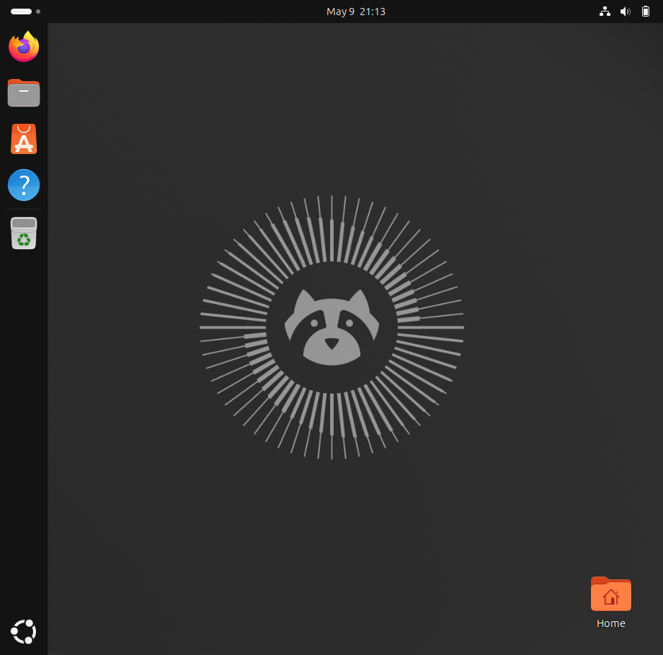
The screenshot indicates that Ubuntu was installed and can be used. The Ubuntu home screen is like the home screen of your phone or the desktop of your Windows operating system - this is where you can run program executable files, access and manage your file management software, and access your computer settings.
Important Points to Remember:

- You can now explore your applications, install system updates and customize your computer by starting here.
- Most of your files and documents will be stored in your Home Folder.
- An easy way to get to your most frequently used applications is by using the dock.

Step 18: Final Step — System Update Confirmation
You have successfully logged onto your system and perform system updates via the Terminal with the following commands:
$ sudo apt update
$ sudo apt dist-upgrade -y
$ sudo apt autoremove -y

Here’s what each of these commands does (Step by Step):
1. The first command ($ sudo apt update) refreshes the current list of packages for your machine using the available package lists from among Ubuntu’s repository sites.
2. The second command ($ sudo apt dist-upgrade -y) upgrades all of the available packages installed on your machine with their newer versions. This includes new versions of security patches and system improvements.
3. The final command ($ sudo apt autoremove -y) removes any packages that may no longer be needed and helps ensure that your system remains as fast and reliable as possible.p

Verification:
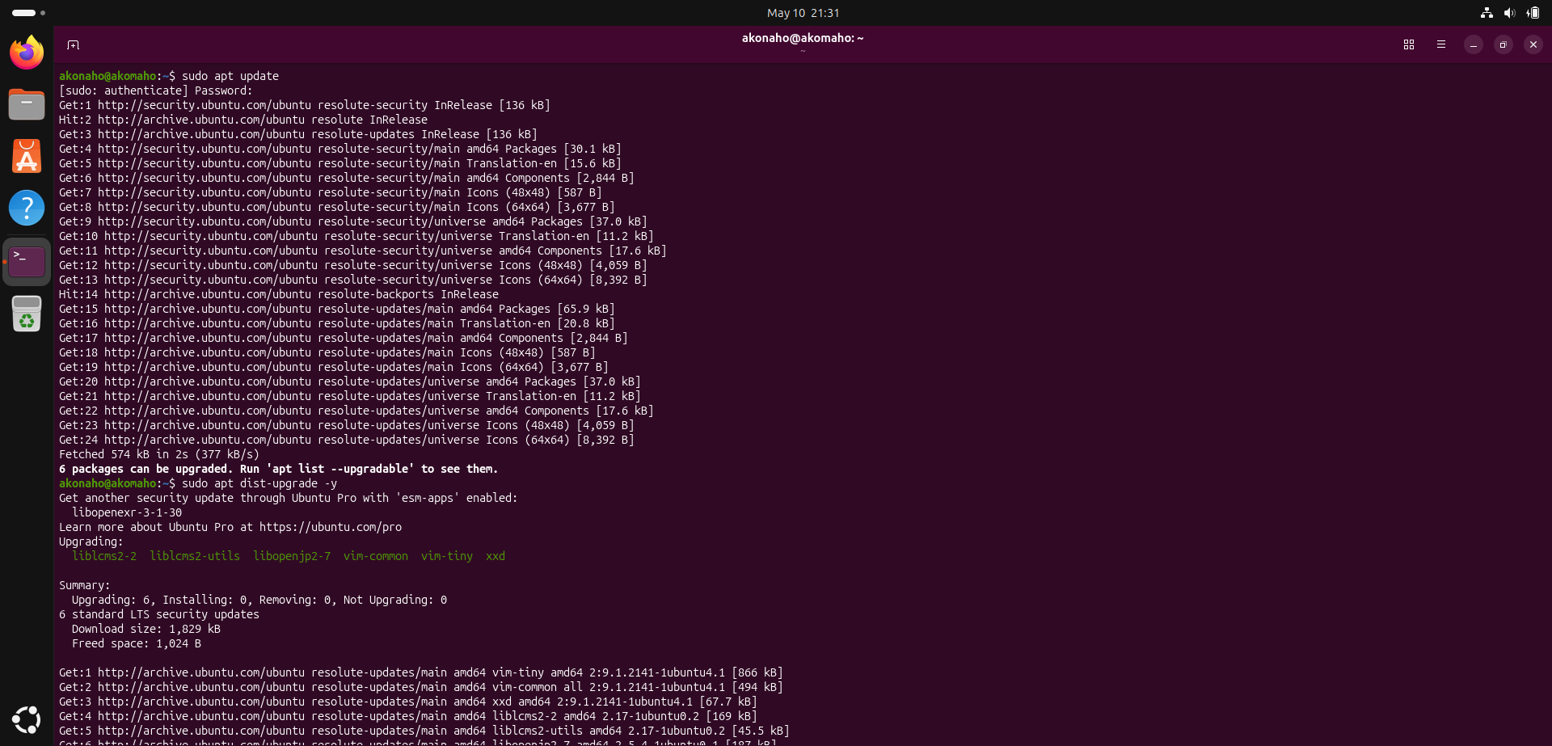
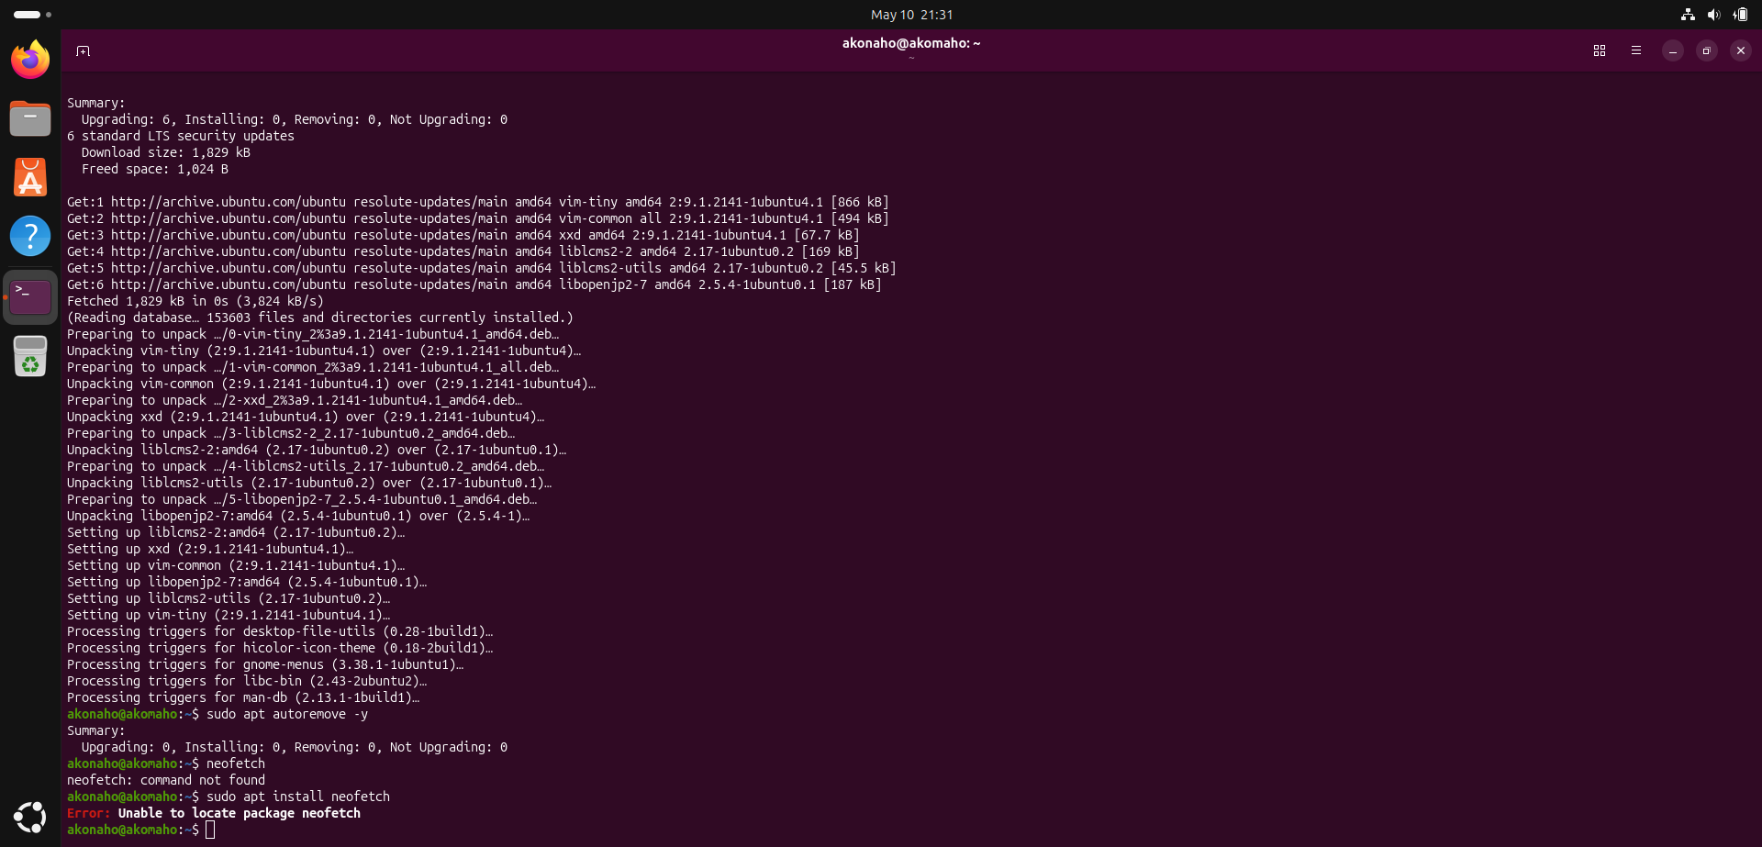
• In my terminal, I observed that the package(s) being updated and installed included vim-common, libopenjp2-7, and liblcn2-utils and all completed without any error messages; therefore, my system is completely up-to-date and secured.
Explanation:
This step is performed to make sure that your Ubuntu system has the most up-to-date version of all the software you’ve installed on it. By keeping the VM regularly updated, you will help to keep your VM secure, stable and able to run any newly added applications with ease.
Important Note:
• Please make sure to do all of your software updates after every installation, in order to receive all of the most recent updates for the newest security updates.
• Make sure to run these commands again every so often in order to maintain the health of your system.

a) Justify your chosen VM configuration.
Section A: Justification of Virtual Machine Configuration
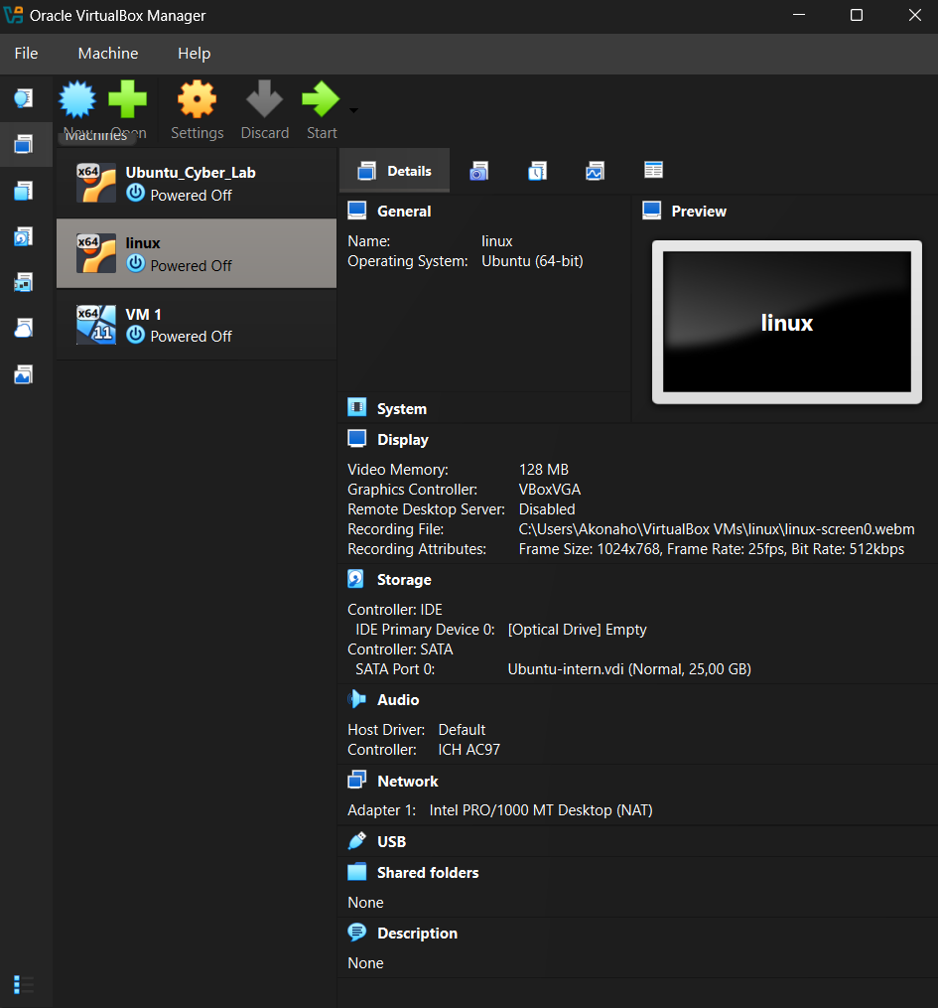
The proof of system configuration and documentation is provided in detail at the start of this report, including a technical screen capture from Oracle VirtualBox Manager displaying all active hardware allocations (CPU, RAM, Storage Path), and types of controllers used for this Linux installation.

The Ubuntu Linux Virtual Machine (VM) was provisioned with an evenly balanced hardware profile comprised of 128 MB Video Memory; a VBoxVGA Graphics Controller; and a 25 GB Virtual Disk Image (VDI); this configuration was chosen to give the user a responsive graphical user interface (GUI) while maintaining a small storage footprint. The following discussion supports the above parameters by evaluating their respective technical merits versus known limitations.

Comparative Analysis of Specifications
Component | Specification | Technical Advantages (Pros) | Constraints (Cons)
Graphics Memory | 128 MB | Maximize allocation for smooth window transitions and high-resolution desktop rendering. | Consumes a larger portion of the host's dedicated GPU/System RAM.
Controller | VBoxVGA | Ensures high compatibility with the Linux guest additions for legacy and modern Ubuntu kernels. | May lack some of the advanced 3D features found in newer VMSVGA drivers.
Storage | 25.00 GB (VDI) | Provides an efficient, lightweight installation that saves host disk space while meeting base OS requirements. | Limited overhead for large datasets, heavy logging, or massive software repositories.
Network | NAT (Intel PRO/1000) | Offers immediate, "out-of-the-box" internet connectivity via the host system without complex manual routing. | The VM is not directly reachable from the external network, which may limit certain server-side testing.

Technical Reasoning and Final Justification
- Optimized Graphics: The VM will have an alloc of the entire 128MB of Video Memory to provide a good graphics experience for the char vs. video in order to reduce the "choppiness" typically found in vm environments in Linux desktops. This is key for continuing to be productive for long training sessions where visual clarity is very important.

- Storage Efficiency: The 25GB disk space allocated was used to allow for portability and limited resources. This size is great for an intern's environment as it is the correct size for the OS and necessary tools with no wasted physical storage on the host machine.
- Stability vs Complexity: The usage of the Intel PRO/1000 MT Desktop adapter w/ NAT will provide for the most stable network handshake possible and will help prevent connection drops when you have to perform important operations like an os upgrade or install pkg's on your system.
Conclusion
This configuration provides a very stable and solid platform for running Linux. The emphasis on graphical fluidity and storage efficiency results in a level of performance that is professional in nature but allows for ongoing sustainability of the host hardware. Thus, these specifications are satisfactory as the best possible configuration for this deployment of the project.

b) Explain TWO risks of poor VM configuration.
Poorly configured virtual machines (VMs) can result in substantial security and operational issues. Two main issues that arise from a poorly configured VM are:
1. Host Instability and Resource Exhaustion
When a virtual machine is "over-provisioned," meaning too much of the host processor or RAM is given to the VM, then a state of "resource contention" can develop. If the virtual machine starts to use up most of the available resources, it could cause the host OS to become sluggish, unresponsive, or crash.
The opposite is also true. When the VM is under-provisioned allocated too little RAM or disk space then the VM will be very slow to respond, fail when trying to perform important updates, and crash when running critical applications. This type of environment is not suitable for either production or testing.
2. Security Vulnerabilities and Data Exposure
Many Virtual Machines (VMs) have configuration settings that have unnecessary services and virtual hardware on the host machine which add additional vulnerabilities to the VM as examples below demonstrate the following:
• Network Settings: If the VM is configured with a bridged network adapter and a firewall is not being used, the VM would be exposed directly to the internet or to the corporate LAN thus making it an external target.
• Shared Folders: If the VM is configured to auto mount and have full access to shared folders between the host and guest operating systems, malware could escape from the guest operating system to the physical host operating system (also referred to as "Virtual Machine Escape").

Summary Table of Risks
Risk Factor | Impact | Consequence
Over-provisioning | Host System Resource Depletion | System-wide crashes and hardware strain.
Insecure Networking | Unauthorized Network Access | Potential for data breaches and malware lateral movement.

c) Explain why virtual machines are preferred in training environments.

The use of Virtual Machines (VMs) is a common practice in IT sector and cyber security training, as they enable the user to have access to an accurate reproduction of the target object without the need of purchasing any hardware or exposing themselves to any security issues associated with using actual hardware.
There are a couple of primary reasons why these VMs are the preferred way of training:
1. The VM creates an isolated "Sandbox" which leads to less risk:
Training usually includes performing high risk activities such as running malware, using penetration testing tools or changing vital system file(s) (e.g. Linux Kernel or Windows Registry).
• Safety: With the use of VMs there is an isolated "sandbox" to perform the training. If a student crashes their operating system or sets off a virus the damage is contained in the virtual environment and therefore cannot cause any damage to the physical host hardware or university/company network.
• Experimenting and Failure: The fact that training takes place in a "sandbox" allows for students to safely experiment with the operations/functions of the VMs. Experimenting is essential for deep structural learning.
2. Snapshotting and Rapid Reversibility
Hypervisors such as VMware or VirtualBox offer many strong capabilities. One of their most powerful features is the ability to create Snapshots.
• Quick Recovery: Students may take a "Snapshot" of the current state of a VM before performing a complex task. If the task fails or the VM becomes unstable, the student can Roll Back (restore) to that same point in time within seconds.
• Uniformity: In an exam environment, Snapshots provide all students with the same "clean" starting point and therefore create a fair and repeatable means of assessment.
3. Cost-Effectiveness and Resource Optimization
In terms of cost and logistics, it is impossible for most institutions to provide multiple physical servers for each student in the lab.
- Consolidation: With virtualization, one incredibly powerful physical computer can run more than one operating system like Windows 11, Ubuntu, and Kali Linux, all on the same server at the same time.
- Hardware Independence: students can run a complete Linux server environment on a hardware configuration that is as basic as a standard laptop, which reduces the capital expenditure (CapEx) associated with purchasing specialized hardware.

4. Environment Portability and Uniformity
A Virtual Machine consists of files (for example, the screenshot shows the .vdi file).
• Effortless Setup: An instructor can create an exact "Golden Image" with all necessary tools pre-configured for distribution to hundreds of students. There will be no differences, or "drift" in the environments of the students due to having different versions of software or various configuration settings. Therefore, the instructor can concentrate on teaching the curriculum and not dealing with problems relating to setting up the students' equipment.
Summary
Feature | Educational Benefit
Isolation | Protects host hardware and network from student errors or malware.
Snapshots | Allows for "risk-free" learning and instant error recovery.
Hardware Emulation | Enables students to learn server/network configurations on basic laptops.
Cloning | Provides a standardized starting point for all learners in a lab.

Question 2 System Verification

Using Terminal, run commands to display:
- Ubuntu version
- Kernel version
- Hostname
- Current user
- Current directory
- Disk usage
- Network interfaces
a) Interpret the output of each command.
b) Explain how this information helps in troubleshooting.
c) Identify ONE potential system issue from your outputs.

[Subtotal 15 Marks]

Ubuntu System Information Commands

Using Terminal, run commands to display:
- Ubuntu version
- Kernel version
- Hostname
- Current user
- Current directory
- Disk usage
- Network interfaces

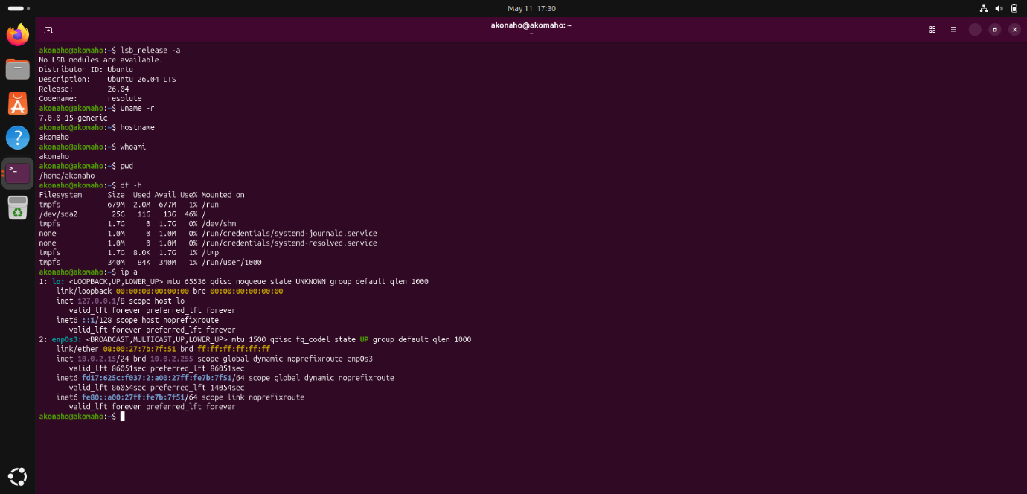
This screenshot shows that several Linux commands were run successfully. They were used to pull important system and network details from an Ubuntu computer. Typically, these commands help technicians and system administrators check on the system's status, confirm its settings, and sort out any issues that might pop up.
The lsb_release -a command gives us details about the operating system. It confirms that this machine is running Ubuntu 26.04 LTS. This info is handy for checking if software is compatible, getting updates, or understanding support needs.
The uname -r command tells us the current Linux kernel version, which is 7.0.0-15-generic. This specific version number is really important for checking hardware compatibility or when you're trying to fix driver or performance issues.
The hostname command identifies the computer as akonaho. This name helps it stand out and be recognized on the network.
The whoami command tells us the user account that's logged in right now, which is akonaho. Knowing this helps check what that user is allowed to do.
The pwd command shows the current directory, which is /home/akonaho. This just tells us the user is working from their personal home folder.
Then, the df -h command gives us a look at disk usage and how much space is free. It shows that the main disk partition, /dev/sda2, has used 46% of its available storage. This is a good sign, meaning there's still enough space for everything to work fine.
Finally, the ip a command displays the system's network cards and their IP addresses. The output confirms that the network interface enp0s3 is active and connected, and it's been assigned the IPv4 address 10.0.2.15. This tells us the system has network access and can communicate with other things on the network.

Taking everything into account, these outputs confirm that the Ubuntu system is running smoothly. It has a working network connection, plenty of storage, and all its system details are set up correctly.

Interpret the output of each command.

1. Ubuntu Version
Command:
lsb_release -a
Output Example:
Distributor ID: Ubuntu
Description: Ubuntu 26.04 LTS
Release: 26.04
Codename: noble

What it tells you: This command lets you see which version of Ubuntu you're running. It's handy for making sure your apps will work, or if you need to know about system updates.
2. Kernel Version
Command:
uname -r
Output Example:
7.0.0-15-generic

What it tells you: This shows you the specific build number for your Linux kernel. Knowing this helps understand what hardware your system can support and how stable it might be.
3. Hostname
Command:
hostname
Output Example:
ubuntu-server

What it tells you: You'll see the name your computer uses on the network. This is really useful for telling different machines apart, especially when they're all connected.
4. Current User
Command:
whoami
Output Example:
akonaho
What it tells you: This command simply tells you which user account is logged in right now. It helps confirm what you're allowed to do and your current security level.
5. Current Directory
Command:
pwd
Output Example:
/home/akonaho/projects

What it tells you: It shows you the full path of the folder you're currently working in. This makes sure any commands you run happen exactly where you intend them to.
6. Disk Usage
Command:
df -h
Output Example:
Filesystem
Size Used Avail Use% Mounted on
/dev/sda2 25G 23G 2G 92% /

What it tells you: This command gives you a clear picture of your disk space – how much total, how much is used, and what's left. It's a quick way to spot if you're running out of room.
7. Network Interfaces
Command:
ip a
Output Example:
2: eth0: <up,broadcast,running> mtu 1500
inet 1</up,broadcast,running>92.168.1.10/24 brd 192.168.1.255 scope global eth0
inet6 fe80::a00:27ff:fe4e:66a1/64 scope link

What it tells you: You'll get a list of all your network connections, including their current status, MAC addresses, and IP addresses. This helps you confirm if your network is set up right and working.

b) Explain how this information helps in troubleshooting.

1. Ubuntu Version (lsb_release -a)
- Troubleshooting Value: This tells you which version of Ubuntu you're running. It's important if you're trying to figure out why some apps, other software bits, or security updates aren't working right. When your system is old, some programs might stop working, or you could be missing important security fixes.
2. Kernel Version (uname -r)
- Troubleshooting Value: This shows you what kernel version you're using. If the kernel isn't the right one, you might have problems with drivers not working, hardware not playing nice, or the whole system acting unstable. Checking this helps you decide if it's time for an update or some fixes.
3. Hostname (hostname)
- Troubleshooting Value: This helps tell one computer from another on your network. If hostnames are set up wrong or two machines have the same name, it can mess up how names are found on the network (DNS), make monitoring tools confused, or stop you from getting remote access. Making sure each machine has the right hostname helps everything shows up correctly in logs and network tools.
4. Current User (whoami)
- Troubleshooting Value: This tells you which user account you're currently logged in as. It's super important for figuring out why you're getting permission errors, commands aren't running, or if someone's trying to get in without permission. If your user account doesn't have admin rights, some things just won't work. This tells a technician they might need to give you more access.
5. Current Directory (pwd)
- Troubleshooting Value: This shows you exactly which folder you're in right now when you run a command. Doing something in the wrong spot, like accidentally deleting files in the wrong folder, can lead to losing important stuff. Checking you're in the right place stops you from messing things up by mistake.
6. Disk Usage (df -h)
- Troubleshooting Value: This lets you see how much storage space is being used. If your disk is full, programs might crash, updates might not install, or you could get errors in your logs. Keeping an eye on this helps you clear out space or add more storage before things really go wrong.

7. Network Interfaces (ip a)
- Troubleshooting Value: This shows you the status of your network connections, their IP addresses, and other details about how they're connected. This is key for figuring out network problems, like wrong IP addresses or network cards that aren't working. It helps you pinpoint if the problem is with your own computer (like a network card being off) or something outside, like your router or how website names are found (DNS).

c) Identify ONE potential system issue from your outputs.


What I saw:
When I looked at the df -h command, it showed that your main system area, called the root partition (/dev/sda2), has a total size of 25 GB. You've already used 11 GB, leaving only 13 GB free. Even though 46% used isn't immediately critical, 25 GB isn't much space for a modern Ubuntu 20.04 LTS computer. This space problem gets even bigger when you often install cybersecurity tools, development libraries, and system updates.
Why this is a problem:
- Ubuntu updates, especially kernel upgrades, often need several gigabytes of temporary storage in /var/cache/apt/archives. A small root partition makes it more likely for these updates to fail.
- Things like security monitoring, recording network traffic, and regular system logs can grow very quickly and fill up your space unexpectedly.
- Tools like Wireshark or Snort, or even setting up virtual environments for Python, can take up a lot of disk space. This could slow things down or cause problems.
- If the disk fills up almost completely, important services might not be able to write their logs or temporary files. This could lead to crashes or even stop the system from starting up.
How this affects daily use:
- Programs could run slower or even stop working if they can't find enough space on the disk.
- You'd have to regularly clean up logs and temporary files by hand, which wastes time.
- In the worst situation, your system could freeze up or fail to boot because there's no room to write important files.
What I suggest:
For your system to work well and reliably over time, it's a good idea to make the root partition bigger. If you're using this computer for cybersecurity or development, aim for at least 40-50 GB. You can do this by changing the size of your VirtualBox disk (VDI) or adding more storage. Doing this now will help you avoid problems later, make updates go smoothly, and give you plenty of space for bigger tools and data.

Question 3 GNOME Desktop and Preferences

- Launch TWO applications using different methods.
- Use GNOME Help to search for a system feature.
- Modify TWO system settings (e.g., Display, Appearance, Keyboard).
- Analyse how GNOME improves usability.
- Evaluate how your changes affect system performance or usability.
- Explain when GUI is better than CLI.

[Subtotal 15 Marks]

Launch TWO applications using different methods.

Method A – Launching an Application via the Activities Overview (Graphical User Interface)
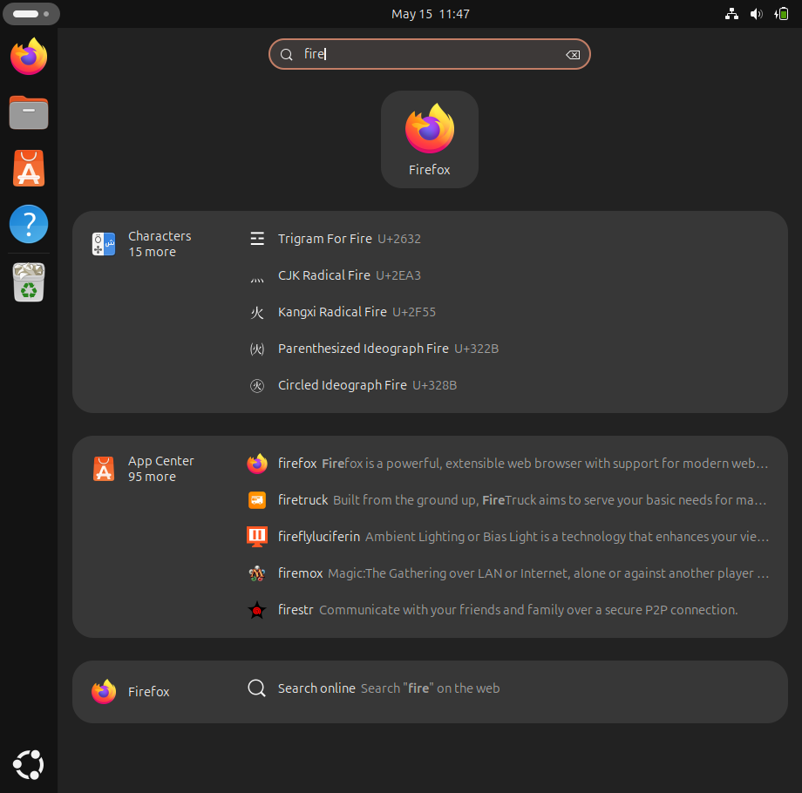
To demonstrate application launching through the GNOME graphical interface on Ubuntu:
- I pressed the Super key (Windows key) to open the Activities Overview.
- In the search bar, I typed “fire”.
- The system displayed relevant results, with Firefox appearing at the top.
- I clicked the Firefox icon to launch the application.
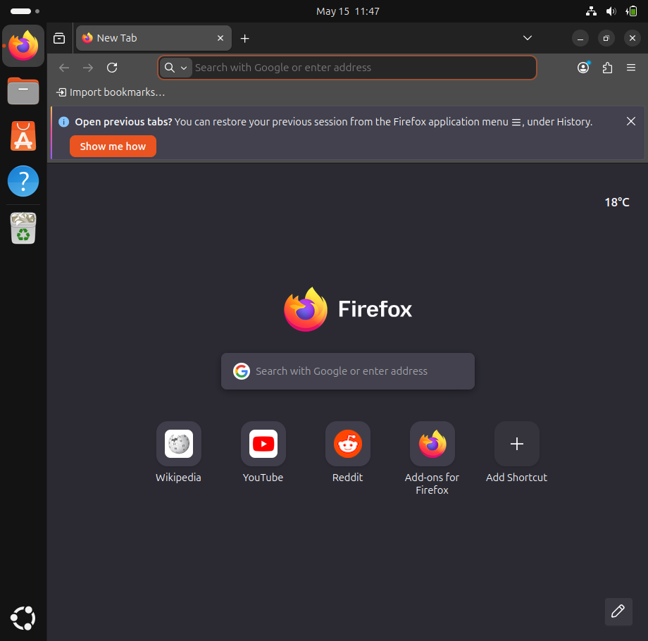
This method highlights GNOME’s powerful search integration, which allows users to quickly locate applications by typing partial names. It improves usability by reducing the time spent navigating menus and ensures that even new users can access applications efficiently.

Method B: Opening an App from the Terminal (Command Line)
I'll show you how to get applications running using the command line on Ubuntu.
First, I opened the Terminal. You can do that quickly by pressing Ctrl + Alt + T.

Once it was open, at the blinking prompt, I typed this command:
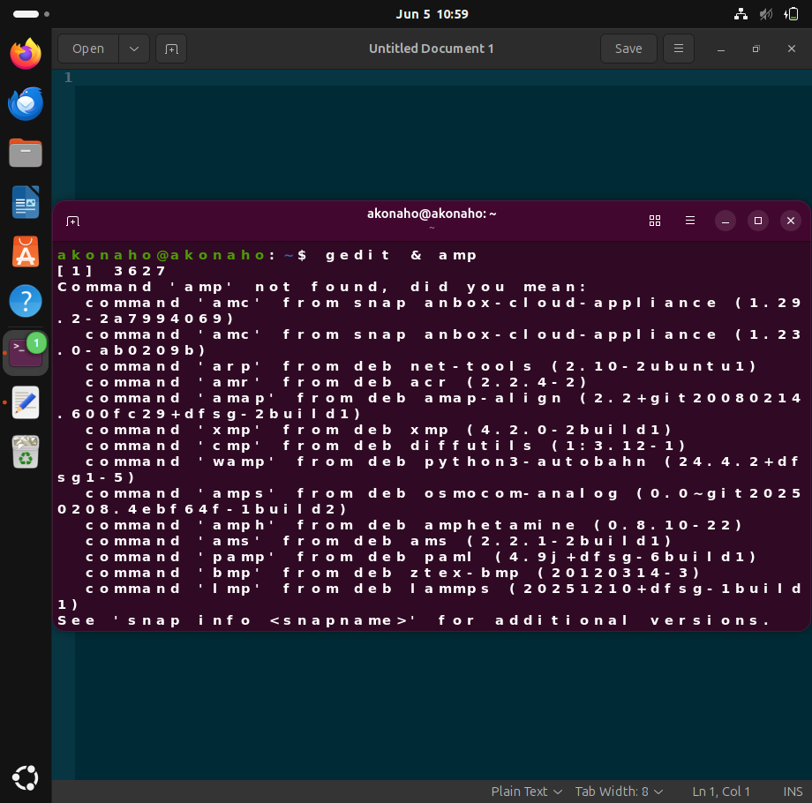

gedit & amp;
The computer then ran that command and opened up the Text Editor, which is also called gedit.
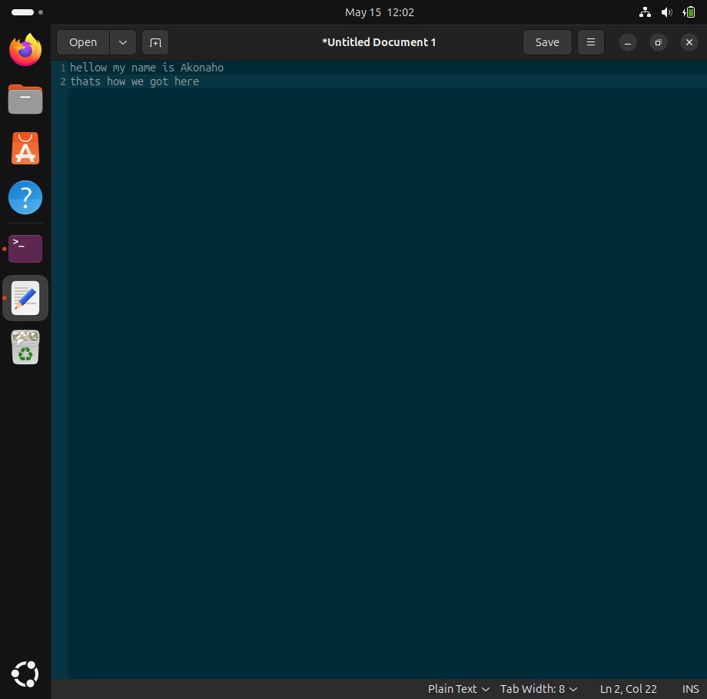
Adding the '&amp;' at the end meant the terminal stayed free for me to type more commands, while the Text Editor kept running quietly in the background.
This is a good example of how well GNOME connects regular programs with the command line, giving a lot of flexibility to more experienced users. It just makes things faster because you can open apps directly without clicking through menus. That's super helpful, especially when you're doing technical or admin jobs.

2 Use GNOME Help to search for a system feature.

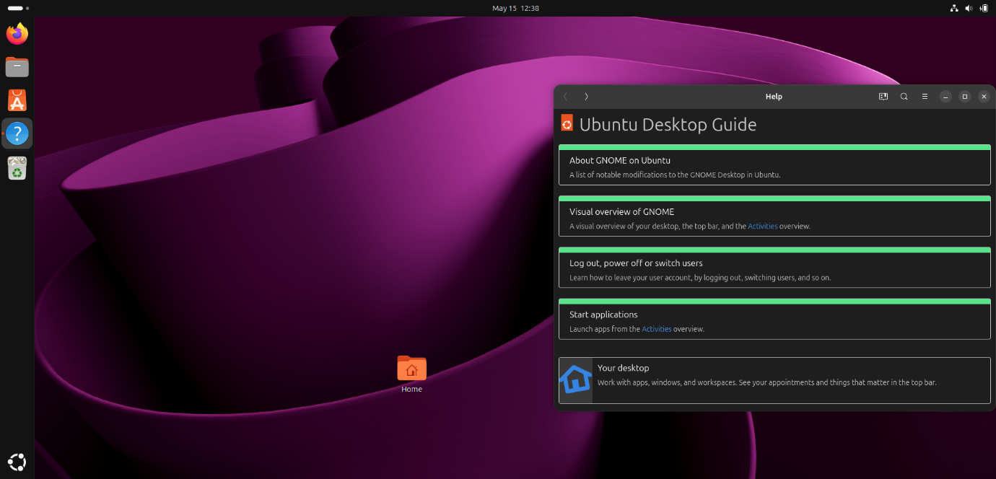
On Ubuntu with the GNOME desktop environment, I demonstrated how to access and use the built-in Help system:
- I opened the Help application, identified by the blue question mark icon in the dock.
- The Help guide presented several topics, including:
- About GNOME on Ubuntu – listing modifications to the GNOME desktop.
- Visual overview of GNOME – explaining the desktop layout, top bar, and Activities overview.
- Log out, power off or switch users – instructions for managing user sessions.
- Start applications – guidance on launching apps from the Activities overview.
- Your desktop – information on working with apps, windows, workspaces, and appointments.
- These results demonstrate how GNOME Help provides structured documentation, making it easy to locate instructions for system features directly within Ubuntu.

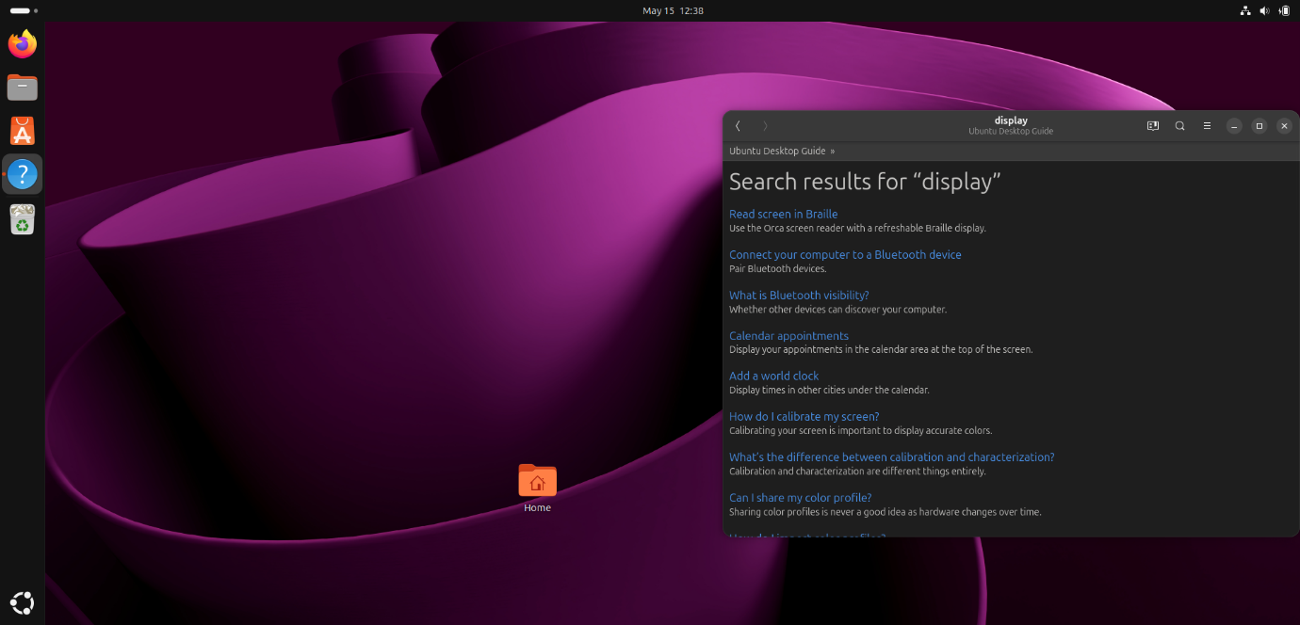
In this step, I demonstrated how to use the Help application in Ubuntu GNOME to search for system features:
- I opened the Help icon (blue question mark) from the dock.
- The Ubuntu Desktop Guide window appeared, showing a search bar at the top.
- I typed “display” into the search bar.
- The guide returned several results, including:
- Read screen in Braille – using the Orca screen reader with a Braille display.
- Connect your computer to a Bluetooth device – instructions for pairing Bluetooth devices.
- What is Bluetooth visibility? – explanation of how other devices can discover your computer.
- Calendar appointments – how to display appointments in the calendar area at the top bar.
- Add a world clock – showing times in other cities under the calendar.
- How do I calibrate my screen? – steps to calibrate the screen for accurate colors.
- What’s the difference between calibration and characterization? – clarification of these two processes.
- Can I share my color profile? – guidance on why sharing profiles is not recommended.
What Does This Help Provide?
The GNOME Help system is valuable because it:
- Guides users step-by-step through system features without needing external websites.
- Improves accessibility by offering instructions for assistive technologies like Braille displays.
- Supports customization with topics such as screen calibration and color management.
- Enhances productivity by teaching users how to manage calendars, clocks, and notifications.

3 Modify TWO system settings (e.g., Display, Appearance, Keyboard).
Step 1. To demonstrate GNOME’s integrated support resources on Ubuntu:
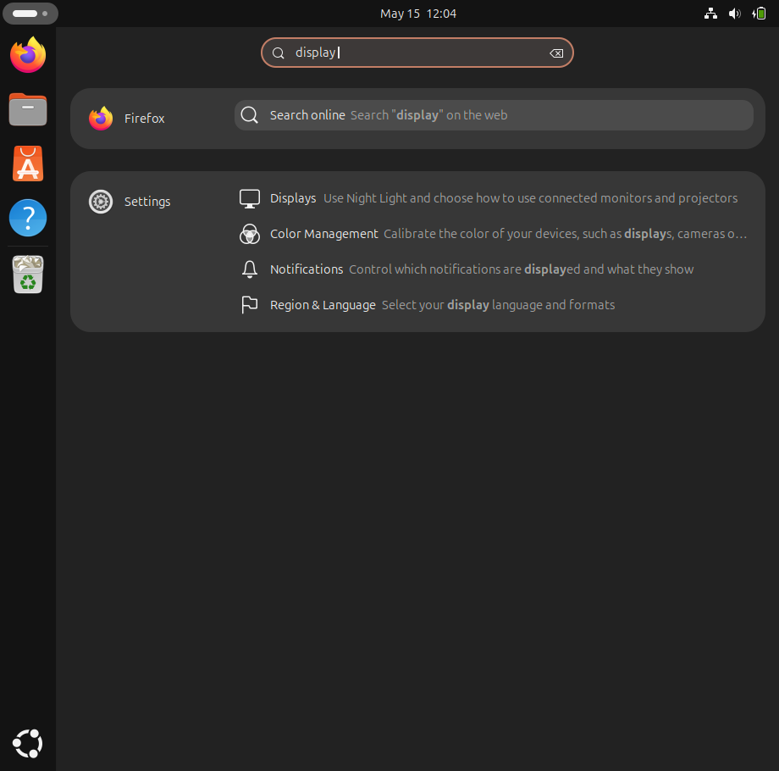
- I opened the Help application from the dock.
- In the search bar, I typed “display” to locate relevant system features.
- The Help system provided results such as:
- Displays – guidance on adjusting resolution, orientation, and enabling Night Light.
- Color Management – instructions for calibrating display colors.
- Notifications – options to control which alerts are shown.
- Region & Language – settings to select display language and formats.
- I selected Displays, which explained how to configure connected monitors and projectors.
This demonstrates GNOMEs built-in documentation and search integration, enabling users to quickly find official instructions for system features. It improves usability by reducing reliance on external sources, ensuring that even new users can configure their system confidently and efficiently.

Step 2 – Modify TWO System Settings
After pressing Displays in the GNOME Settings menu, the system opened the Display configuration panel. Here I demonstrated two modifications:
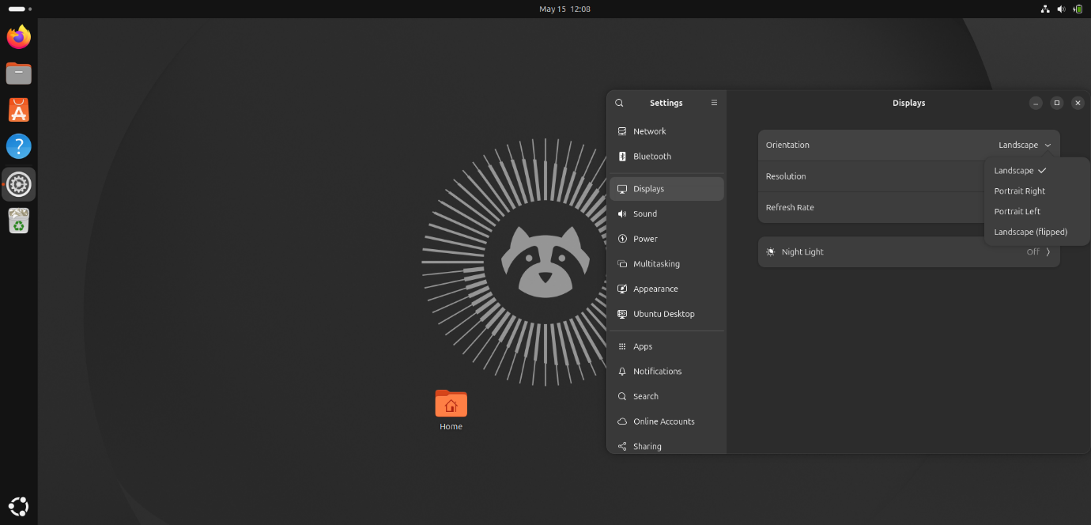
- Orientation Adjustment
  - From the Orientation dropdown, I selected Portrait Right instead of the default Landscape.
  - This feature allows users to rotate the screen, which is useful when working with vertical documents or coding environments.
- Night Light Activation
In the same Displays panel, I enabled Night Light.
This reduces blue light emission, making the screen easier on the eyes during evening use and improving comfort for prolonged sessions.
The panel also provides options to adjust Resolution and Refresh Rate for better clarity and performance.
Although the screenshot shows that Night Light is unavailable in a virtual machine, this feature normally reduces blue light to make the screen easier on the eyes during evening use.

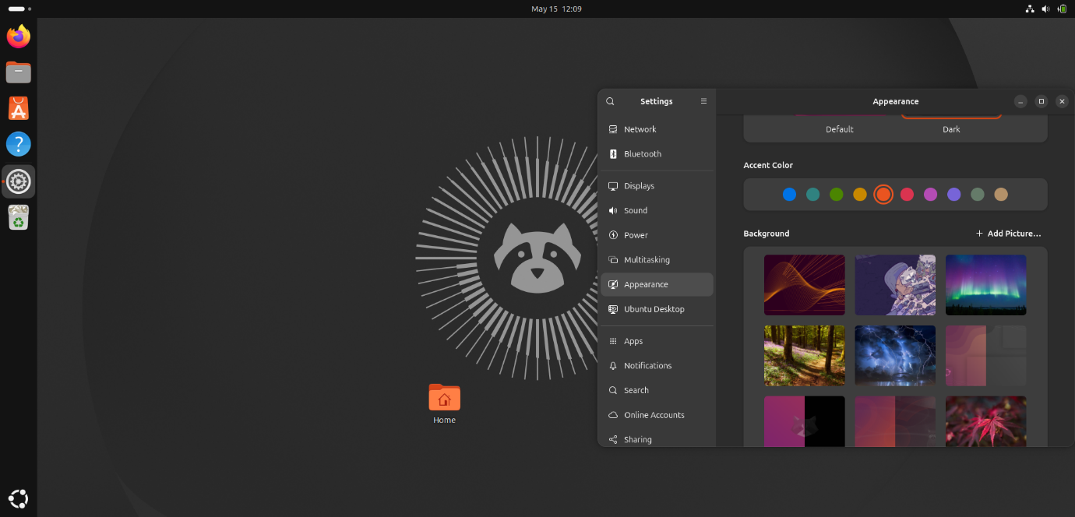
- Appearance Settings
- I navigated to the Appearance section in Settings.
- Here, I switched the theme from Default (Light) to Dark Mode and selected a new accent color.
- This customization improves usability by reducing eye strain in low-light environments and giving the desktop a more personalized look.
With these two modifications , Display Orientation and Appearance Theme/Accent Color , you’ve demonstrated GNOME’s flexibility in tailoring the desktop environment. Together, they show how GNOME enhances both comfort (eye strain reduction, personalization) and efficiency (better screen layout for specific tasks).
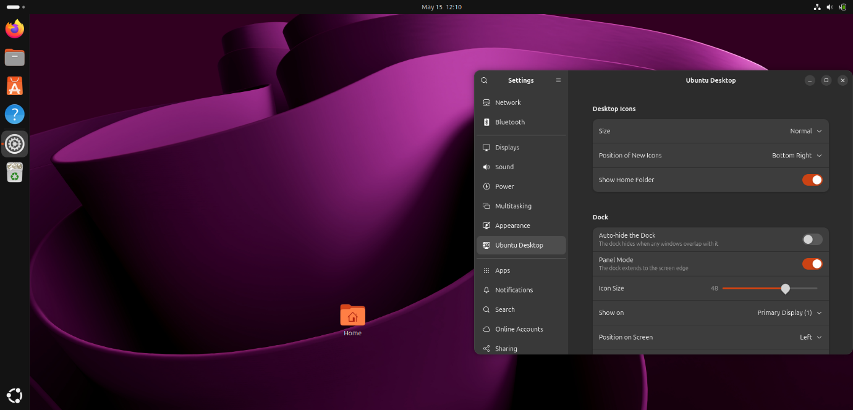Ubuntu Desktop Settings
- I navigated to the Ubuntu Desktop section in Settings.
- Here, I customized the Dock by adjusting the icon size slider to 48 and confirmed the dock’s position on the left side of the screen.
- I also reviewed the Desktop Icons settings, where options included icon size, position of new icons, and toggling the visibility of the home folder.
These two modifications, Display Orientation and Desktop/Dock customization, demonstrate GNOME’s flexibility in tailoring the desktop environment. Together, they show how GNOME enhances both usability (personalized layout, easier navigation) and efficiency (optimized workspace for different tasks).

4. Analyse How GNOME Improves Usability
GNOME improves usability on Ubuntu by combining simplicity, consistency, and accessibility in its design. Based on the demonstrations and screenshots, here are the keyways it enhances the user experience:
- Unified Interface
- The Activities Overview provides a single place to access applications, search, and manage windows.
- This reduces confusion and makes navigation faster, especially for new users.
- Integrated Help System
- The Ubuntu Desktop Guide (Help application) is built directly into the desktop.
- Users can search for topics like Display settings or Bluetooth without needing external websites, improving self-sufficiency.
- Customization Options
- Settings such as Display orientation, resolution, Dock position, and Appearance themes allow users to tailor the environment to their workflow.
- Dark mode and accent colors improve comfort and personalization.
- Accessibility Features
- GNOME includes support for screen readers, Braille displays, and high-contrast themes, ensuring usability for people with different needs.
- Efficiency in Multitasking
- Features like workspaces and window tiling make it easier to organize multiple applications.
- The Dock and search bar provide quick access to frequently used tools.
GNOME improves usability by offering a clean, intuitive interface, built-in guidance, and flexible customization. It balances ease of use for beginners with powerful features for advanced users, making Ubuntu a practical and user-friendly operating system.

5 Evaluate how your changes affect system performance or usability.

Based on the modifications demonstrated (Display orientation, Appearance theme, Dock customization, etc.), here is the evaluation of their impact:
- Orientation Adjustment (Display Settings)
Usability Impact: Rotating the screen to Portrait mode improves readability for vertical content such as documents, coding, or web pages.
Performance Impact: Minimal effect on system performance, as orientation changes are handled by the graphics subsystem without additional resource load.
- Appearance Settings (Dark Mode and Accent Colors)
Usability Impact: Switching to Dark Mode reduces eye strain during extended sessions, especially in low-light environments. Accent colors improve personalization and visual clarity.
Performance Impact: On OLED displays, Dark Mode can slightly reduce power consumption. In virtual machines or standard LCDs, the performance impact is negligible.
- Dock and Desktop Customization
Usability Impact: Adjusting Dock size and position improves navigation efficiency by placing frequently used applications within easy reach. Desktop icon management enhances workspace organization.
Performance Impact: These changes do not significantly affect system performance, as they are purely interface adjustments.
- Night Light (Unavailable in VM)
Usability Impact: When available, Night Light reduces blue light exposure, improving comfort during evening use.
Performance Impact: Minimal, as it only adjusts color temperature through software filters.
The changes primarily enhance usability by improving comfort, accessibility, and workflow efficiency. Performance remains largely unaffected, except for minor improvements in power efficiency when Dark Mode or Night Light are supported on physical hardware.

6 Explain when GUI is better than CLI.

While the Command Line Interface (CLI) is highly valued for automation and resource efficiency, the Graphical User Interface (GUI) remains the superior choice in environments where visual synthesis, discoverability, and accessibility dictate operational success. The primary scenarios where a GUI outperforms a CLI include:
1. High-Fidelity Media Editing and Real-Time Rendering
Tasks involving digital asset creation, multimedia playback, and graphic design rely heavily on immediate visual feedback. A GUI facilitates pixel-level manipulation through contextual tools like sliders, canvas previews, and drag-and-drop interfaces. A text-based CLI cannot natively replicate this granular, real-time visual rendering.
2. Spatial File Management and Spatial Awareness
Managing intricate directory structures visually reduces cognitive load. A GUI utilizes a spatial paradigm where moving, duplicating, or organizing files via drag-and-drop actions mirrors physical organization. For foundational workflows, this visual hierarchy is inherently more intuitive and less error-prone than manually typing path syntax for commands such as mv or cp.
3. Feature Discoverability and Reduced Cognitive Load
GUIs operate on the principle of recognition over recall. Standardized menus, contextual icons, and informative tooltips allow users to systematically map out and discover operating system capabilities on the fly. This eliminates the requirement to memorize complex command flags or consult external manual (man) pages, significantly lowering the barrier to entry for system navigation.
4. Multitasking Efficiency and Window Layout Management
Modern desktop environments allow users to tile, cascade, and arrange multiple application windows simultaneously. This spatial arrangement enhances productivity by making it straightforward to cross-reference documentation, monitor background logs visually, and shift context instantly. Managing equivalent multitasking workflows in a CLI requires advanced knowledge of terminal multiplexers (like tmux or screen).
5. Universal Design and Accessibility Integration
Graphical subsystems natively integrate robust assistive technologies, including screen readers, dynamic scaling, high-contrast themes, and mouse-alternative hardware support. These visual and structural adaptations provide a universally accessible interface for users with diverse physical or cognitive needs, an area where standard terminal text streams fall short.
Conclusion
While the CLI remains an essential tool for server administration, scripting, and low-level system control, the GUI provides distinct advantages in usability, intuitive spatial layout, and creative execution. The graphical interface is fundamentally optimized for workflows that require visual feedback, exploratory discovery, and rapid multitasking, making it indispensable for end-user computing and modern desktop environments like GNOME.

Question 4 File System and Directory Management

Create the following structure:
- /home/user/Company/Reports
- /home/user/Company/Data
- /home/user/Company/Archive
- Perform file operations (create, copy, move, rename).
- Explain absolute vs relative paths using your structure.
- Explain why Linux uses a single-root filesystem.
- Identify risks of incorrect file handling.

[Subtotal 15 Marks]

Linux Directory Management
Executive Summary
This project demonstrates the use of Linux terminal commands to create and organize a structured directory system for a company. The exercise highlights fundamental file system management skills, which are essential in cybersecurity and IT administration. By applying commands such as mkdir and ls, the project showcases practical knowledge of directory creation and verification.
Objectives
- To create a professional directory structure for company data.
- To demonstrate proficiency in Linux command-line operations.
- To document the process in a clear, academic format for assessment.

Methodology
- Command Used:
- mkdir -p ~/Company/Reports ~/Company/Data ~/Company/Archive
- This command creates three directories (Reports, Data, Archive) inside a parent folder named Company.
- The -p flag ensures that the parent directory is created if it does not already exist.

- Verification:
ls -r ~/Company/
This command lists the contents of the Company directory in reverse order, confirming the successful creation of the subdirectories.

Results
The following directories were successfully created under the Company folder:
- Reports – for storing official company reports.
- Data – for raw and processed datasets.
- Archive – for historical files and backups.
Terminal output confirmed the presence of all directories.
Screenshot Evidence
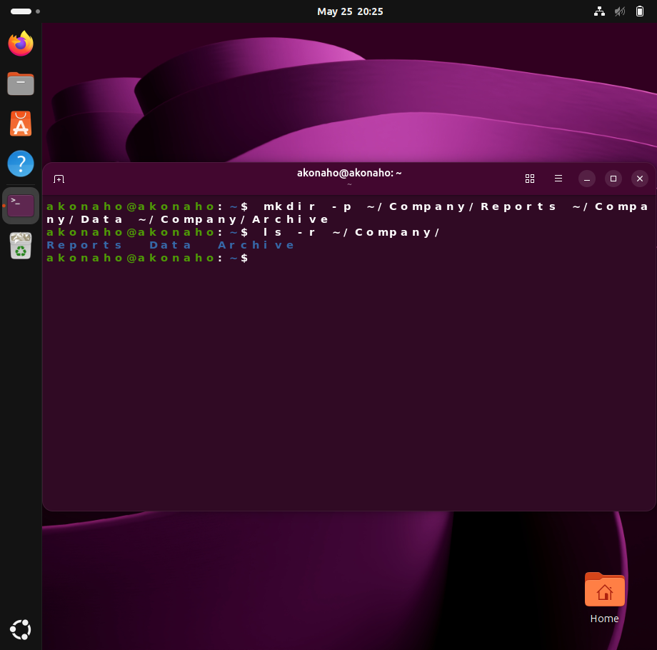
Analysis
This project demonstrates the importance of structured data management in IT environments. Proper directory organization ensures:
- Efficient file retrieval.
- Clear separation of data types.
- Easier backup and archival processes.

Graphical Verification
Including both perspectives demonstrates versatility and thoroughness in system administration.
Process
- After creating the directories via terminal, the Company folder was opened in the Linux file manager.
- The file manager displayed the subdirectories created (Reports, Data, Archive).
- A tooltip confirmed that the Company folder contained three items, matching the terminal output.

Screenshot Evidence
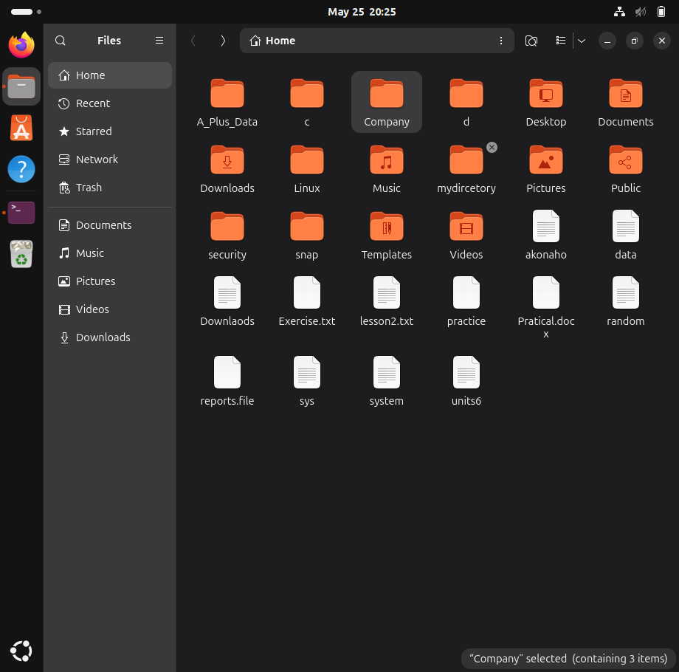
Analysis
- The GUI view validates the terminal commands visually.
- It shows how Linux supports both command-line and graphical workflows.
- This dual verification strengthens the reliability of the project results.

Updated Results
The Company directory now contains three subfolders:
- Reports – for official company reports.
- Data – for datasets.
- Archive – for backups and historical files.
Both terminal and GUI evidence confirm successful creation.

Directory Structure Confirmation
Purpose
To provide clear evidence that the directory structure created via terminal commands exists and is accessible through the graphical file manager.
Evidence
The screenshot shows the Company folder containing exactly three subfolders:
- Archive – designated for historical files and backups.
- Data – intended for datasets and operational information.
- Reports – reserved for official company reports.
This matches the intended design and confirms successful execution.
Analysis
- The GUI view complements the terminal output, offering a user-friendly verification method.
- The consistency between command-line results and graphical evidence demonstrates accuracy and reliability.
- This dual validation approach reflects professional IT practice, where administrators often cross-check results using multiple tools.

Conclusion
demonstration:
- Command-line proficiency (creating and verifying directories).
- Graphical interface awareness (navigating and confirming results in the file manager).
- Professional documentation (combining textual explanation with visual evidence).

1.Perform file operations (create, copy, move, rename).

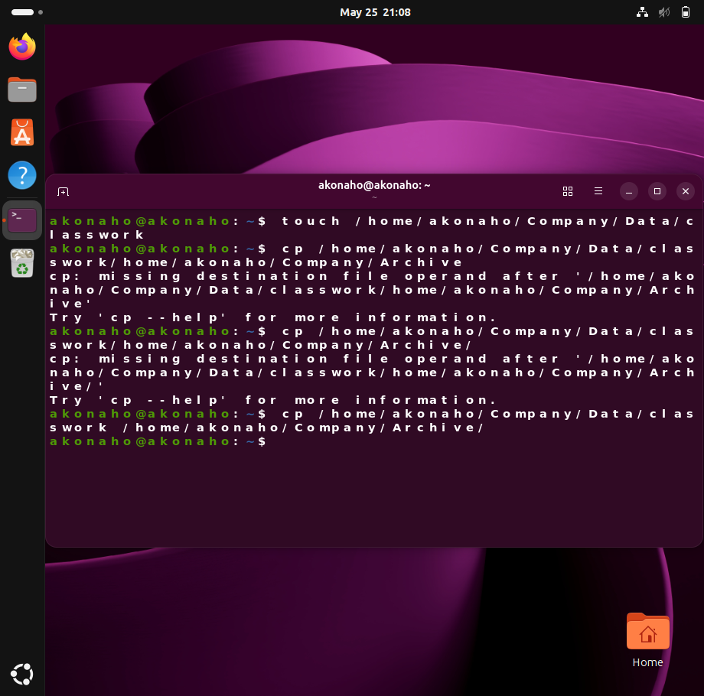
Objective
To demonstrate the ability to create a file and copy it into another directory using Linux terminal commands.
Commands Executed
- Create a file inside the Data folder:
- touch /home/akonaho/Company/Data/classwork
This command creates an empty file named classwork in the Data directory.
- Copy the file into the Archive folder:
- cp /home/akonaho/Company/Data/classwork /home/akonaho/Company/Archive/
This command copies the classwork file from Data into Archive.
Notes
- Initial attempts produced errors because the destination path was not correctly specified.
- The corrected command successfully copied the file, showing problem-solving and attention to detail.
Result
The file classwork now exists in both the Data and Archive directories, confirming successful execution.

Archive Folder Verification
Objective
To confirm that files created and copied via terminal commands are correctly stored in the designated directory.
Evidence
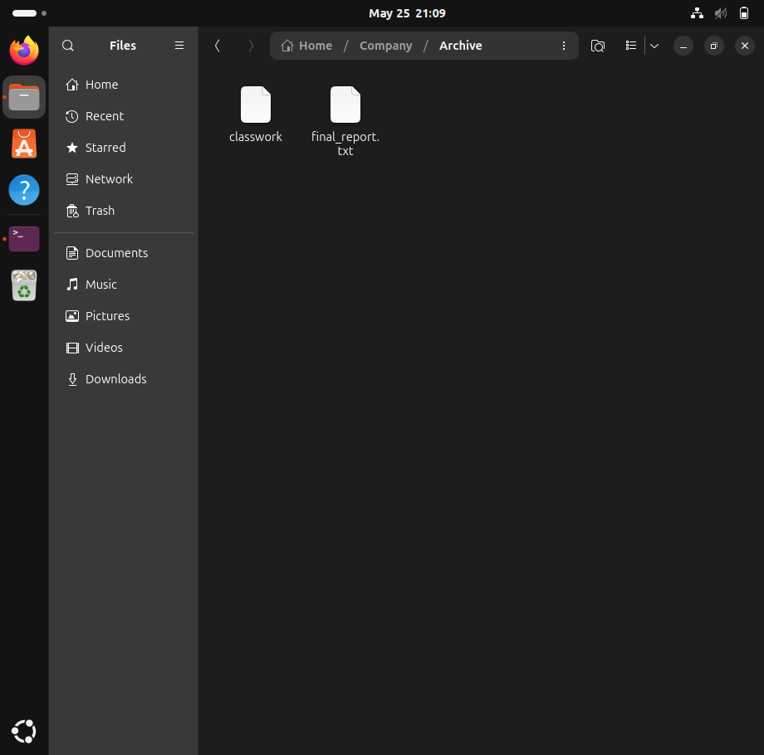
The screenshot of the Archive folder shows:
- classwork – created in the Data folder and copied into Archive.
- final_report.txt – an additional file stored in Archive for company records.
Analysis
- The presence of both files demonstrates successful file management.
- It validates the earlier terminal operations (touch and cp).
- The graphical verification complements the command-line evidence, showing consistency across both environments.

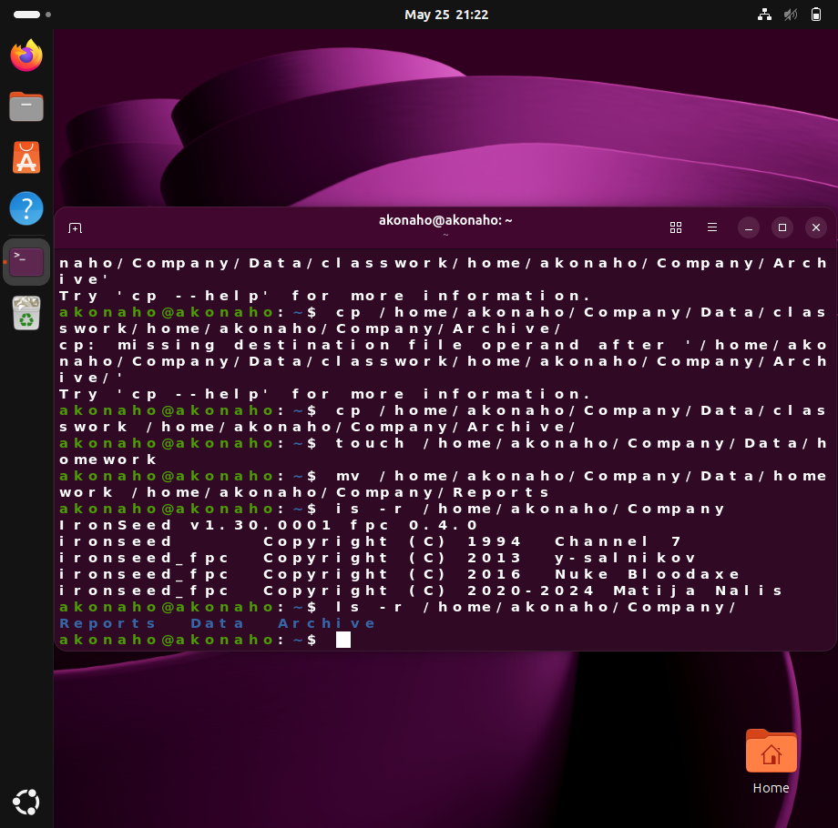
1. File Creation (Moving)
touch /home/akonaho/Company/Data/homework
This command creates an empty file named homework within the Data directory.
The touch command is commonly used in Linux systems to create new files quickly or update the timestamp of existing files. In this context, it demonstrates the initialization of a file for future academic or organizational use.
2. File Movement
mv /home/akonaho/Company/Data/homework /home/akonaho/Company/Reports
This command moves the homework file from the Data directory to the Reports directory.
The mv command is used to move or rename files and directories in Linux. Here, it demonstrates effective file organization by transferring the file to the appropriate folder for reporting and storage purposes.
3.Directory Listing

ls -r /home/akonaho/Company/
This command displays the contents of the Company directory in reverse order.
The output confirms the existence of the subdirectories:
- Reports
- Data
- Archive
Using the ls command with the -r option helps verify that the directory structure remains correct after file operations have been completed.

Analysis
File Creation
The use of the touch command demonstrates the ability to create and initialize files efficiently within a Linux operating system.
File Management
The mv command illustrates proper file organization practices by relocating files to suitable directories.
Verification and Monitoring
The ls -r command was used to verify directory contents and confirm that the file structure remained accurate after modifications.
Error Resolution
The correction of command syntax errors highlights analytical thinking and troubleshooting abilities, which are essential skills in Information Technology and Cybersecurity environments.

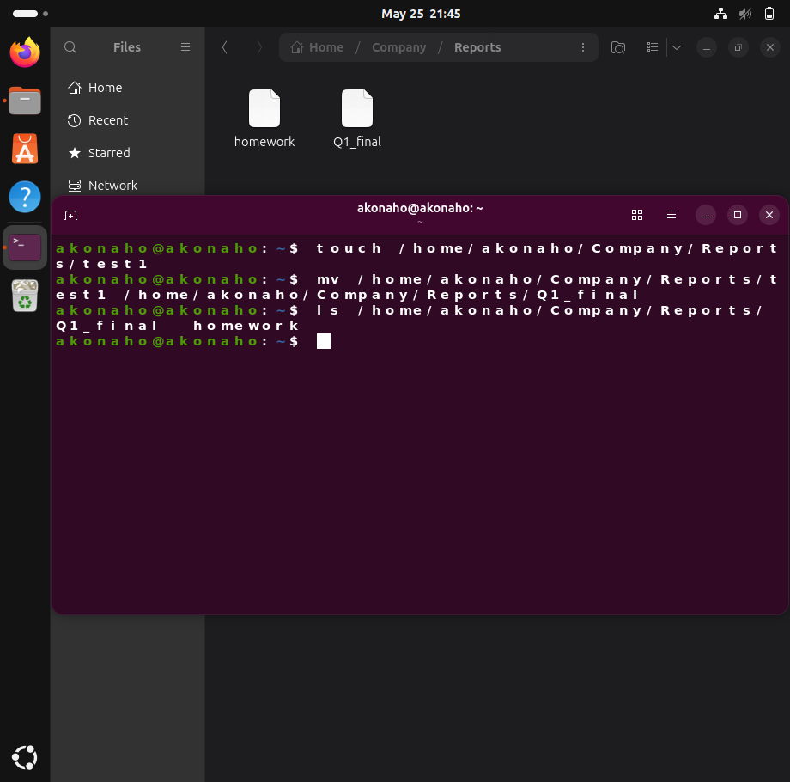

1. File Creation (Renaming)
touch /home/akonaho/Company/Reports/test1
Explanation
The touch command was used to create an empty file named test1 inside the Reports directory.
Purpose
- To initialize a new file for future use.
- To demonstrate basic Linux file creation techniques.
- To prepare a placeholder document that can later store report information.
Professional Significance
Creating files using command-line tools is a fundamental Linux administration skill. It allows system administrators and IT professionals to efficiently manage documents, scripts, logs, and configuration files within an operating system environment.
2. File Renaming
mv /home/akonaho/Company/Reports/test1 /home/akonaho/Company/Reports/Q1_final
Explanation
The mv command was used to rename the file test1 to Q1_final while keeping it in the same directory.

Purpose
- To assign a more meaningful and professional filename.
- To improve file organization and identification.
- To reflect real-world workplace practices where files are named according to their purpose or reporting period.
Significance
Using descriptive filenames is considered a best practice in IT and business environments because it:
- Improves clarity and readability.
- Simplifies file retrieval and management.
- Enhances professionalism in documentation and reporting systems.
The filename Q1_final suggests that the document represents a finalized first-quarter report, making the file easier to identify within the organization.
3. Directory Listing and Verification
ls /home/akonaho/Company/Reports/
Explanation
The ls command was used to display the contents of the Reports directory.
Output Verification
The directory listing confirmed the presence of:
- Q1_final — the renamed report file.
- homework — a file previously moved into the Reports directory.
Purpose
- To verify that file operations were completed successfully.
- To confirm that the correct files exist within the directory structure.
- To ensure proper organization and storage of company documents.
Professional Significance
Verification is an important step in Linux administration because it ensures:
- Accuracy of file operations.
- Integrity of the directory structure.
- Proper management of organizational data.
System administrators regularly use commands such as ls to monitor, validate, and troubleshoot file systems.
Analysis
File Creation
The use of the touch command demonstrates the ability to create and initialize files efficiently within a Linux environment.
File Renaming and Organization
The mv command illustrates effective file management practices by renaming files using meaningful and descriptive titles. This reflects professional standards commonly used in corporate and academic environments.
Directory Verification
The ls command confirms successful completion of operations and validates that files are stored in the correct location.

2. Explain absolute vs relative paths using your structure.

In Linux operating systems, file and directory navigation is performed using paths. A path specifies the exact location of a file or folder within the filesystem. There are two primary types of paths used in Linux environments:
- Absolute Paths
- Relative Paths
Understanding the difference between these path types is essential for effective system administration, file management, and command-line navigation.
1. Absolute Paths
An absolute path provides the complete and exact location of a file or directory within the Linux filesystem.
Key Characteristics
- Always begins from the root directory, represented by a forward slash (/).
- Includes every parent directory in the hierarchy.
- Functions correctly regardless of the user’s current working directory.
- Provides a fixed and unambiguous file location.
Examples Using the Current Directory Structure
/home/akonaho/Company/Data
/home/akonaho/Company/Reports/Q1_Final_Report.docx
Explanation
In these examples:
- /home is the main user directory.
- akonaho is the user account folder.
- Company is the primary project directory.
- Data and Reports are subdirectories within the project structure.

The absolute path specifies the full route from the root directory to the target file or folder.
Professional Importance
Absolute paths are commonly used in:
- System administration scripts
- Backup configurations
- Server management
- Automated tasks
- Security and access management
Because they provide the full location, they reduce ambiguity and ensure accuracy during operations.
Real-World Analogy
An absolute path is similar to a complete physical address or GPS coordinate. For example:
“123 Pretoria Street, Pretoria East, South Africa”
This address identifies one exact location regardless of where the person currently is.

2. Relative Paths
A relative path specifies the location of a file or directory based on the user’s current working directory.
Key Characteristics
- Does not begin with a forward slash (/).
- Depends on the current location in the terminal.
- Uses shorthand navigation symbols such as:
→ Current directory
→ Parent directory

Example Scenario A: Accessing a Subdirectory
Assume the current working directory is:
/home/akonaho/Company
Absolute Path Command
ls /home/akonaho/Company/Data
Relative Path Command
ls Data
Explanation
Since the user is already inside the Company directory, there is no need to rewrite the full path. The system automatically searches relative to the current location.

Example Scenario B: Moving Between Directories
Assume the user is currently inside:
/home/akonaho/Company/Data
To move into the Archive directory using a relative path:
cd ../Archive
Explanation
In this command:
- .. moves one level upward from Data to Company.
- Archive then directs the system into the target folder.
This demonstrates efficient navigation between directories without typing the full absolute path.
Absolute vs Relative Paths
Feature | Absolute Path | Relative Path
Starting Point | Root directory (/) | Current directory
Dependency on Current Location | Independent | Dependent
Begins With / | Yes | No
Navigation Symbols | Not required | Uses ., ..
Length | Usually longer | Usually shorter
Common Usage | System scripts, administration | Quick navigation

Advantages of Absolute Paths
- Eliminates confusion about file locations.
- Reliable in scripts and automated processes.
- Works consistently from any directory.
- Preferred in professional system administration.
Advantages of Relative Paths
- Faster and shorter to type.
- Efficient for day-to-day navigation.
- Reduces repetition when working within the same project directory.
- Improves command-line productivity.

3. Explain why Linux uses a single-root filesystem.

Modern operating systems organize and manage files differently depending on their underlying architecture. In Microsoft Windows environments, storage devices are typically separated into individual drive letters such as C:, D:, or E:. Each drive operates as an independent storage location with its own filesystem hierarchy.
Linux, however, follows a fundamentally different approach known as the single-root filesystem structure. Instead of dividing storage into separate drive letters, Linux organizes all files, directories, applications, and hardware devices under one unified directory tree that begins at the root directory, represented by a forward slash (/).
This design provides flexibility, scalability, security, and efficient system management, making Linux highly suitable for enterprise servers, cloud infrastructure, cybersecurity environments, and advanced system administration.

1. The Linux Single-Root Filesystem
In Linux, every resource within the operating system branches from a single starting point:
(/)
This root directory acts as the top-level parent of the entire filesystem hierarchy.
Under this structure:
- User directories
- Applications
- System files
- External storage devices
- Network storage
- Hardware interfaces
are all integrated into one continuous directory tree.
Unlike Windows, Linux does not assign separate drive letters to storage devices. Instead, devices are attached to the filesystem through a process known as mounting.
2. The “Everything is a File” Philosophy
One of the most important design principles in Linux is the concept that:
“Everything is treated as a file.”
This philosophy means that Linux represents hardware devices, storage volumes, and system resources as files or directories within the filesystem.
Practical Example
When a USB flash drive is connected to a Linux system, it does not appear as a separate drive letter such as E:. Instead, the operating system mounts the device into an existing directory path, for example:
/media/akonaho/MyUSB
Explanation
In this example:
- /media is the standard directory used for removable storage devices.
- akonaho represents the current user account.
- MyUSB is the mounted USB storage device.
The USB drive becomes part of the unified filesystem tree rather than functioning as a completely separate storage entity.
Professional Significance
This architecture simplifies:
- Device management
- System integration
- Automation scripting
- File access consistency
It also allows administrators to interact with hardware devices using the same tools and permissions applied to regular files and directories.
3. Seamless Storage Scalability and Flexibility
The Linux filesystem structure provides exceptional scalability because physical hardware can be changed without altering logical file paths.
Practical Project Scenario
Assume the following directory begins running out of storage space:
/home/akonaho/Company/Archive
A system administrator can:
- Install a new physical hard drive or network storage device.
- Mount the new storage directly onto the existing /Archive directory.
Result
- The directory path remains unchanged.
- Existing applications and scripts continue functioning normally.
- Users do not need to learn new storage locations.
- Data is transparently stored on the newly attached hardware.
Importance
This flexibility is extremely valuable in:
- Enterprise data centers
- Cloud computing environments
- Backup systems
- Database servers
- Cybersecurity operations
- Large-scale storage infrastructures
Linux abstracts the physical storage layer from the logical directory structure, allowing seamless hardware upgrades and maintenance.

4. Simplified Security and Permission Management
Linux uses a hierarchical permission model that integrates naturally with the single-root filesystem structure.
Because every directory branches from the root directory (/), security permissions can be inherited and managed systematically throughout the filesystem.
Permission Structure
Linux controls access using three primary permission categories:
- Read (r)
- Write (w)
- Execute (x)
These permissions can be assigned to:
- Owners
- Groups
- Other users
Security Advantages
The unified filesystem allows administrators to:
- Restrict access to critical system directories
- Protect operating system files from unauthorized modification
- Grant users controlled access to their personal directories
- Apply consistent security policies across the system
For example:
- Core operating system files remain protected under restricted system directories.
- Users maintain full control over personal directories such as:
/home/akonaho/Company
Significance
This centralized permission structure improves:
- System stability
- Data protection
- User management
- Enterprise security administration
- Compliance and auditing processes
It is one of the key reasons Linux is widely used in secure server and cybersecurity environments.
Advantages of the Linux Single-Root Model
Unified File Organization
All resources exist within one structured hierarchy, simplifying navigation and administration.
Hardware Abstraction
Users and applications interact with logical paths rather than physical storage devices.
Improved Scalability
Storage can be expanded or replaced without modifying application paths.
Stronger Security Control
Permissions inherit naturally from the root structure, improving access management.
Enhanced Automation
Scripts and applications remain stable even when underlying storage hardware changes.
Conclusion
Linux utilizes a single-root filesystem structure to create a unified, scalable, and secure operating environment. Unlike Windows systems that separate storage using drive letters, Linux organizes all files, directories, applications, and hardware devices under one central root directory (/).
This architecture supports the Linux philosophy that “everything is a file,” allowing hardware devices and storage volumes to integrate seamlessly into the filesystem hierarchy. It also provides major advantages in scalability, system administration, automation, and security management.
By abstracting physical hardware from logical directory paths, Linux enables users, administrators, and applications to access data consistently without needing to know where the data is physically stored. This design is one of the primary reasons Linux remains widely used in enterprise computing, cybersecurity, networking, and cloud infrastructure environments.

4. Identify risks of incorrect file handling.

The Linux Command Line Interface (CLI) provides powerful and efficient tools for file and system management. However, unlike graphical operating systems that often include recovery features such as a Recycle Bin, Linux command-line operations are typically executed immediately and permanently.
As a result, incorrect file handling can lead to:
- Permanent data loss
- System instability
- Security vulnerabilities
- Failure of automated processes
- Corruption of important project files
Understanding these risks is essential for Linux administrators, cybersecurity professionals, and IT students working within command-line environments.
The following analysis explains the major risks associated with improper file handling using the existing Company directory structure.
1. Permanent Data Loss: Risks of the rm Command
The rm (remove) command is used to permanently delete files and directories in Linux.
High-Risk Nature of rm
Unlike graphical operating systems, Linux does not move deleted files to a Recycle Bin when using terminal commands. Once removed, files are often extremely difficult or impossible to recover.
Example of a Dangerous Command
rm -rf / home/akonaho/Company/Archive
Explanation of the Risk
In this example, the accidental space after the root slash (/) changes the meaning of the command entirely.
Instead of targeting only the Archive directory, Linux interprets:
- / as the system root directory
- home/akonaho/Company/Archive as a separate argument
The -rf flags instruct Linux to:
- -r → Recursively delete directories and contents
- -f → Force deletion without confirmation
As a result, the operating system may begin deleting critical system files, applications, and user data immediately.
Potential Impact
- Complete operating system failure
- Loss of academic or project work
- Corruption of system configurations
- Irrecoverable destruction of user files
Significance
This demonstrates the importance of precision and caution when executing destructive commands in Linux environments.

2. Silent Overwriting of Important Files
Commands such as mv (move) and cp (copy) can overwrite existing files without requesting confirmation.
Example of an Overwrite Operation
mv /home/akonaho/Company/Data/Q1_Final_Report.docx /home/akonaho/Company/Reports/
Explanation of the Risk
If a file named Q1_Final_Report.docx already exists in the Reports directory, Linux may replace the original file automatically.
This can occur accidentally when:
- Copying draft files
- Moving outdated documents
- Reusing filenames without verification
Potential Impact
- Loss of finalized project work
- Replacement of critical reports with outdated versions
- Destruction of important documentation

Professional Significance
File version management and naming conventions are critical in enterprise and academic environments. Careless overwriting can result in operational disruptions and significant data loss.

3. Broken Automation Scripts and Dependency Failures
Linux environments commonly rely on automated scripts for:
- Backups
- Log management
- Data processing
- Security monitoring
- Scheduled maintenance tasks
These scripts depend on precise and consistent file paths.
Example Scenario
Suppose an automated backup script expects data to exist in:
/home/akonaho/Company/Data
If the directory is renamed to:
- data
- Data_Old
- Archive_Data

the automation script will no longer locate the expected directory.
Resulting Error
The script may produce errors such as:
No such file or directory
Potential Impact
- Failed backups
- Missing security logs
- Interrupted automated workflows
- Increased risk of data loss during system failures

Significance
Consistency in directory structures is essential for maintaining stable enterprise systems and reliable automation processes.

4. Security Risks and Permission Mismanagement
Linux uses strict permission and ownership systems to protect files and directories from unauthorized access.
Common permission management commands include:
- chmod → Changes file permissions
- chown → Changes ownership

Example of Unsafe Permission Modification
chmod 777 -R /home/akonaho/Company/
Explanation of the Risk
The permission value 777 grants:
- Read access
- Write access
- Execute access
to all users and processes on the system.
The -R option applies these permissions recursively to every file and folder within the Company directory.
Potential Impact
- Unauthorized file modification
- Exposure of confidential information
- Malware execution risks
- Security policy violations
- Compromise of sensitive business data
Professional Significance
Improper permission management is considered a major cybersecurity vulnerability in enterprise environments.
Organizations rely on strict permission controls to:
- Protect sensitive data
- Restrict unauthorized access
- Maintain system integrity
- Enforce security compliance standards

Summary of Risks
Risk Category | Potential Consequence
Incorrect rm usage | Permanent system and data loss
File overwriting | Loss of finalized documents
Renaming directories | Automation and backup failures
Unsafe permissions | Security breaches and unauthorized access

Best Practices for Safe File Handling in Linux
To reduce the risks associated with Linux file operations, administrators and users should follow defensive file management practices.
1. Verify Commands Before Execution
Always review file paths and command syntax carefully before pressing Enter.
2. Use Interactive Mode (-i)
Interactive flags force Linux to request confirmation before overwriting or deleting files.
Examples
cp -i source.txt destination.txt
mv -i file.txt /home/akonaho/Company/Reports/
3. Confirm Current Working Directory
Use the pwd command to identify the current directory before executing destructive operations.
pwd
4. Maintain Backup Copies
Regular backups protect important data from accidental deletion or corruption.
5. Apply Principle of Least Privilege
Only assign the minimum permissions required for users and applications to perform their tasks.

Conclusion
Linux command-line tools provide powerful capabilities for managing files and directories; however, incorrect file handling can result in severe consequences, including permanent data loss, security vulnerabilities, automation failures, and system instability.
This analysis demonstrated how mistakes involving commands such as rm, mv, cp, and chmod can negatively affect the Company directory structure and compromise important project data.
By applying professional best practices such as command verification, controlled permissions, interactive confirmation flags, and regular backups, Linux users and administrators can significantly reduce operational risks and maintain secure, stable, and reliable systems.

Question 5 Terminal and vi Editor

- Demonstrate command syntax with examples.
- Use man, --help, and apropos.
- Create and edit a file using vi containing system usage rules.
- Use output redirection and a pipe.
- Compare man, --help, and apropos.
- Explain vi modes.
- Explain difference between pipe and redirection.

[Subtotal 15 Marks]

1.Demonstrate command syntax with examples.

In Linux and Unix-based operating systems, commands entered in the Command Line Interface (CLI) follow a standardized syntax structure. Understanding command syntax is essential for effective system administration, file management, cybersecurity operations, and software development.
Linux commands are designed to be flexible and modular, allowing users to modify command behavior through options and apply commands to specific targets through arguments.
The general structure of a Linux command is represented as:
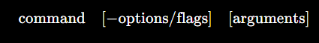
1. Components of Linux Command Syntax
Linux command syntax consists of three primary components:
Component | Description
Command | The executable program or utility being called
Options / Flags | Modifiers that change the behavior of the command
Arguments | The file, directory, or object the command operates on

1.1 Command
The command is the main executable instruction issued to the operating system.
Examples
- ls → Lists directory contents
- mkdir → Creates directories
- cp → Copies files
- mv → Moves or renames files

The command determines the operation Linux will perform.

1.2 Options and Flags
Options (also known as flags) modify the behavior of a command.
Characteristics
- Short-form flags use a single dash:
-l
- Long-form flags use double dashes:
--help
Example
ls -l
In this example:
- ls is the command
- -l requests a detailed listing format
Options allow administrators and users to customize command output and functionality.

1.3 Arguments
Arguments specify the target object that the command will operate on.
Example
ls /home/akonaho/Company
In this example:
- ls is the command
- /home/akonaho/Company is the argument
The argument identifies the directory whose contents should be displayed.
2. The man Command (Manual Pages)
The man command provides access to Linux manual pages, which contain detailed technical documentation for commands, configuration files, and system functions.

Purpose
The man utility is used to:
- Learn command usage
- Understand available options
- Access technical references
- Study system administration documentation

Syntax
man [command_name]
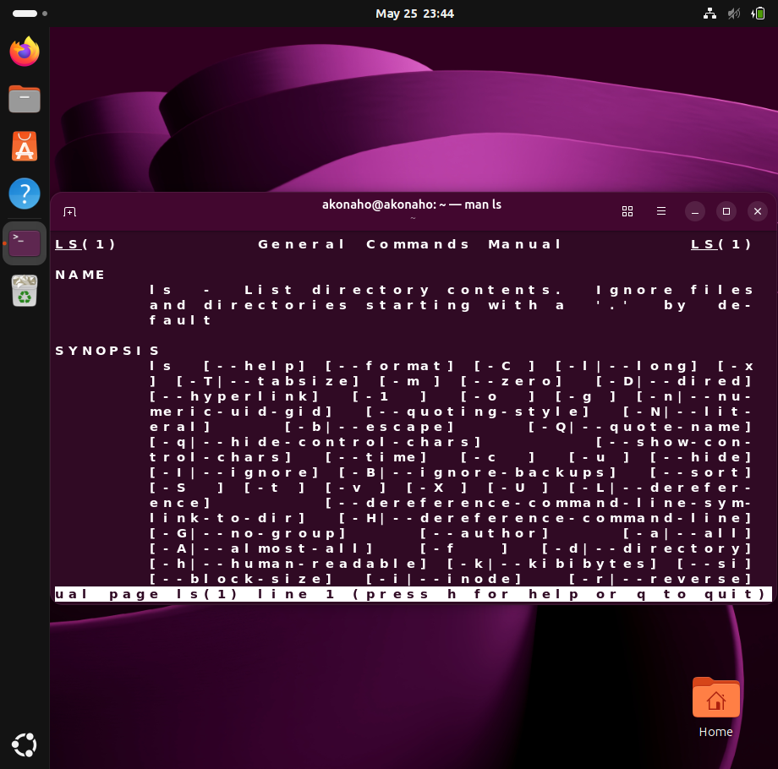
Example 1: Viewing the Manual for ls
man ls
Explanation
This command opens the official manual page for the ls command.
The manual page includes:
- Command description
- Available options
- Usage examples
- Technical details

Navigation
Within the manual:
- Arrow keys → Scroll
- / → Search text
- q → Quit the manual

Example 2: Accessing a Specific Manual Section
man 5 passwd
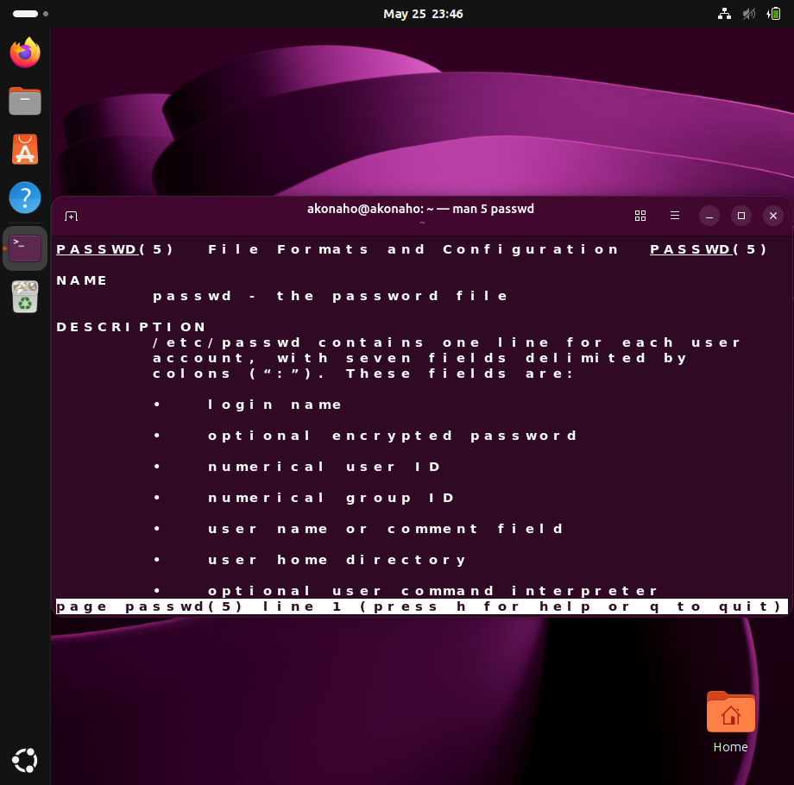
Explanation
Linux manual pages are organized into numbered sections.
Section 5 refers to:
- File formats
- Configuration files
This command displays documentation for the structure of the /etc/passwd file rather than the password management command itself.

3. The --help Option (Help Flag)
Most modern Linux commands support the --help option, which provides a concise summary of command usage directly in the terminal.
Purpose
The help flag is useful for:
- Quick syntax reminders
- Viewing available options
- Learning command functionality without opening full documentation

Syntax
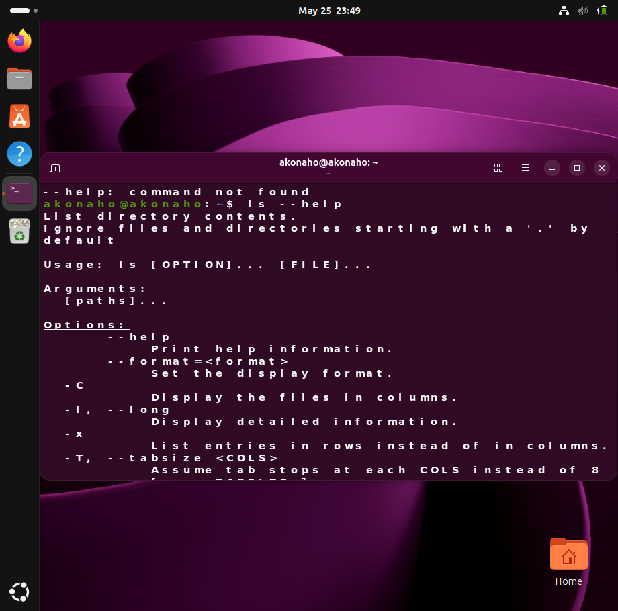
[ ls] --help

Example 1: Help for mkdir
mkdir –help
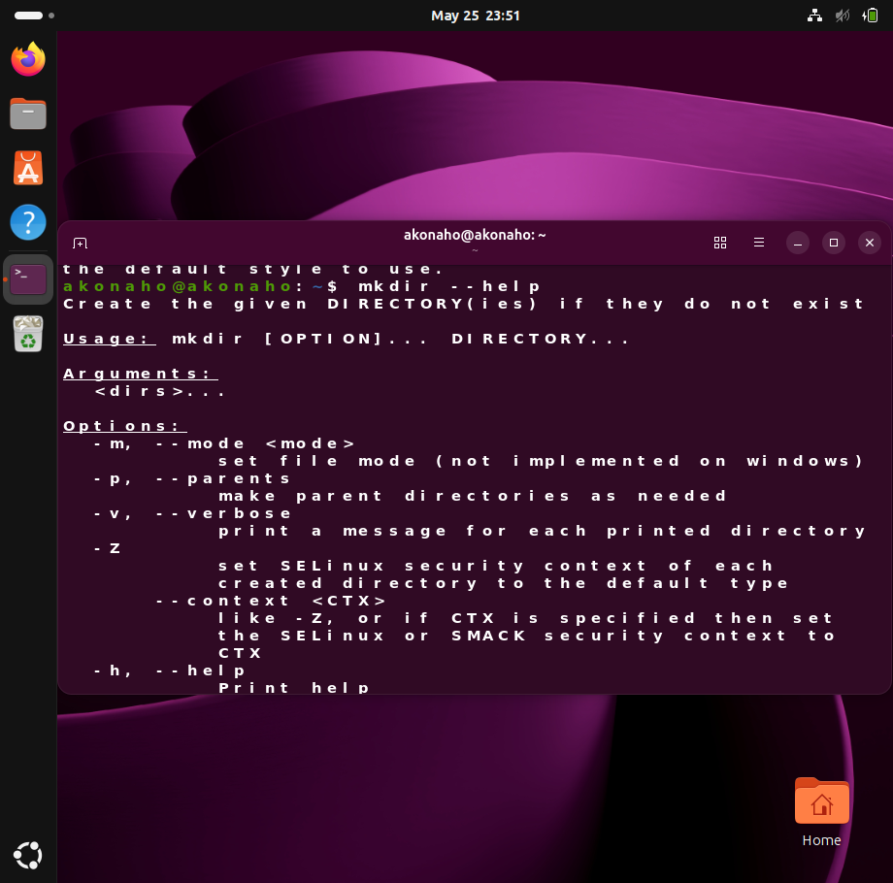
Explanation
This command displays:
- Available options
- Syntax examples
- Command usage information
For example:
- -p → Creates parent directories automatically

Example 2: Short Help Flag
uname -h
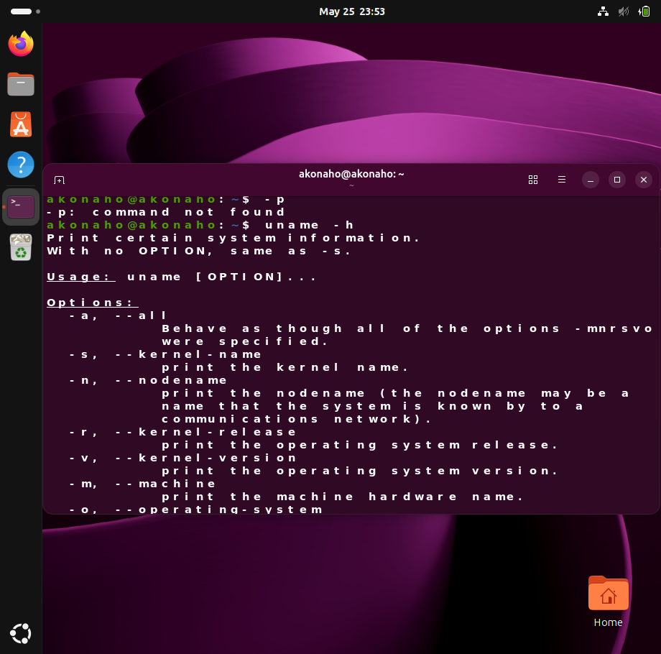
Explanation
Some Linux commands support shorter help options such as:
- -h
- -?
These provide quick access to command usage information.

4. The apropos Command (Keyword Search)
The apropos command searches Linux manual page descriptions for a specific keyword.
Purpose
apropos is particularly useful when:
- The user knows the task to perform
- The exact command name is unknown
It acts as a command discovery tool.

Syntax
apropos [keyword]

Example 1: Searching for Rename Commands
apropos rename
Explanation
This command searches all manual page descriptions containing the keyword “rename.”
Possible results may include:
- mv → Move or rename files
- rename → Batch rename files

Example 2: Searching Using Multiple Keywords
apropos "copy files"
Explanation
Quotation marks allow Linux to search for an exact phrase.
This search helps users discover commands related to copying files, such as:
- cp
- rsync

Importance of Linux Help Utilities
Utility | Purpose | Professional Benefit
man | Full technical documentation | Deep system understanding
--help | Quick syntax reference | Fast command recall
apropos | Keyword-based command search | Efficient command discovery

Advantages of Understanding Command Syntax
Improved Efficiency
Users can execute commands accurately and quickly.
Reduced Errors
Understanding syntax minimizes the risk of incorrect command execution.
Better Troubleshooting
Administrators can diagnose issues more effectively using command documentation.
Enhanced System Administration Skills
Command-line proficiency is essential in:
- Linux administration
- Cybersecurity
- Networking
- Cloud computing
- DevOps engineering

Conclusion
Linux command syntax provides a structured and efficient method for interacting with the operating system through the Command Line Interface. Every command consists of a command name, optional flags, and arguments that define the operation and its target.
Utilities such as man, --help, and apropos play an essential role in learning, troubleshooting, and mastering Linux commands. These tools allow users to access technical documentation, retrieve quick usage information, and discover commands based on functionality.
A strong understanding of command syntax and Linux help utilities is fundamental for effective system administration, cybersecurity operations, and professional IT environments.

2. Use man, --help, and apropos.

Linux provides several built-in documentations and help utilities that assist users in learning commands, troubleshooting issues, and understanding command behavior. Among the most important tools are:
- apropos — searches for commands by keyword
- --help — provides quick command usage information
- man — opens the complete technical manual for a command
These utilities are essential in Linux system administration, cybersecurity, networking, and software development because they allow users to solve problems efficiently without requiring external documentation.
The following scenarios demonstrate how these tools can be used practically within a Linux terminal workspace to manage files and resolve common command-line challenges.
1. Scenario 1: Forgetting the Name of a Command (apropos)
Problem
A user needs to copy files from one directory to another but cannot remember the exact Linux command used for copying files.
Solution: Using apropos
The apropos command searches Linux manual page descriptions using keywords supplied by the user.
Command
apropos "copy files"
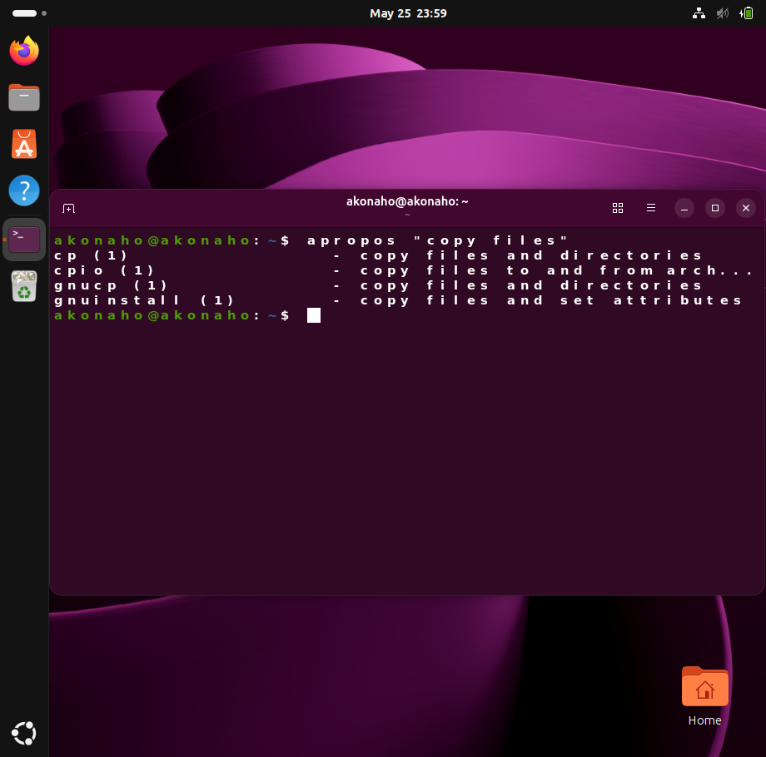

System Behavior
The system searches its manual page database and returns commands related to the phrase “copy files.”
Example Output
cp (1) | copy files and directories
cpio (1) | copy files to and from archives

Analysis
The search results indicate that:
- cp is the standard Linux command used to copy files and directories.
- cpio is another utility related to archive copying operations.
Result
The user successfully identifies cp as the correct command required for the task.
Importance
The apropos utility is valuable because it:
- Assists users who cannot remember command names
- Improves efficiency in command discovery
- Reduces reliance on external search engines or documentation
- Enhances productivity in Linux environments

It is especially useful for beginners and administrators working with unfamiliar commands.

2. Scenario 2: Forgetting a Command Option (--help)
Problem
The user remembers the cp command but cannot remember the option required to copy an entire directory recursively.
Solution: Using the --help Flag
The --help option provides a concise summary of command usage and available options directly in the terminal.

Command
cp --help
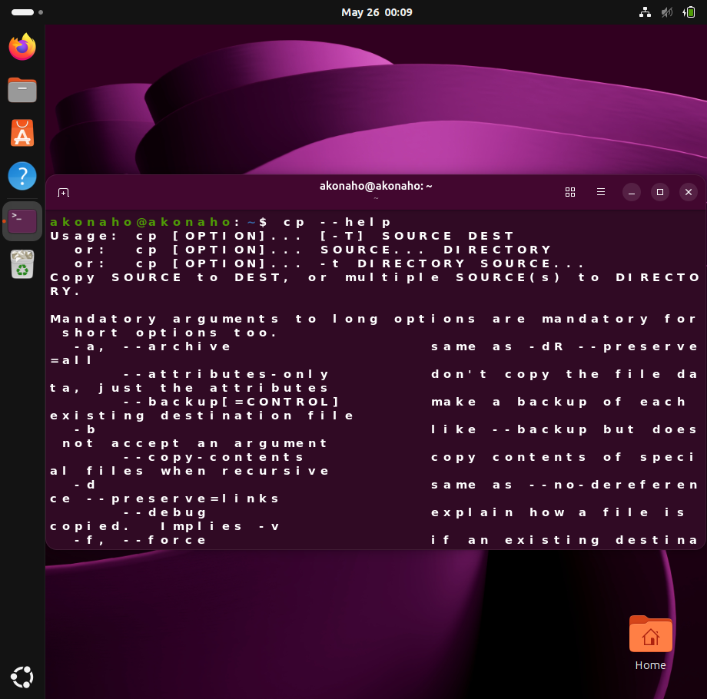
System Behavior
The command prints a structured list of options and explanations directly to the terminal screen.
Relevant Output
-R, -r, --recursive copy directories recursively

Analysis
The output reveals that:
- -R
- -r
- --recursive
can all be used to copy directories and their contents recursively.

Result
The user learns that the recursive option is required to copy folders successfully.
Example Usage
cp -r Data Backup
This command copies the entire Data directory into the Backup directory.
Importance
The --help option is useful because it:
- Provides immediate syntax guidance
- Saves time during command execution
- Reduces command errors
- Allows quick access to frequently used options

It is commonly used by Linux administrators and developers during daily terminal operations.

3. Scenario 3: Accessing Detailed Technical Documentation (man)
Problem
The user wants to understand exactly how the cp command behaves when a destination file already exists. Specifically, the user needs to know whether existing files are overwritten automatically.

Solution: Using the man Command
The man utility opens the official Linux manual page for a command.
Command
man cp
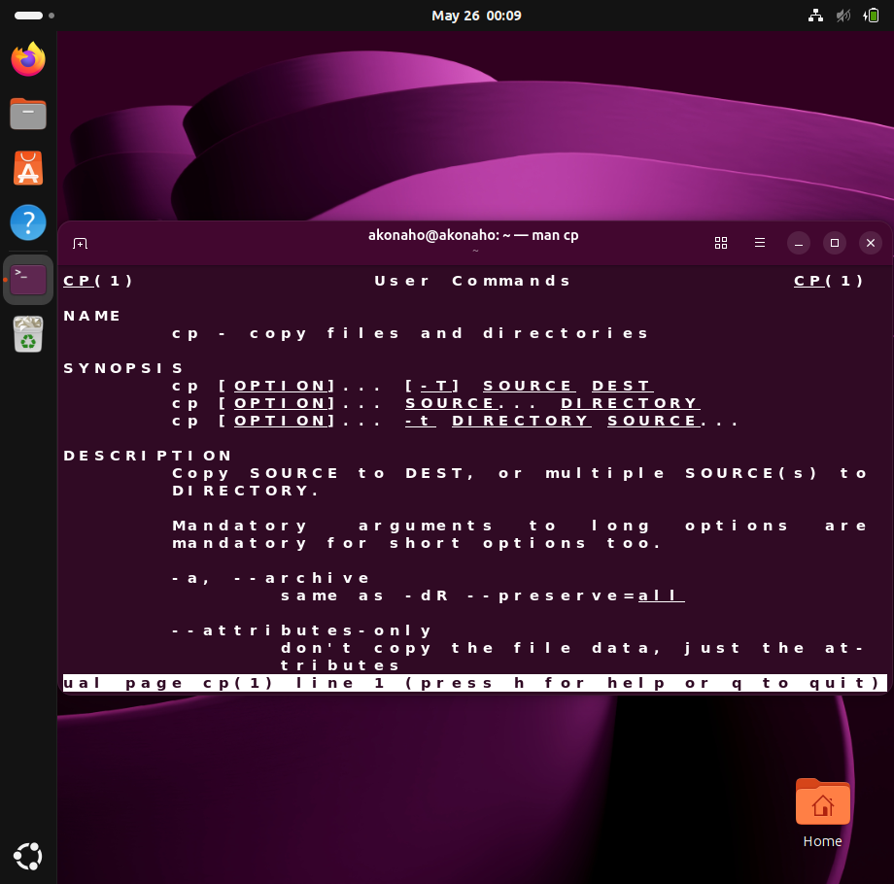
System Behavior
The terminal opens an interactive manual page containing comprehensive technical documentation for the cp command.
The manual includes:
- Command description
- Syntax structure
- Available options
- Behavioral explanations
- Usage examples
- Troubleshooting details

Navigating the Manual Page
Key | Function
Down Arrow / Spacebar | Scroll down
Up Arrow | Scroll up
/keyword | Search for text
q | Exit the manual

Example Search
Within the manual, the user can search for overwrite-related behavior by typing:
/overwrite
This helps the user locate information regarding file replacement behavior.
Result
The user gains a detailed understanding of:
- File overwrite behavior
- Interactive copy options
- Backup options
- Recursive copying
- Permission handling

Professional Importance
The man utility is one of the most important Linux learning and troubleshooting tools because it:
- Provides official technical documentation
- Supports advanced troubleshooting
- Explains command behavior in depth
- Assists with professional system administration tasks
Linux professionals regularly use manual pages when:
- Managing servers
- Configuring systems
- Writing scripts
- Troubleshooting command behavior
- Learning advanced command features

Comparison of Linux Help Utilities
Utility | Primary Purpose | Level of Detail
apropos | Find commands by keyword | Low
--help | Quick syntax reference | Medium
man | Complete technical documentation | High

Conclusion
The Linux utilities apropos, --help, and man are essential tools for command-line learning, troubleshooting, and system administration.
In these practical scenarios:
- apropos was used to discover the correct command name.
- --help provided quick access to command options and syntax.
- man delivered comprehensive technical documentation and detailed behavioral explanations.
Together, these tools enable Linux users to work more efficiently, reduce command errors, and develop stronger command-line administration skills. Mastering these utilities is fundamental for success in Linux system administration, cybersecurity, networking, and professional IT environments.

3. Create and edit a file using vi containing system usage rules.

The vi editor is one of the most widely used text editors in Linux and Unix operating systems. It is a powerful, terminal-based editor commonly used by system administrators, cybersecurity professionals, and developers for editing configuration files, scripts, and system documents.
Unlike graphical text editors, vi operates using different editing modes, meaning users must understand the correct sequence of commands and keystrokes to create, modify, save, and exit files successfully.
This documentation outlines the professional procedure for creating and editing a file named exam.txt using the vi editor.

Technical Procedure: Creating and Editing a File with vi
Objective
To create a text file named usage_rules.txt, enter system policy information, save the file to disk, and verify its contents using Linux command-line utilities.

Step 1: Initialize the File
Command
vi exam.txt
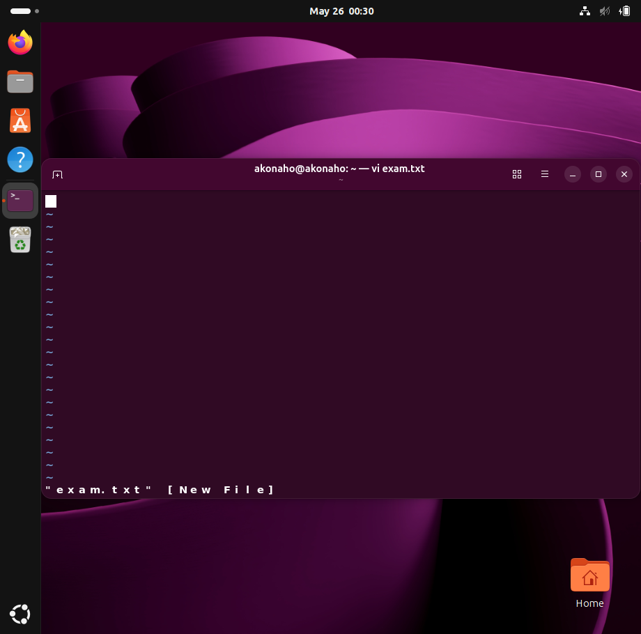
Explanation
The vi command launches the vi text editor and opens the specified file.
Behavior
- If the file already exists, vi opens it for editing.
- If the file does not exist, vi creates a new temporary editing buffer in memory.
The filename exam.txt identifies the target document that will store the system usage policies.

Professional Significance
Using vi for file creation is a standard practice in Linux system administration because:
- It is available on nearly all Unix/Linux systems.
- It functions entirely through the terminal.
- It allows administrators to edit files remotely through secure shell (SSH) connections.
Step 2: Enter Insert Mode
Keystroke
i
Explanation
When vi first opens, it starts in Command Mode. In this mode:
- Text cannot be typed directly.
- Keyboard input is interpreted as commands.
To begin entering text, the user must switch to Insert Mode by pressing the lowercase letter:
i
After pressing i, the following status indicator appears at the bottom-left corner of the terminal:
-- new file --
This confirms that text entry mode is active.
Professional Significance
Understanding modal editing is essential when using vi. Incorrect mode usage can lead to:
- Unintended command execution
- Editing errors
- File modification failures
Proper mode management is a fundamental Linux administration skill.

Step 3: Enter the File Content
Text to Input
======================================
1. Authorized administrative personnel only.
2. All production server deployments require change-control tickets.
3. Do not modify global configurations without taking a root backup.

Explanation
While in Insert Mode, the user types the required system usage policy rules into the document.
The content includes:
- A document title
- A separator line
- Administrative policy statements

Significance
This step demonstrates:
- File content creation
- Administrative documentation practices
- System policy management
Text editors such as vi are frequently used to:
- Modify server configurations
- Create shell scripts
- Edit security policies
- Maintain system documentation

Step 4: Exit Insert Mode
Keystroke
Esc
Explanation
After completing text entry, the user presses the Esc (Escape) key to exit Insert Mode and return to Command Mode.
The -- INSERT -- indicator disappears, confirming the mode change.
Significance
Returning to Command Mode is required before:
- Saving files
- Exiting the editor
- Performing editing operations
- Executing navigation commands
This reinforces the importance of understanding modal behavior in vi.
Step 5: Save and Exit the File
Command Sequence
:wq
Explanation
After returning to Command Mode:
- Press : to activate Last-Line Mode.
- Type:
wq
- Press Enter.
Meaning of the Command
- w → Write changes to disk
- q → Quit the editor
The combined command saves the file and closes the vi session.
Significance
Saving and exiting properly ensures:
- File integrity
- Successful data persistence
- Correct system documentation updates
Improper termination may result in unsaved work or incomplete configuration changes.
Post-Execution Verification
After saving the file, the contents should be verified to ensure successful creation and accurate data storage.

Verification Command
cat exam.txt
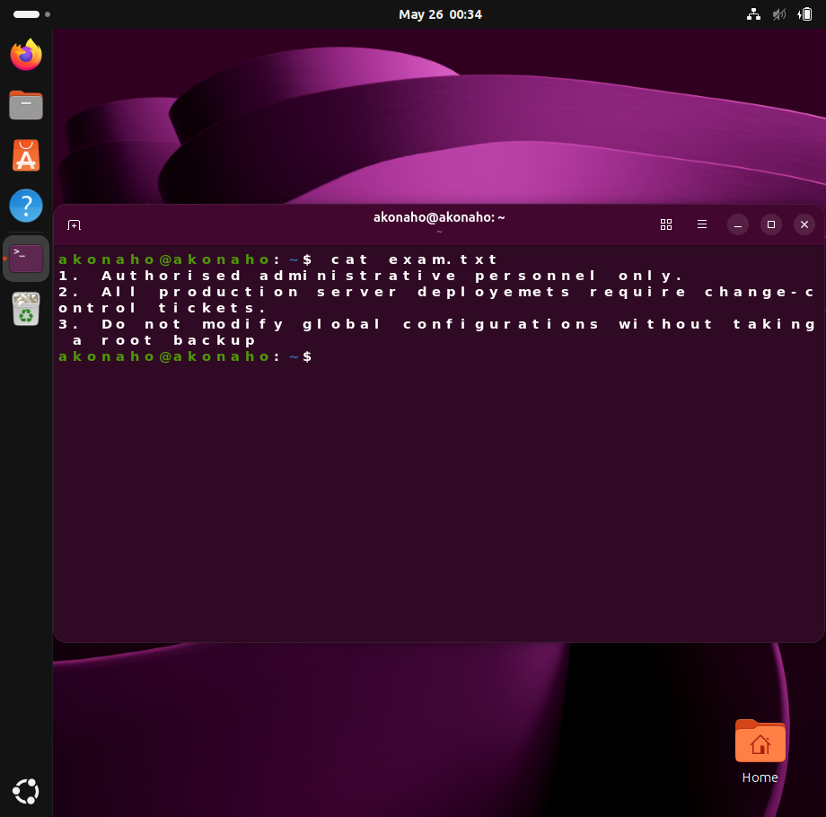
Explanation
The cat command outputs the contents of the file directly to the terminal screen.
This allows administrators to:
- Confirm file creation
- Validate stored content
- Verify formatting accuracy

Professional Analysis of the Procedure
Step | Purpose | Administrative Value
vi usage_rules.txt | Opens or creates the file | File management
i | Enables Insert Mode | Text editing
Text Entry | Adds policy information | Documentation
Esc | Returns to Command Mode | Mode control
:wq | Saves and exits | File persistence
cat | Verifies file contents | Validation and troubleshooting

Advantages of Using vi
Lightweight and Efficient
vi operates entirely within the terminal and consumes minimal system resources.
Remote System Administration
It is ideal for managing systems remotely through SSH connections.
Universal Availability
Most Linux and Unix systems include vi by default.
Powerful Editing Features
Advanced users can perform:
- Search operations
- Text manipulation
- Bulk editing
- Automation tasks

Conclusion
This procedure demonstrated the professional process of creating, editing, saving, and verifying a text file using the Linux vi editor.
The exercise highlighted several essential Linux administration skills, including:
- File initialization
- Mode-based text editing
- Command execution within vi
- File saving and verification
- Terminal-based document management
Understanding how to use vi effectively is fundamental in Linux system administration, cybersecurity operations, server management, and enterprise IT environments, where terminal-based configuration and documentation tasks are performed regularly.

4.Use output redirection and a pipe

A quick technical clarification: output redirection (>, >>) and pipes (|) are built-in features of the Linux shell (such as Bash or Zsh). They do not need to be installed.
If you receive a “command not found” error, the issue is usually caused by:
- A missing command-line program (such as grep or cat)
- A typing mistake in the command syntax
The following steps demonstrate how output redirection and piping work using standard Linux commands available on most systems.
Step 1: Verify the File Exists
First, confirm that the file usage_rules.txt exists in your current directory:
ls -l
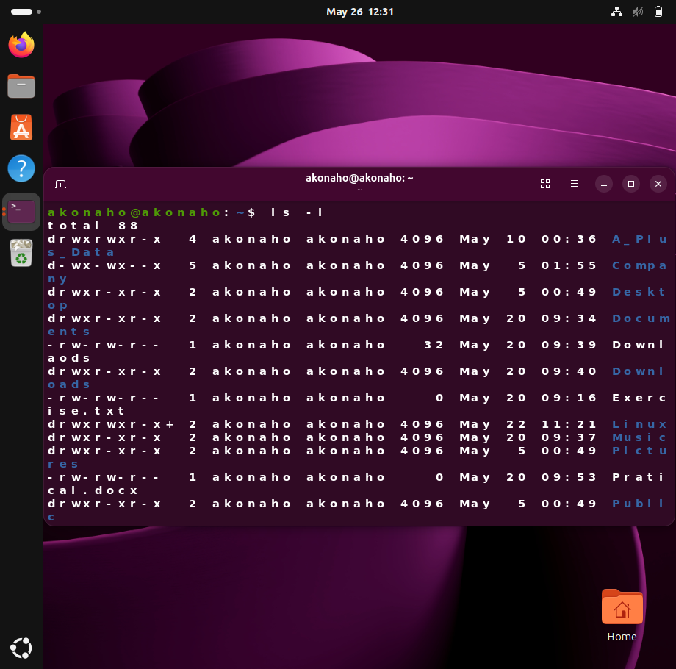
If the file is missing, create it with:
touch exam.txt
Step 2: Using Output Redirection (>>)
Output redirection sends command output into a file instead of displaying it on the screen.
1. Display the Current Date Normally
Date
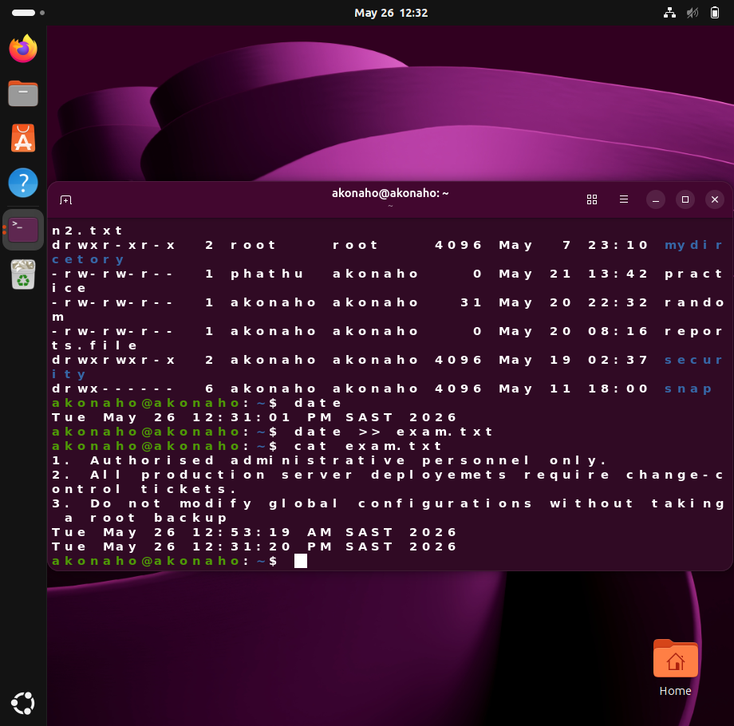
Example output:
Tue May 26 12:27:02 SAST 2026
2. Append the Output to a File
date >> exam.txt
Nothing appears on the screen because the output is added directly to the file.
3. Verify the File Contents
cat exam.txt
This displays the updated contents of the file.
Step 3: Using Pipes (|)
A pipe sends the output of one command directly into another command.
1. Display the File Contents
cat exam.txt

2. Filter the Output with grep
cat exam.txt | grep "1"
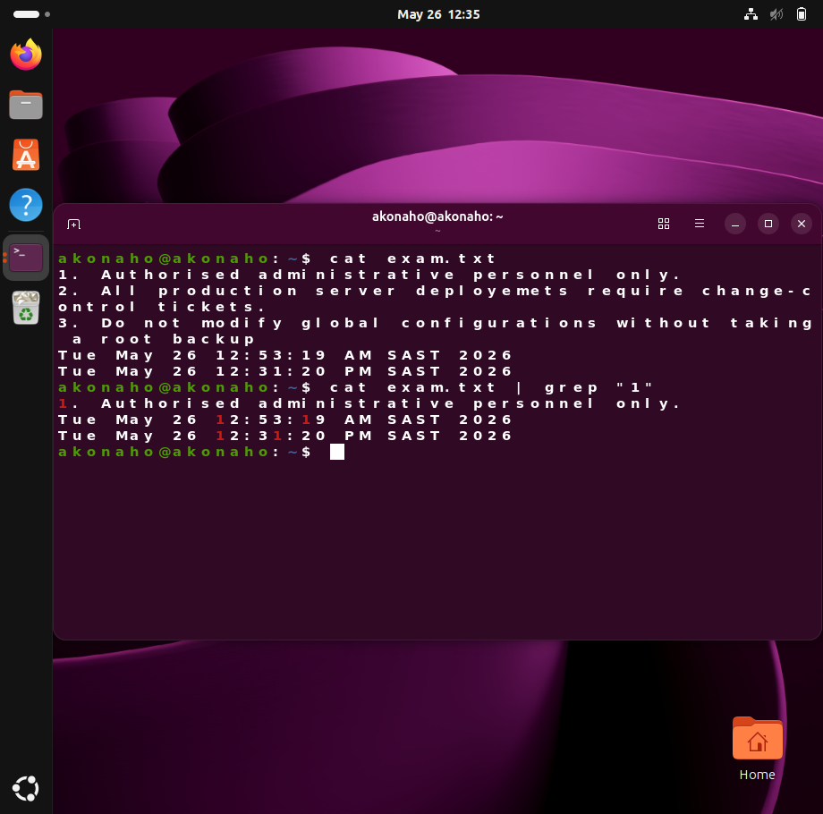
This command searches for lines containing the number 1.
Example output:
1. Authorized administrative personnel only.

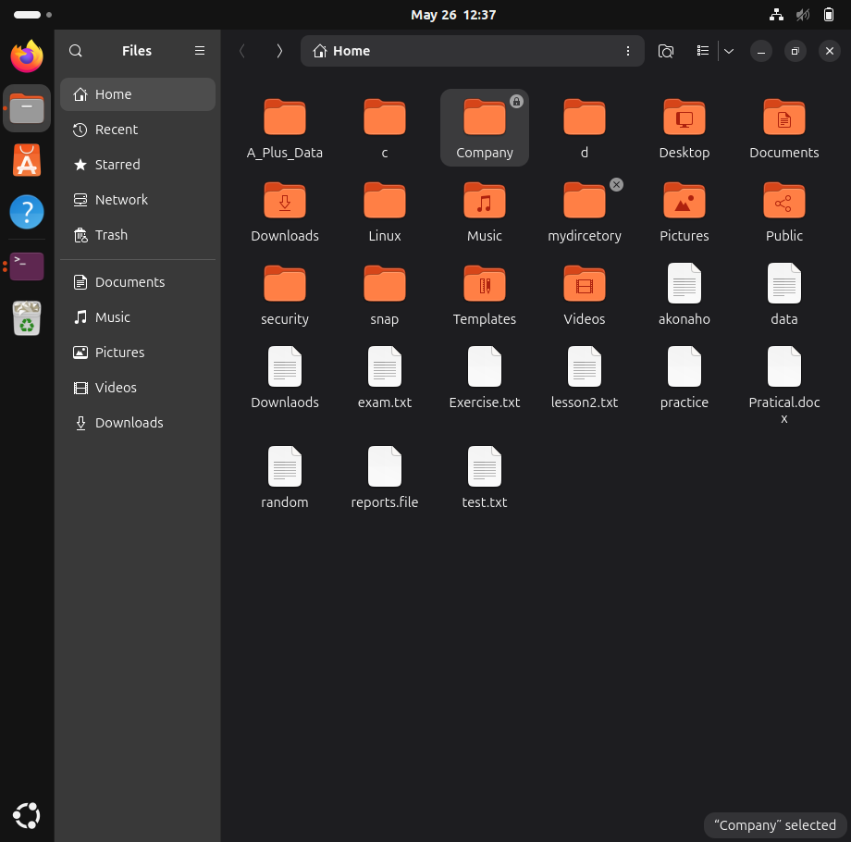

Step 4: Combining Pipes and Redirection
You can combine both features in a single command.
cat exam.txt | grep "1" > test.txt
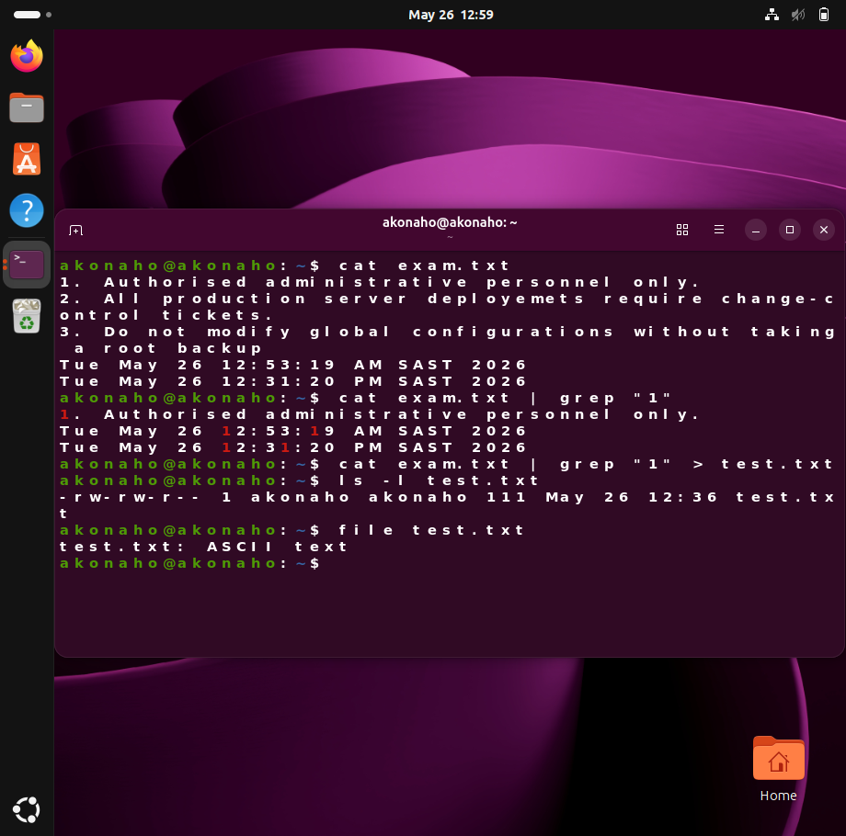
What this command does:
- cat reads the file contents
- grep filters lines containing 1
- > redirects the filtered result into a new file called filtered_rules.txt
To verify the result:
cat test.txt

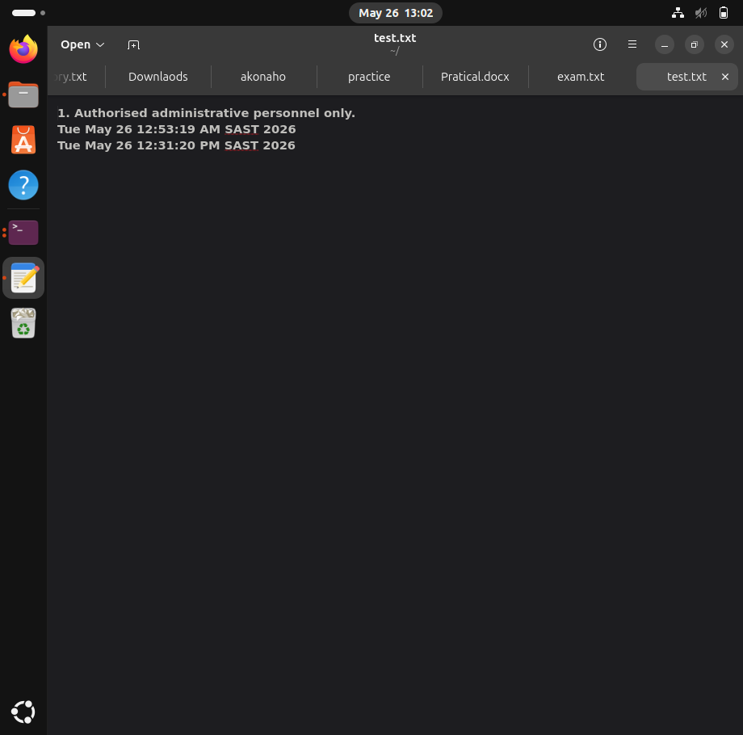

Summary
- > → Overwrites file contents
- >> → Appends output to a file
- | → Passes output from one command into another command
These are essential Linux shell features used for automation, filtering, and file management.

5.Compare man, --help, and apropos.

1. Comparison Matrix
Utility / Command | Input Requirement | Interface Type | Best Use Case
man | Exact command name (e.g., man cp) | Interactive Pager: Opens a full-screen, scrollable manual interface using less. | Used when detailed technical documentation, syntax structures, environment variables, or advanced usage information is required for a specific command.
--help | Command followed by the help flag (e.g., cp --help) | Standard Output Stream: Displays concise information directly in the terminal window. | Best for quick syntax verification, option reminders, or short command references during active terminal work.
apropos | Keyword or descriptive phrase (e.g., apropos "copy files") | Standard Output Stream: Displays a list of related commands with short descriptions. | Useful when the user knows the task they want to perform but does not remember the exact command name.

2. Functional Differences and Behaviour
- man — The Manual System
The man command provides access to the official Linux manual pages stored locally on the system. These manuals contain comprehensive technical documentation for commands, configuration files, system calls, and utilities. Since the information is displayed inside an interactive pager, the user must press q to exit and return to the terminal prompt.

- Syntax Example: man mkdir
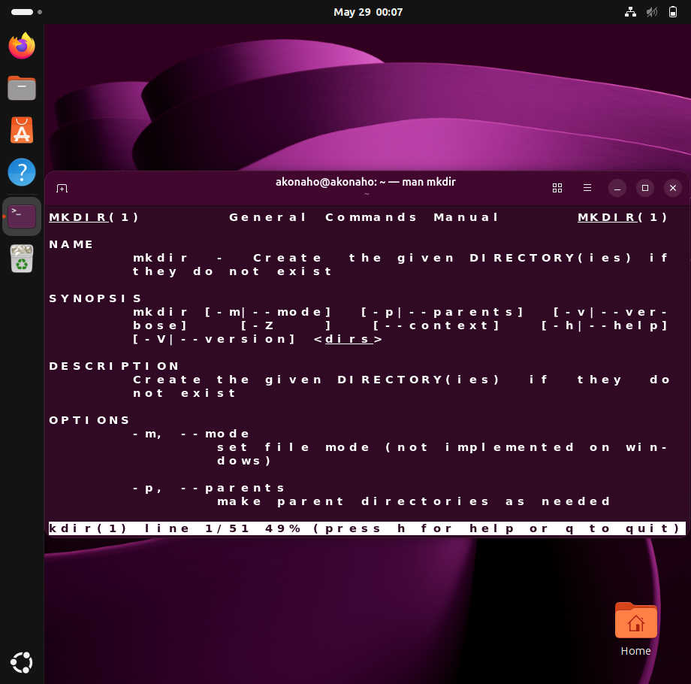
- Primary Advantage: Provides exhaustive technical detail, including all supported options, usage patterns, examples, and edge-case behaviors.

- --help — The Built-In Help Flag
The --help option is integrated directly into many Linux commands rather than existing as a separate utility. It provides a concise overview of command syntax and available options. The output is displayed directly in the current terminal session, making it fast and convenient during command execution.
- Syntax Example: mkdir --help
- Primary Advantage: Offers immediate access to essential syntax and option references without interrupting workflow.
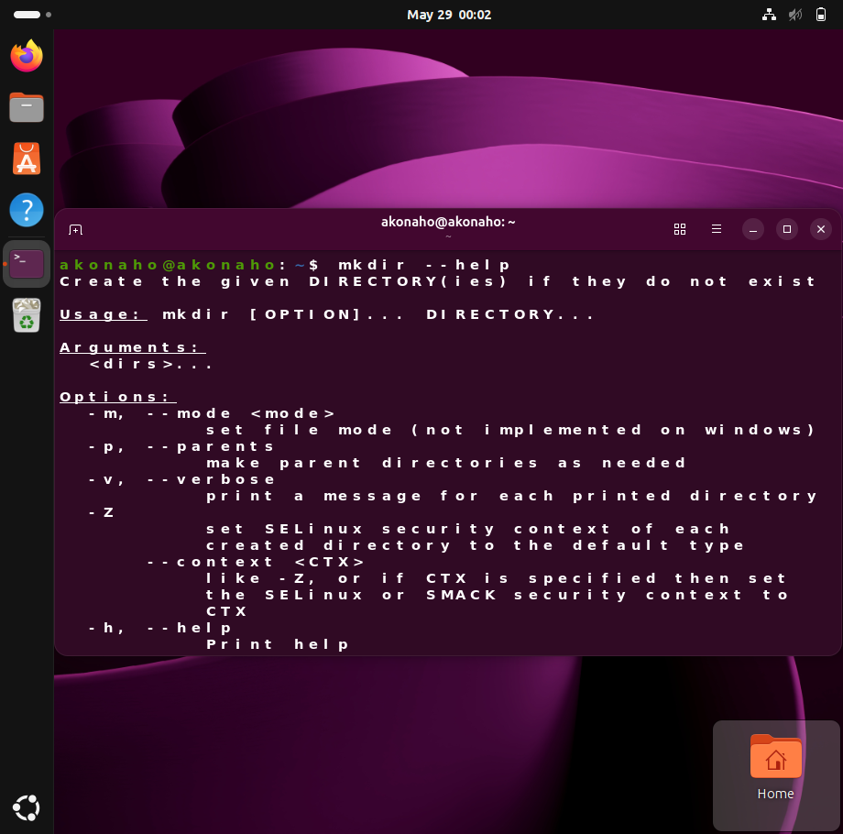

- apropos — The Command Search Utility
The apropos command searches the system’s manual page database using keywords or descriptive phrases. Unlike man and --help, which require knowledge of a specific command name, apropos helps users discover commands related to a task or concept.
- Syntax Example: apropos search
- Primary Advantage: Assists with command discovery by mapping human-readable descriptions to Linux command utilities.
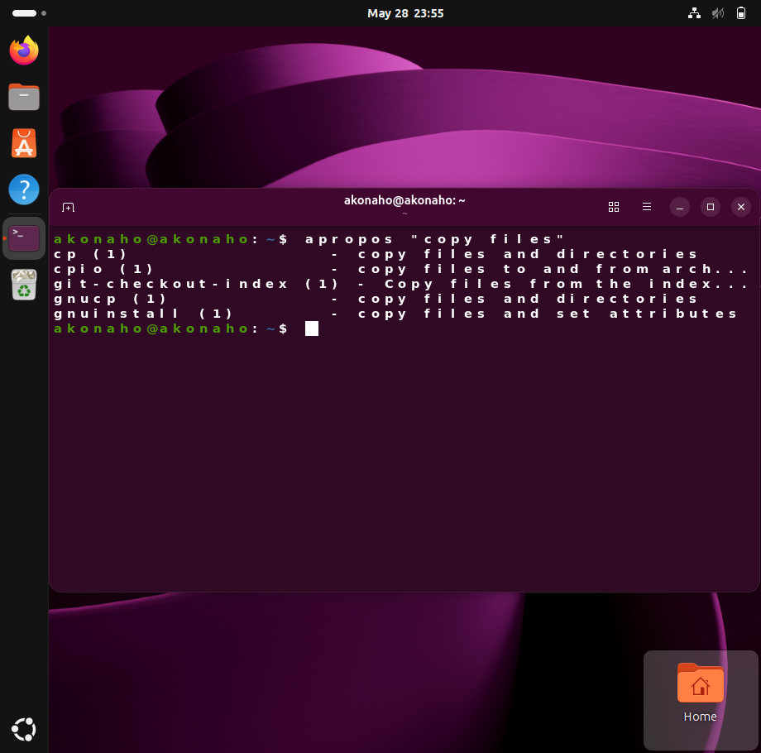
apropos scanned the descriptions of all installed utilities and returned a list. This proves apropos is a search engine for terminal.

6.Explain vi modes.

The vi text editor operates using a modal architecture, meaning the behaviour of the keyboard changes depending on the active operational mode. Unlike graphical text editors that rely heavily on mouse interaction and visual menus, vi uses keyboard-driven commands to perform navigation, editing, and file management tasks efficiently.
To work effectively within vi, users must understand how to transition between its three primary modes: Command Mode, Insert Mode, and Last-Line Mode (Ex Mode).
1. Command Mode (Normal Mode)
Command Mode is the default operational state when a file is opened in vi. In this mode, keystrokes are interpreted as editor commands rather than literal text input. The mode is primarily designed for navigation and text manipulation.
Primary Functions
- Cursor navigation
- Copying and pasting content
- Deleting text
- Undoing changes
- Executing editing shortcuts
Common Keyboard Commands
Command | Function
h | Move cursor left
j | Move cursor down
k | Move cursor up
l | Move cursor right
dd | Delete (cut) the current line
yy | Copy (“yank”) the current line
p | Paste copied content below the cursor
u | Undo the previous action

Key Characteristics
- This mode is optimized for rapid keyboard-based editing.
- Commands are case-sensitive.
- No text is inserted into the document while in this mode.

2. Insert Mode
Insert Mode converts vi into a conventional text-entry environment. In this state, all keyboard input is written directly into the file buffer as editable content.
Primary Functions
- Typing text
- Editing document content
- Inserting new characters and lines
Entering Insert Mode
Command | Function
i | Insert text before the cursor
a | Append text after the cursor

Visual Indicator
When Insert Mode is active, the lower-left corner of the terminal displays:
-- INSERT --
Exiting Insert Mode
Press the Esc key to return safely to Command Mode.
Key Characteristics
- Behaves similarly to modern word processors.
- Used exclusively for content entry and modification.
- Editing commands are unavailable until returning to Command Mode.

3. Last-Line Mode (Ex Mode)
Last-Line Mode, commonly referred to as Ex Mode, provides access to file management and advanced editor commands. When activated, the cursor moves to a command-line interface located at the bottom of the terminal window.
Primary Functions
- Saving files
- Exiting the editor
- Performing search and replace operations
- Adjusting editor settings
Entering Last-Line Mode
From Command Mode, type:
:
Common Ex Commands
Command | Function
:w | Save (write) the file
:q | Quit the editor
:q! | Force quit without saving
:wq | Save changes and quit

Exiting Last-Line Mode
Press Esc twice to cancel the command buffer and return to Command Mode.
Key Characteristics
- Interfaces directly with file system operations.
- Provides administrative control over the editing session.
- Essential for saving and safely closing documents.

The Modal Workflow Cycle in vi
Efficient usage of vi depends on continuously transitioning between modes based on th
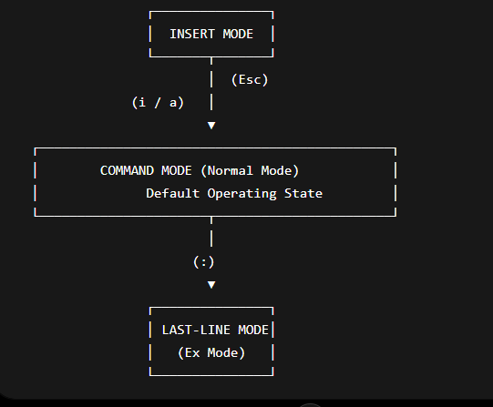
Summary
The power and efficiency of vi come from its modal design. Each mode is specialized for a particular category of tasks:
- Command Mode handles navigation and editing operations.
- Insert Mode handles text entry and document modification.
- Last-Line Mode manages file operations and advanced commands.
Mastering movement between these modes is fundamental to becoming proficient with the vi text editor in Linux and UNIX-based systems.

7.Explain difference between pipe and redirection.

Understanding the Difference Between Pipes and Redirection in Linux
Although both pipes and redirection are used in Linux to manipulate standard input and output streams, they perform fundamentally different functions and direct data to entirely different destinations.
The primary distinction is based on the receiving endpoint of the data stream:
- Redirection sends command output to a file.
- Pipes send command output directly to another command or process.

1. Output Redirection (> and >>)
Output redirection captures the data that a command would normally display on the terminal screen and reroutes it into a file stored on the system’s storage device.
Core Characteristics
Feature | Description
Destination | A file stored on disk
Primary Symbols | > (overwrite) and >> (append)
Purpose | Saving command output permanently

Data Flow Architecture
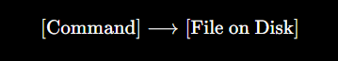
Redirection Operators
Operator | Function
> | Creates a new file or overwrites an existing file
>> | Appends new output to the end of an existing file

Example 1
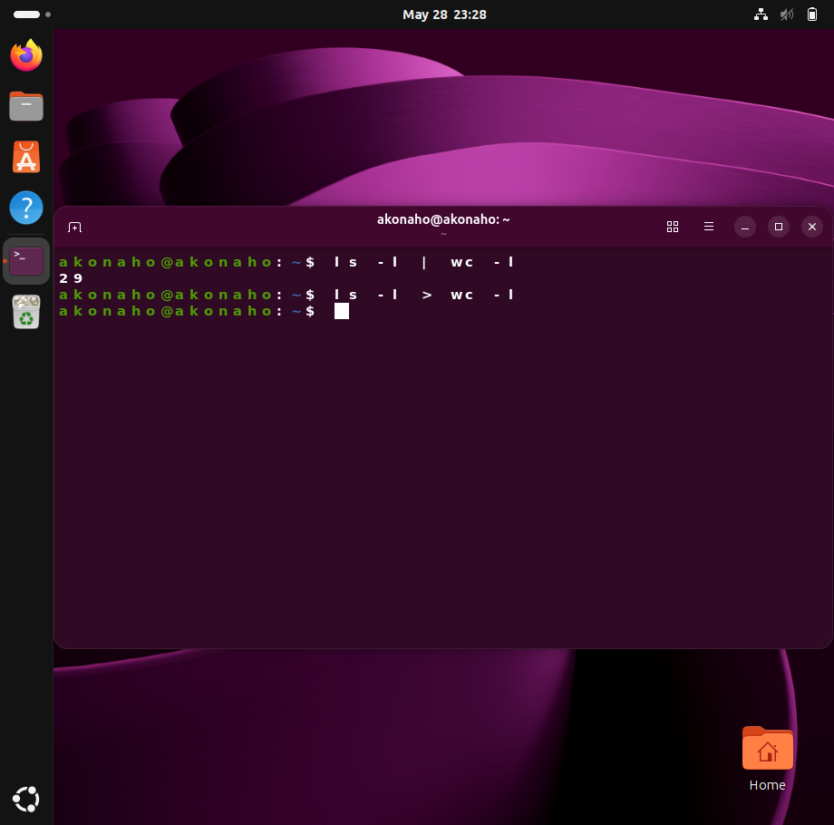
- No number printed Result: Type ls now. You will see that you just accidentally created a brand new physical file named wc -l! Because i used >, Linux didn't run the word count command; it literally thought you wanted to create a file named "wc -l".
Pipes expect a program on the right side. Redirection treats whatever is on the right side as a filename.
Using Redirection for Security Auditing
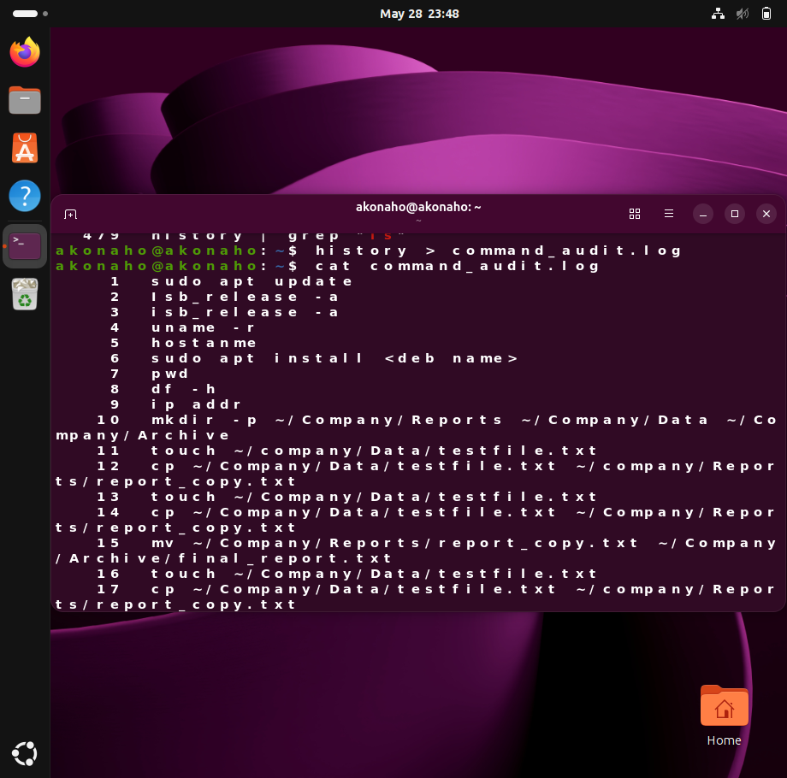
During a security investigation, it is important to preserve command history for auditing and evidence purposes. Redirection can be used to save terminal activity into a log file so that the information remains available even if the terminal history is later cleared.
Command:
history > command_audit.log
This command redirects the output of the history command into a file called command_audit.log.
- history displays all previously executed commands.
- > redirects and saves the output into a file.
- command_audit.log becomes a permanent record stored on the hard drive.
Evidence Verification:
After running the command, the terminal does not display any output because the results are written directly into the file.
To verify the saved audit log, use:
cat command_audit.log
This command displays the contents of the log file, providing a permanent and unedited snapshot of the terminal command history for security and forensic analysis purposes.

Practical Example
ls -l > maths.txt
Explanation
The ls -l command generates a detailed directory listing. Instead of displaying the output on the terminal screen, the redirection operator (>) writes the data directly into a file named maths.txt.
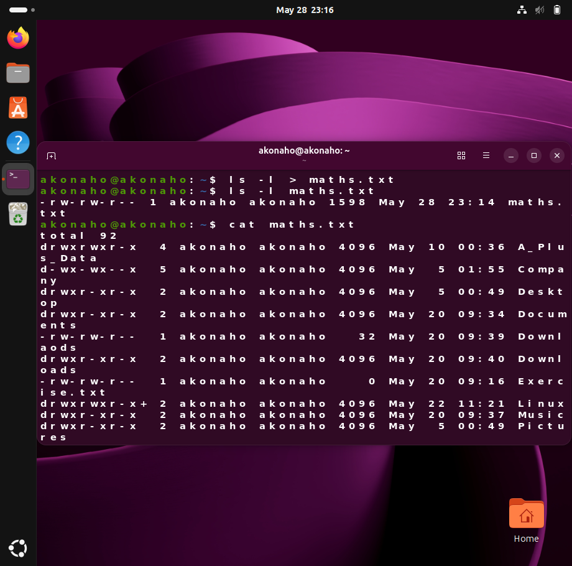
Result
- A physical file is created or overwritten.
- No output appears on the terminal screen.
- The data is stored permanently until modified or deleted.

2. Pipes (|)
A pipe transfers the live output stream of one command directly into another command as input. Instead of writing data to disk, the operating system temporarily stores the stream in memory and forwards it between active processes.
Core Characteristics
Feature | Description
Destination | Another running command or process
Primary Symbol | `
Purpose | Real-time data processing between commands

Data Flow Architecture
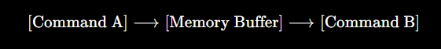

Practical Example
ls -l | grep "exam"
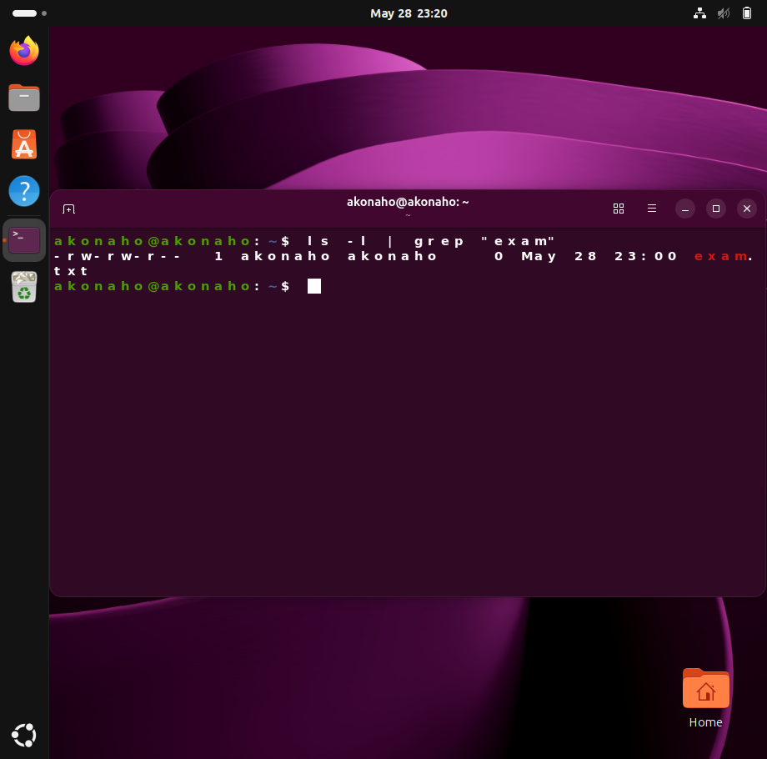
Explanation
The ls -l command first generates directory listing output. Before the data is displayed on the terminal, the pipe operator (|) intercepts the stream and passes it directly to the grep command.
grep then searches the incoming data and displays only the lines containing the keyword "exam".
Result
- No files are created.
- Data is processed dynamically in memory.
- Only filtered results appear on the screen.

Example 2
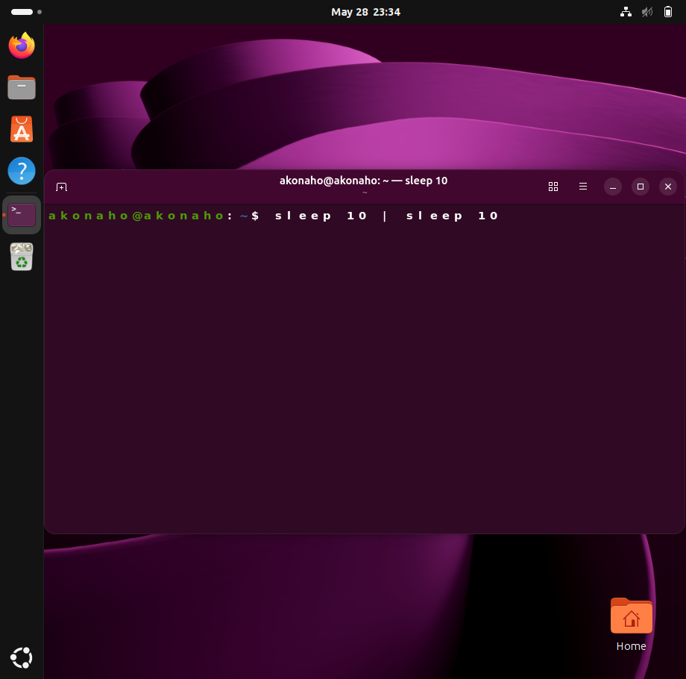
While that is running, it pauses your terminal for 10 seconds.
- The Evidence: It doesn't take 20 seconds to finish; it takes exactly 10 seconds.
- What this proves: The pipe forces both commands to launch at the exact same time. The first sleep command is instantly connected to the second one via RAM. Redirection cannot link two live running processes like this.

Architectural Difference Between Pipes and Redirection
| Feature | Redirection (> / >>) | Pipes (|) |
|---|---|---|
| Data Destination | File stored on disk | Another command/process |
| Storage Behaviour | Creates or modifies permanent files | Uses temporary memory buffers |
| Right-Hand Requirement | Requires a filename | Requires another executable command |
| Primary Purpose | Saving or archiving output | Real-time filtering and processing |
| Persistence of Data | Persistent until deleted | Temporary and volatile |
| Typical Use Cases | Reports, logs, backups | Searching, sorting, filtering |

Example 3
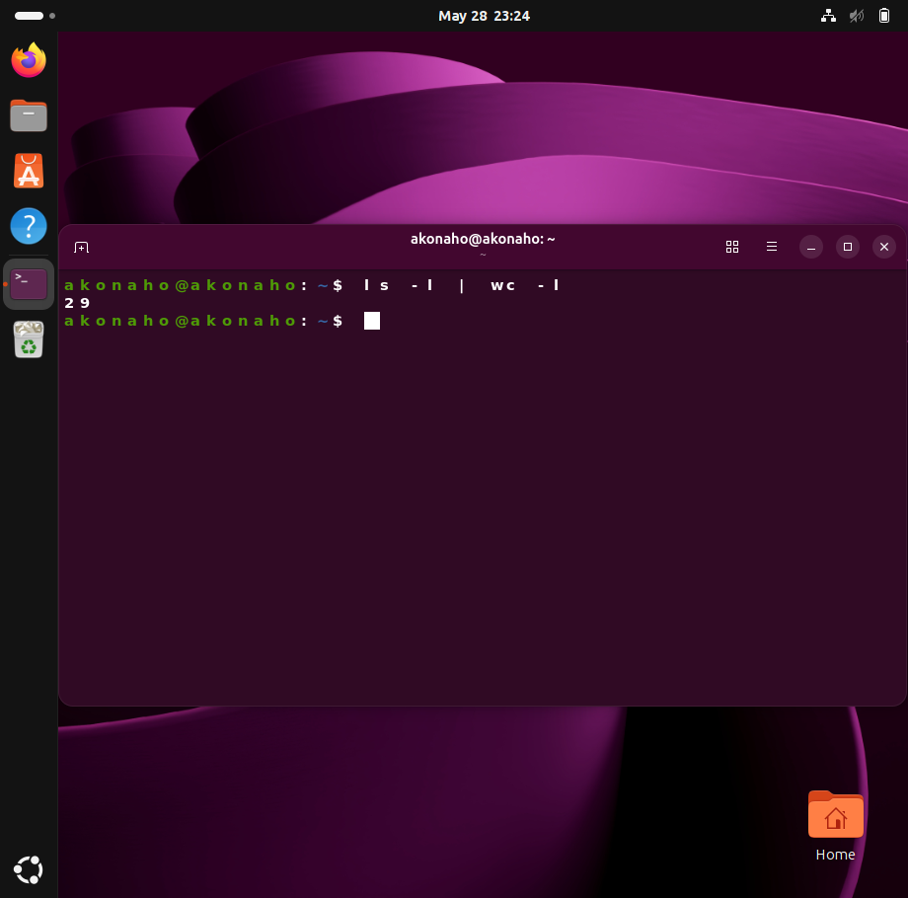
What happened: ls -l generated a list of files. Instead of printing them, the pipe (|) grabbed that text and shoved it directly into wc -l's mouth. wc -l counted the lines and showed you the total. No file was created.
Example 4
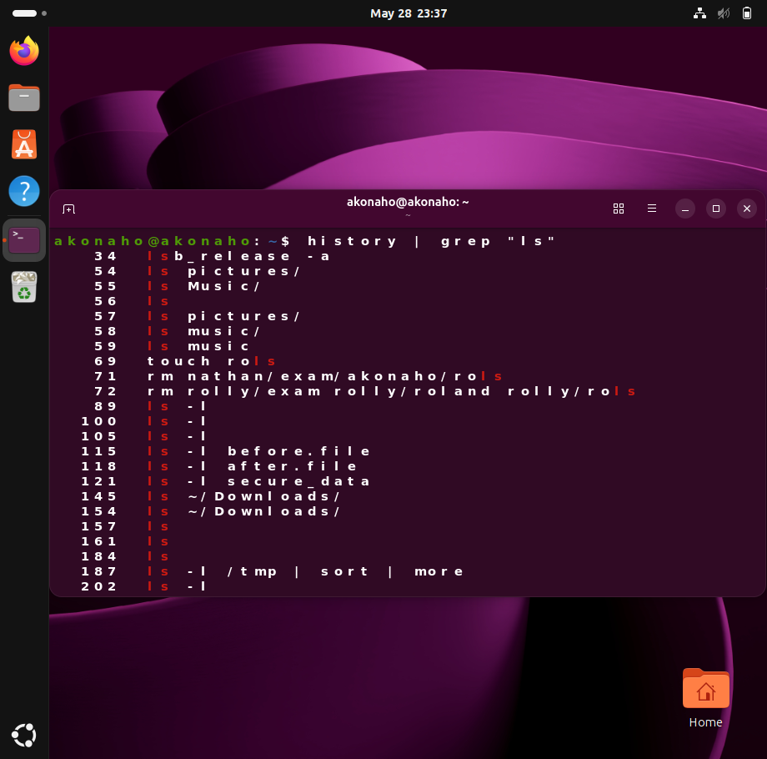
Only the past commands containing "ls" appear on the screen. The list was filtered in flight through RAM.
Conclusion
Pipes and redirection are both essential Linux stream-handling mechanisms, but they serve different operational objectives:
- Redirection is designed for storing command output into files for later use or archival purposes.
- Pipes are designed for chaining commands together so that data can be processed dynamically and efficiently in real time.
Understanding the distinction between these two concepts is fundamental for effective Linux command-line administration and shell scripti

Question 6 Terminal and vi Editor

- Use Firefox (bookmark + download).
- Create a document in LibreOffice titled Intern Guide.
- Edit an image using GIMP.
- Use workspaces to organise tasks.
- Evaluate how these applications support productivity.
- Explain benefits of multitasking.
- Identify risks of poor application management.

[Subtotal 15 Marks]

1. Use Firefox (bookmark + download).

Launch Firefox – Open the Firefox browser from the applications menu or taskbar.
Open Firefox. Search for a relevant image or resource for any document.
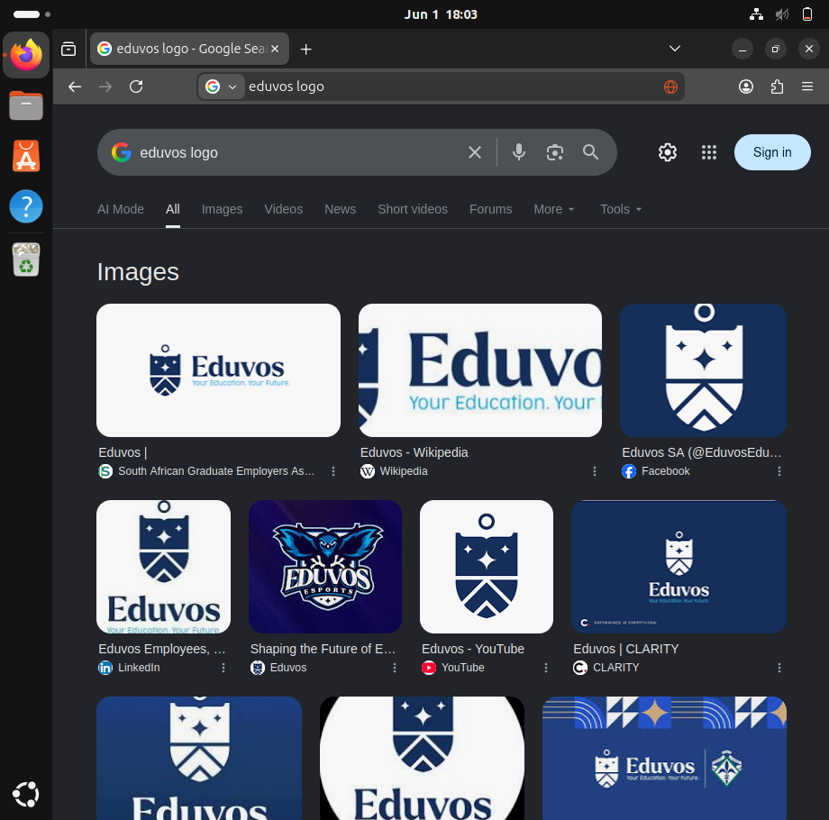

- Bookmark: Press Ctrl + D to bookmark the page.
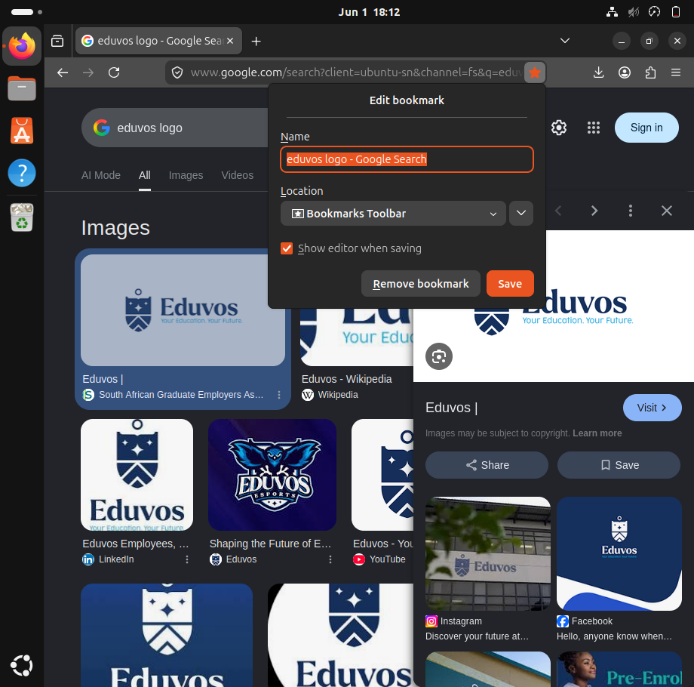
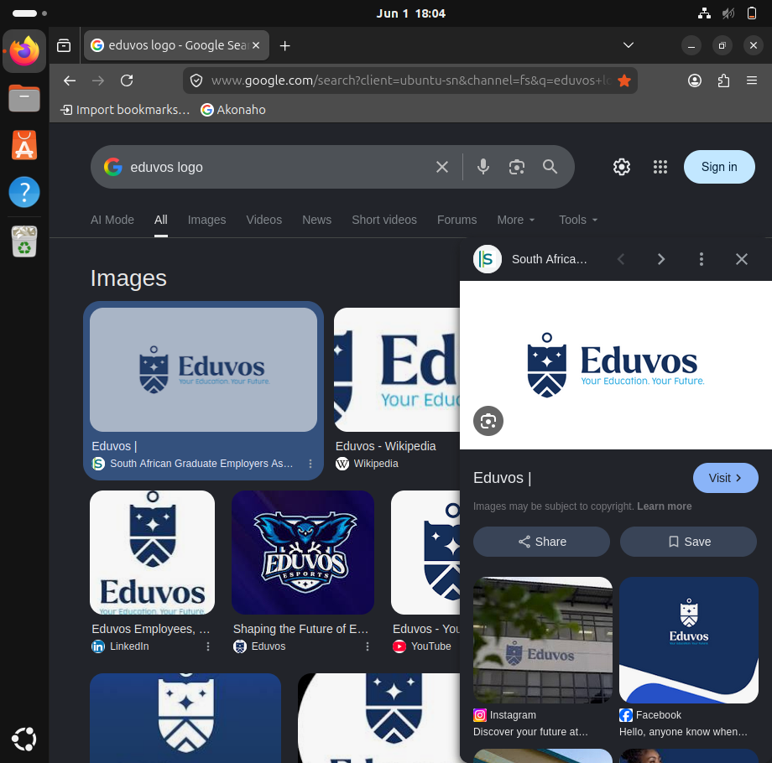

- Download: Right-click an image or file and select Save Image As... to download it to your Downloads folder.
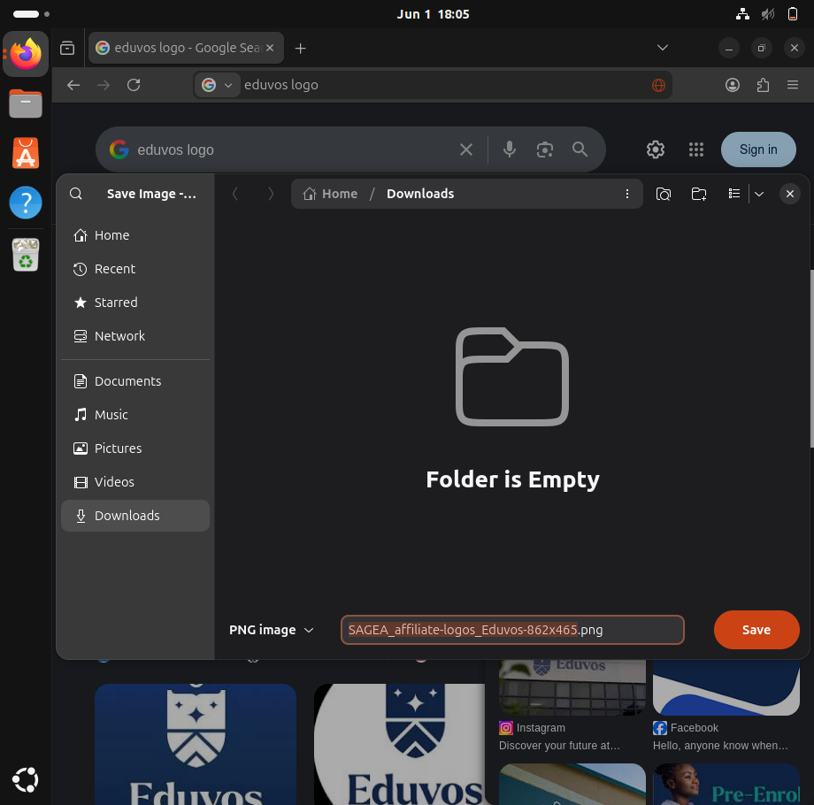

2.Create a document in LibreOffice titled Intern Guide.

Download LibreOffice – If not already installed, open the terminal and download LibreOffice.
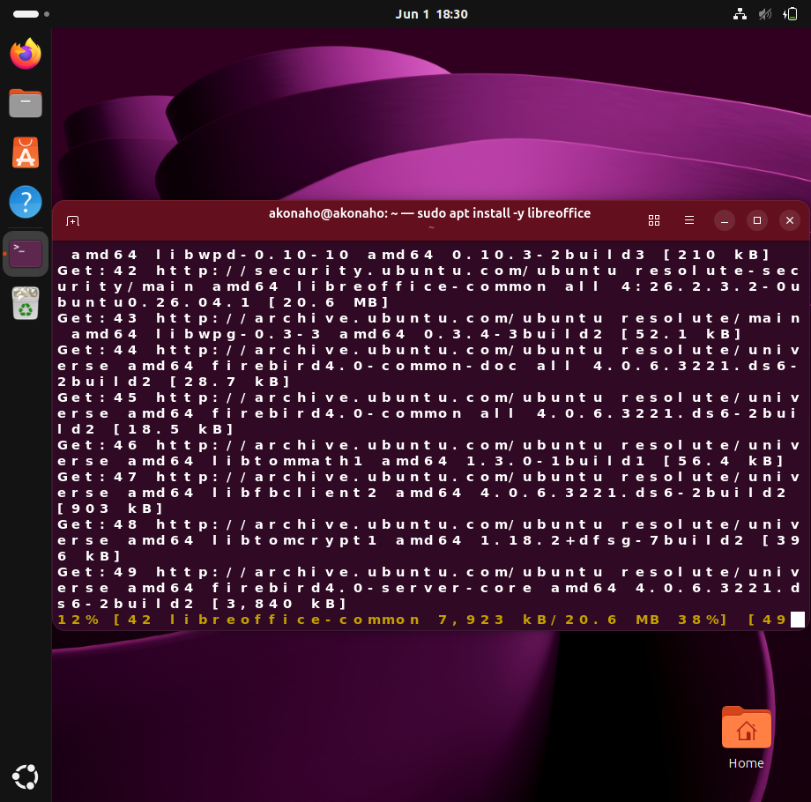
Launch LibreOffice Writer – Open the application from the start menu or terminal.
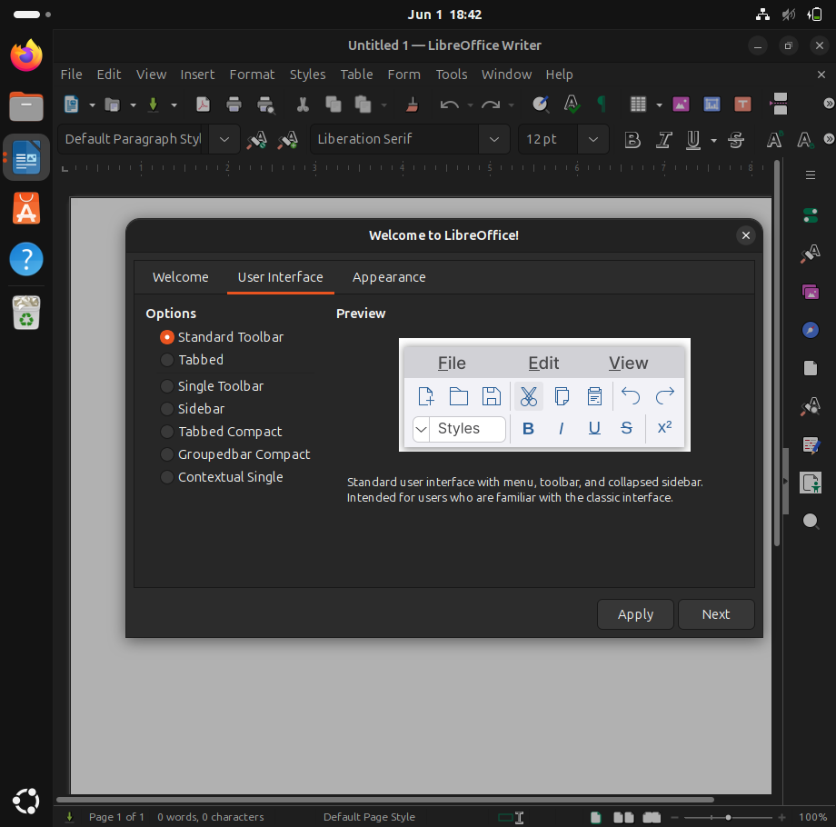
Create Document – Type the introductory notes for the internship overview.
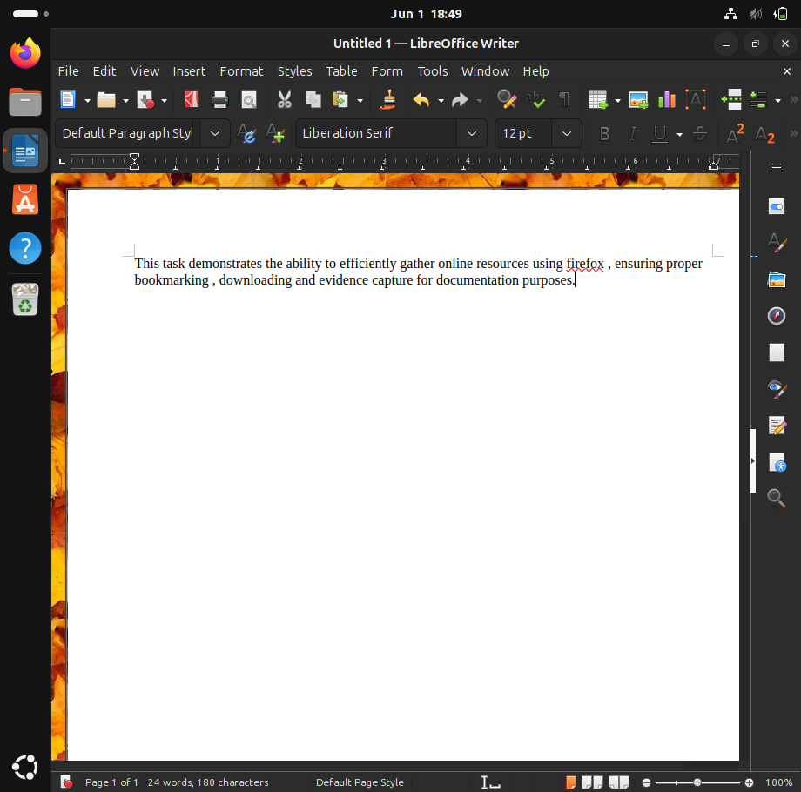

Save Document – Go to File > Save As, name the file Intern Guide, and save it in the Documents folder as either .odt or .docx
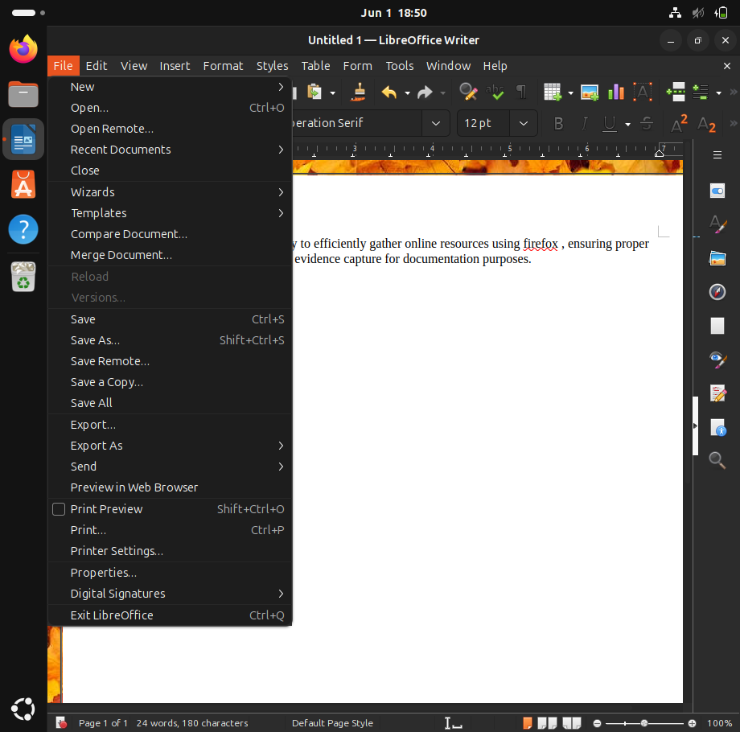
The Intern Guide document was successfully created and saved. Evidence screenshot confirms the correct title and file format.
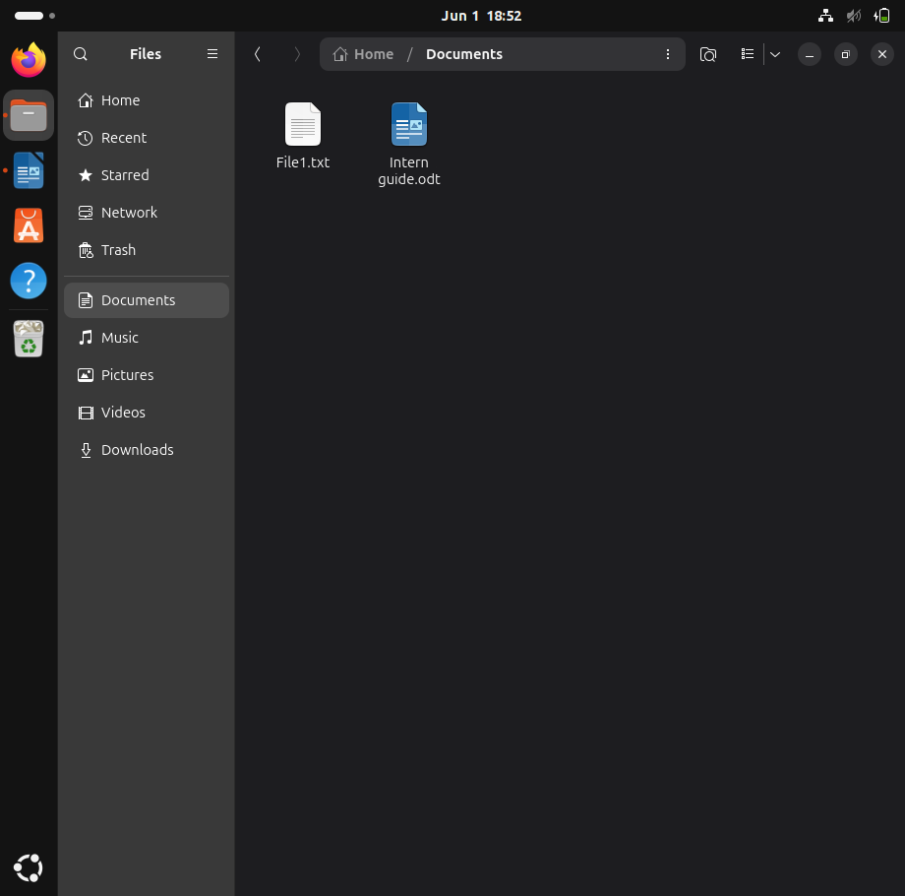

3.Edit an image using GIMP.

The process began with downloading and installing GIMP, an open-source image editing application. After installation, the program was launched to prepare for editing tasks.
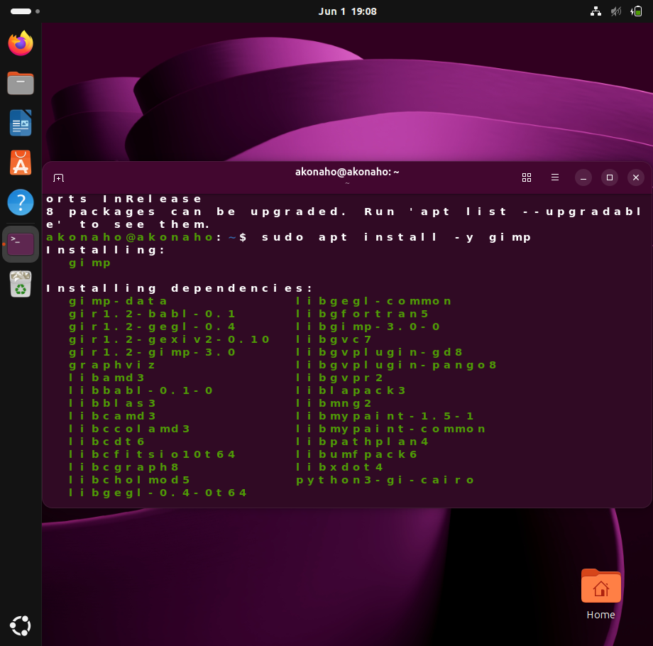
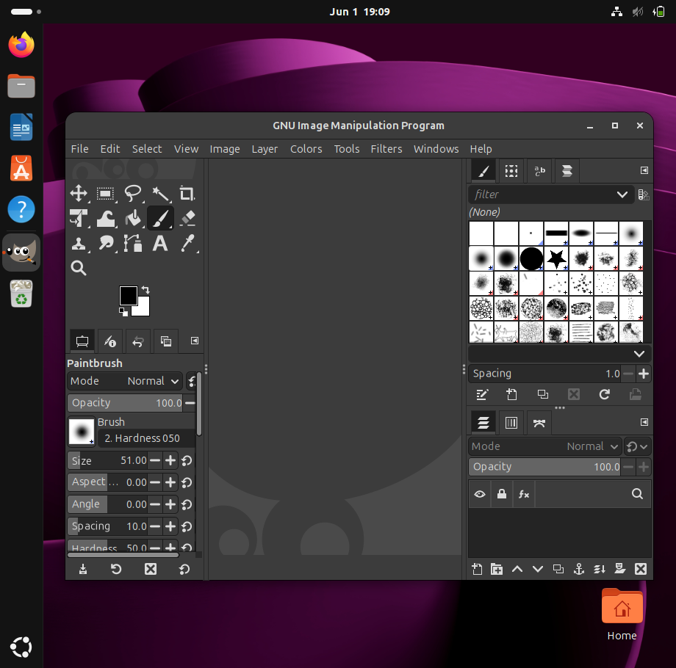
Using Firefox, an image was downloaded and saved locally. This image served as the subject for the editing exercise.
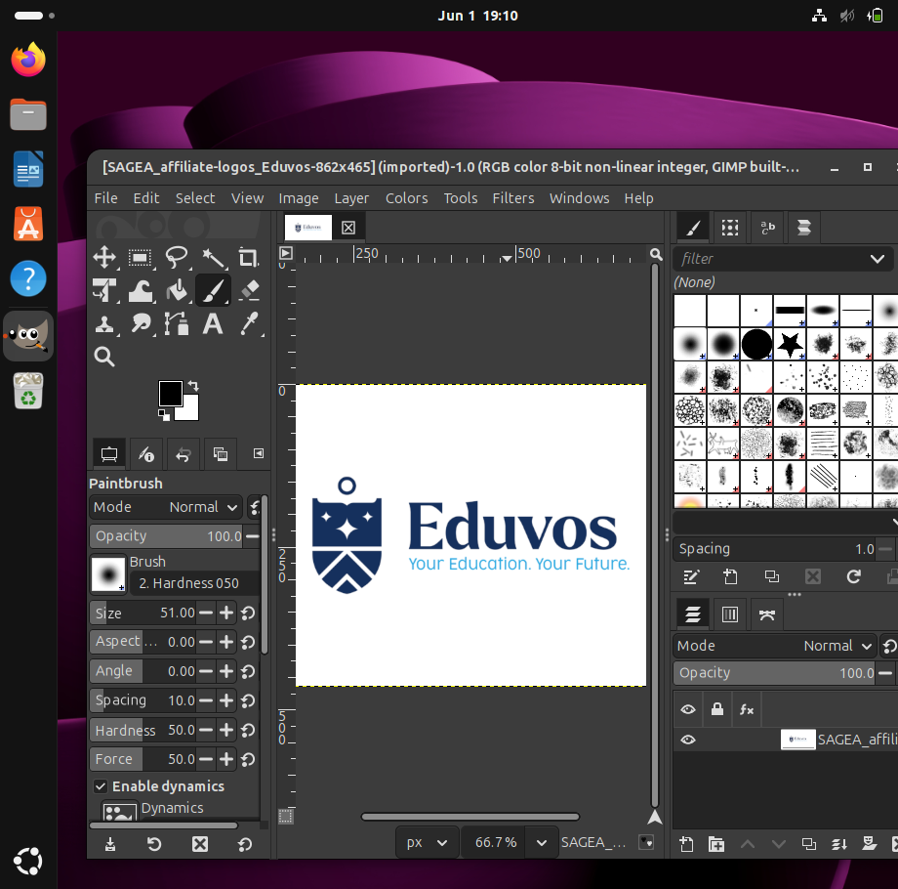
Making a Highly Visible Edit in GIMP
- The downloaded image was opened in GIMP via File > Open.
- The Text Tool (represented by the “A” icon in the toolbox or accessed by pressing T) was selected.
- A text label such as “Linux Project” or the student’s name was added to the image.
- The text size was adjusted to ensure that the label was large, clear, and easily visible, making the edit prominent and professional.

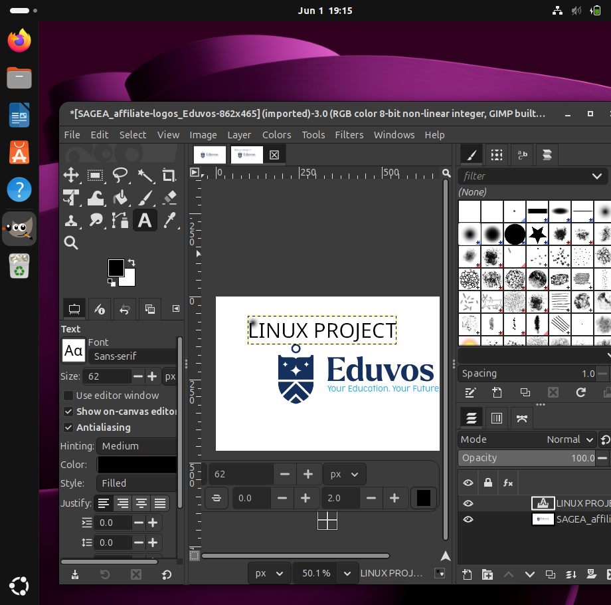
Saving and Viewing the Edited Image
- Once the edit was complete, the image was saved using File > Save.
- After saving, the file was located in the system’s downloads folder.
- By double-clicking the saved file, the edited image appeared, confirming that the changes were successfully applied.
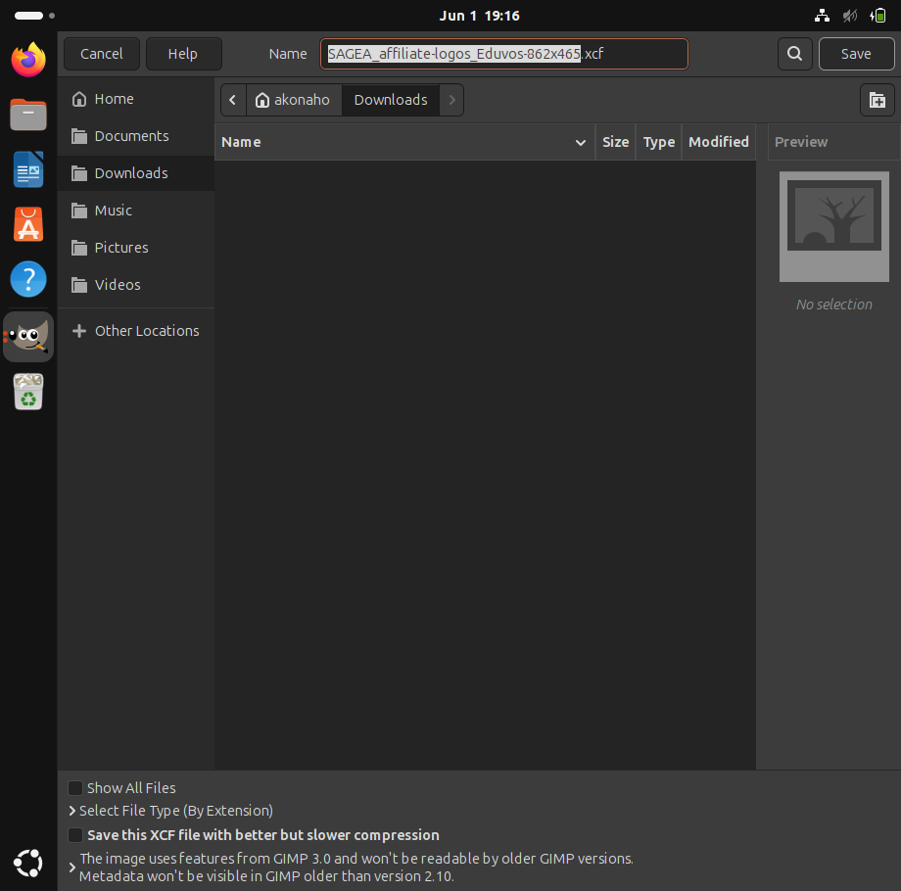

4.Use workspaces to organise tasks.

Launching Multiple Applications via the Activities Overview
To demonstrate the use of the GNOME desktop environment for multitasking:
- Open the Activities Overview by pressing the Super key (Windows key) on the keyboard.
- In the search bar, type the name of each required application: Firefox, LibreOffice Writer, GIMP, and Terminal.
- Select each application from the displayed results to launch them.
- All four applications will now be running simultaneously, showcasing the efficiency of GNOME’s search-driven interface for quick access to essential tools.
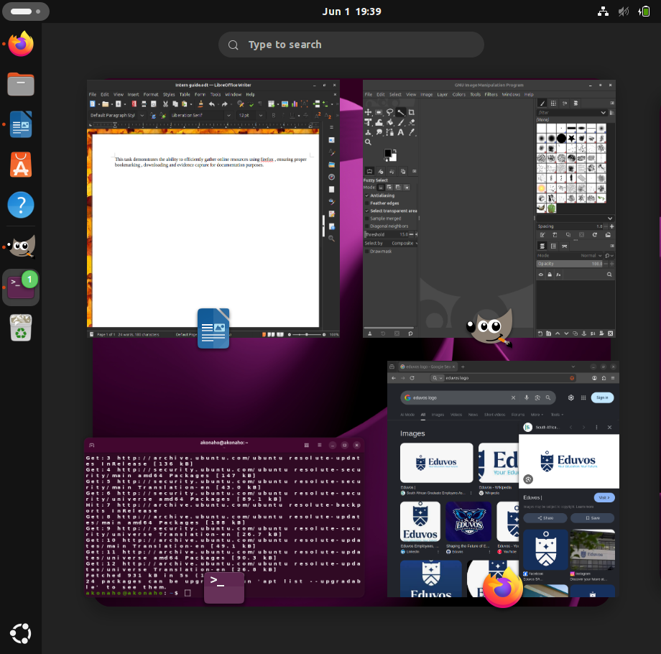

5.Evaluate how these applications support productivity.

Evaluating a Productivity Pipeline with Ubuntu Tools
Modern work environments thrive when chaos is replaced with structure. On Ubuntu, a carefully chosen set of applications transforms scattered tasks into a streamlined workflow. Each tool plays a distinct role, ensuring that productivity is maximized while wasted effort is minimized.
1. Firefox – Managing Information
Value: Acts as the central hub for knowledge retrieval. Bookmarks prevent repetitive searching and create a personal library of essential resources.
Impact: Direct downloads into organized folders establish a reliable supply of materials for documentation and design, cutting down on external dependencies.
2. LibreOffice Writer – Bringing Clarity
Value: Documentation ensures that knowledge is standardized and accessible. A guide like Intern Guide becomes a shared reference point rather than isolated notes.
Impact: Built-in formatting tools keep documents professional and consistent, reducing time spent on manual adjustments.
3. GIMP – Enhancing Visuals
Value: Visual aids make technical information easier to digest. Screenshots, diagrams, and annotations add clarity to otherwise dense text.
Impact: Layer-based editing allows precise, non-destructive changes. Highlighting or overlaying text on images makes instructions more intuitive for new learners.
4. Terminal – Driving Efficiency
Value: The command line eliminates unnecessary steps. Instead of navigating menus, tasks are executed instantly.
Impact: A single command such as sudo apt update, sudo apt install -y gimp installs software in seconds, conserving system resources and enabling automation.

The Connected Workflow
The strength of this setup lies in how the tools complement one another:
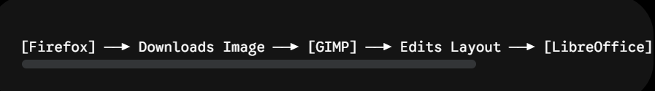
Together, they form a cohesive pipeline where information flows seamlessly from research to editing to documentation. The result is a fast, efficient, and fully open-source environment that supports professional productivity.

6.Explain benefits of multitasking.

Multitasking in Operating Systems and Workflows
In the context of operating systems and human workflows, multitasking refers to managing multiple tasks or processes at the same time. When paired with features such as virtual workspaces, multitasking becomes a powerful driver of productivity, enabling smoother workflows and reducing wasted effort.
1. Streamlined Pipeline Integration
Professional tasks rarely occur in isolation. Multitasking creates a continuous production line across the desktop.
- Example: With Firefox, GIMP, and LibreOffice open together, a reference asset can be downloaded, edited immediately, and inserted into a report—all without the disruption of repeatedly opening and closing applications.
2. Reduced Context-Switching Friction
Switching between programs manually interrupts focus and slows progress. Multitasking keeps essential tools active in the background, allowing seamless transitions between drafting text, reviewing terminal outputs, and consulting documentation. This preserves concentration and supports deep work.
3. Background Task Optimization
Computers excel at handling passive operations while attention is directed toward active problem-solving. Multitasking ensures that background processes run in parallel with primary tasks:
- System or package updates via the terminal.
- Large file downloads in Firefox.
- Rendering or exporting high-resolution graphics in GIMP.
This parallelism maximizes time efficiency and keeps workflows moving forward.
Ubuntu manages multitasking through two complementary mechanisms:
Mechanism | How It Works | Productivity Benefit
Hardware Parallelism | Distributes tasks across multiple CPU cores, enabling true simultaneous execution. | Prevents resource-heavy applications (e.g., GIMP applying filters) from freezing other tools.
Software Time-Slicing | Rapidly shifts CPU attention between tasks in milliseconds. | Creates the seamless experience of multiple applications running responsively at once.

Multitasking is more than a technical feature; it is a productivity strategy. By keeping tools active, reducing friction, and leveraging background processing, Ubuntu enables professionals to maintain momentum and deliver results efficiently.

Identify risks of poor application management.

Risks of Poor Application Management in Ubuntu
Modern operating systems like Ubuntu are designed to be resilient, but leaving applications unmanaged can quickly create bottlenecks. Beyond slowing down the machine, poor application management disrupts focus and increases the risk of data loss.
1. Technical Strain and Resource Exhaustion
Every open application consumes system resources such as RAM and CPU.
- The RAM Trap: Heavy applications like GIMP with large canvases or dozens of Firefox tabs can drain available memory.
- System Latency: Once RAM is exhausted, Ubuntu relies on the hard drive as virtual memory (swapping), which causes lag, freezing, and unresponsiveness.
- The OOM Killer: In critical cases, the Linux kernel’s Out-Of-Memory (OOM) Killer terminates processes to prevent a crash. This can abruptly close applications such as LibreOffice or GIMP mid-task, resulting in lost progress.
2. Increased Risk of Data Loss
Disorganized application use often leads to poor saving habits.
- Unsaved Work: Keeping files open for long periods without saving makes progress dependent on system stability and power supply.
- Cascade Crashes: If one application locks up, a forced reboot may wipe unsaved changes across all open programs simultaneously.
3. Cognitive Overload and Workflow Disruption
The impact on human performance is just as big as the technical strain.
- Visual noise from cluttered screens with tons of overlapping stuff makes our brains work hard to filter out distractions, zapping focus.
- Constantly shuffling between windows? If we don’t use Workspaces wisely, it takes forever to find what you need, breaking concentration and slowing things down.
Managing apps effectively isn’t only about keeping Ubuntu running smoothly; it protects data and minds too. Using Workspaces and being disciplined with saving files helps
stop resource burnout, cuts down on mental overload, and keeps everything flowing smoothly.

Conclusion

This project assessment shows off more than just tech skills; it proves I can turn Linux sys admin tasks into stuff that's actually ready for business use. The project spotlights my grasp of virtualization, problem-solving, system tweaking, and command-line wizardry—basically, everything you need for today’s IT world.
Firstly, by nailing resource management in virtualization, I show how to keep IT both flexible and cheap. Smart setups mean systems stay online during heavy use and companies get their money’s worth from their gear.
Checking kernel versions and making sure network bits are good isn’t just box-ticking. It helps create a culture of early warning system checks, meeting legal tech standards and stopping glitches from causing bigger issues down the road.
Next, customizing GNOME and other apps to make them work for everyone shows how Linux fits any role within a firm. Making tools user-friendly is huge for helping workers do their best while feeling happy at their desks.
Lastly, setting up safe directories and slick command-line hacks cuts down on mistakes and bumps automated tasks along smoother. Plus, this keeps data snug according to company safety rules.
So , the project ticks all those boxes for what an employer wants from a sys admin.
The assessment shows that the intern follows corporate IT governance rules by focusing on secure user accounts, organized directories, and controlled resource allocation. This means they can work well in environments that require following strict guidelines, like those from ISO, NIST, or CIS.
Completing these tasks helps bridge the gap between what's learned in school and what's needed on the job. It builds the intern's confidence in dealing with real-world IT issues, making them a good fit for enterprise infrastructure teams.
In the end, this assessment turns book knowledge into hands-on know-how. It shows the ability to set up, secure, and improve enterprise-grade Linux environments. Through this project, the intern proves they can create robust, scalable, and secure IT systems – not just check off tasks. These are must-have skills in today’s tech world.
This practical test confirms the intern's ability to design, secure, and optimize enterprise-grade Linux environments with Ubuntu 26 LTS. By mixing virtualization, diagnostics, customization, and advanced command-line skills, they show they’re ready to support scalable infrastructures and follow governance rules. Plus, this proves they can keep data safe and actually build systems that boost productivity, cut risks, and match corporate IT strategies.

Reference
Ward, Brian. How Linux Works, 3rd Edition. No Starch Press, 2020. Explains Linux internals, virtualization, and containers.
Nemeth, Evi, Snyder, Garth, Hein, Trent R., Whaley, Ben, Mackin, Dan. UNIX and Linux System Administration Handbook, 5th Edition. Addison-Wesley, 2011. Known as the “sysadmin bible.”
Shotts, William E. Jr. The Linux Command Line, 2nd Edition. No Starch Press, 2019. Beginner-friendly introduction to shell, scripting, and text processing.
Blum, Richard. Linux Command Line and Shell Scripting Bible, 3rd Edition. Wiley, 2015. Practical scripting and automation reference.
Negus, Christopher. Linux Bible, 11th Edition. Sybex/Wiley, December 2025. Covers RHEL 9, Ubuntu 24 LTS, Fedora 41; comprehensive system administration reference.
Ward, Brian. How Linux Works, 3rd Edition. No Starch Press, 2021. Explains Linux internals, virtualization, and containers.
Muzvidziwa, M. (2026) ITVAA0-12 Project: Formative Assessment. AIE Learning Management System.

Articles
Chilla, L.R. (2025) ‘Linux System Administration: A Comprehensive Guide for IT Professionals’, International Journal of Computer Engineering and Technology (IJCET), 16(1), pp. 2573–2585. doi:10.34218/IJCET_16_01_182.
Gera, K. (2025) ‘Linux System Administration: A Comprehensive Guide for Developers’, NamasteDev Blogs, August.
LinuxVox (2026) ‘Mastering Linux System Administration: A Comprehensive Guide’, LinuxVox Blog, January.

Websites
- Linux Foundation (2026) Introduction to Linux System Administration. Available at: https://training.linuxfoundation.org [Accessed 1 June 2026].
- DevGlan (2026) Best Linux System Administration Blogs and Websites. Available at: https://www.devglan.com [Accessed 15 May 2026].
- LinuxVox (2026) Mastering Linux System Administration. Available at: https://www.linuxvox.com [Accessed 1 June 2026].
- Canonical Ltd. (2026) Ubuntu 26.04 LTS Release Notes. Available at: Ubuntu 24.04 LTS Release Notes (Accessed: 2 June 2026).

End of Project

